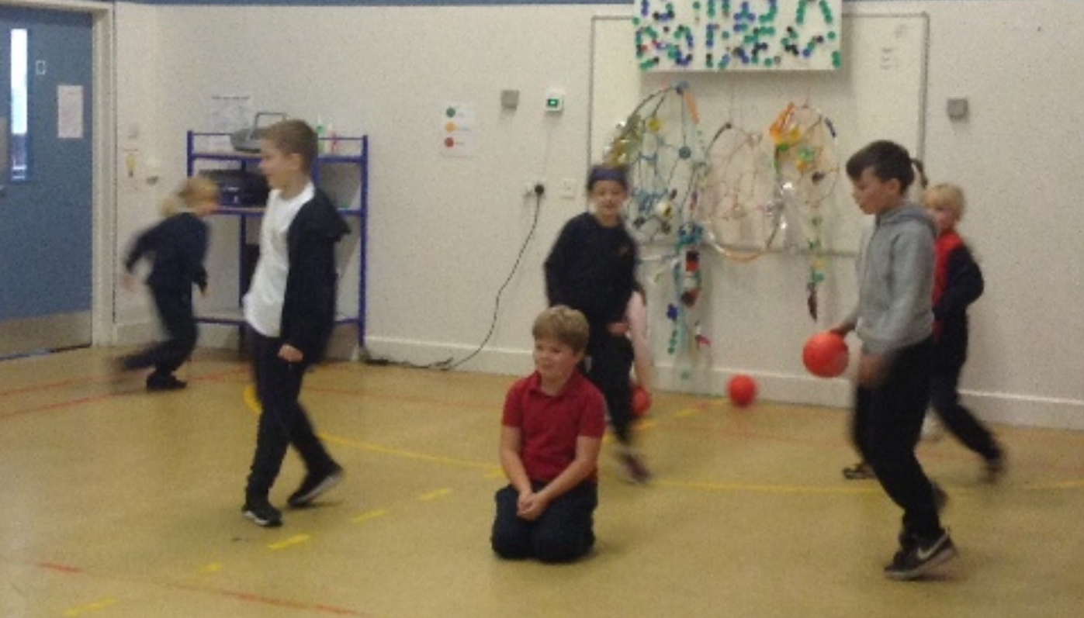
Dodgeball Taster Class 3 2022

On Friday 30th September Class 3 tried Dodgeball. Throughout the year Class 3 will be having taster sessions of different sporting activities before having a go with children from other schools. This is part of the Omnes Games set up by The West Norfolk School Partnership Programme.
The ‘Omnes Games’ meaning ‘For All’ was designed to give those children who don’t usually represent the school an opportunity to do so. The events are run as festivals, so no scores and results are recorded. Just an opportunity to come and play, have fun, meet new friends and fall in love with a new sport.
I thought the dodgeball was fun and exciting. I enjoyed it very much.
Hope, Year 4
I thought it was good.
Esther, Year 3
It was amazing fun.
Lyla, Year 3
Dodgeball was so fun, it was great.
Chase, Year 4
I thought the dodgeball session was great because you must not get hit by the ball.
Amelia, Year 4
I think the Dodgeball session was really fun, my brother is coached by the person who ran it, he’s called Reece. I was with two of my friends on my team so that was good.
Eric, Year 4

