Hate Crime Awareness

On Friday 14th October, those of us remaining in Class 4 had an RSHE lesson with a difference. We joined PC Hazel Tampin and a large number of Norfolk schools for an online lesson about hate crimes.

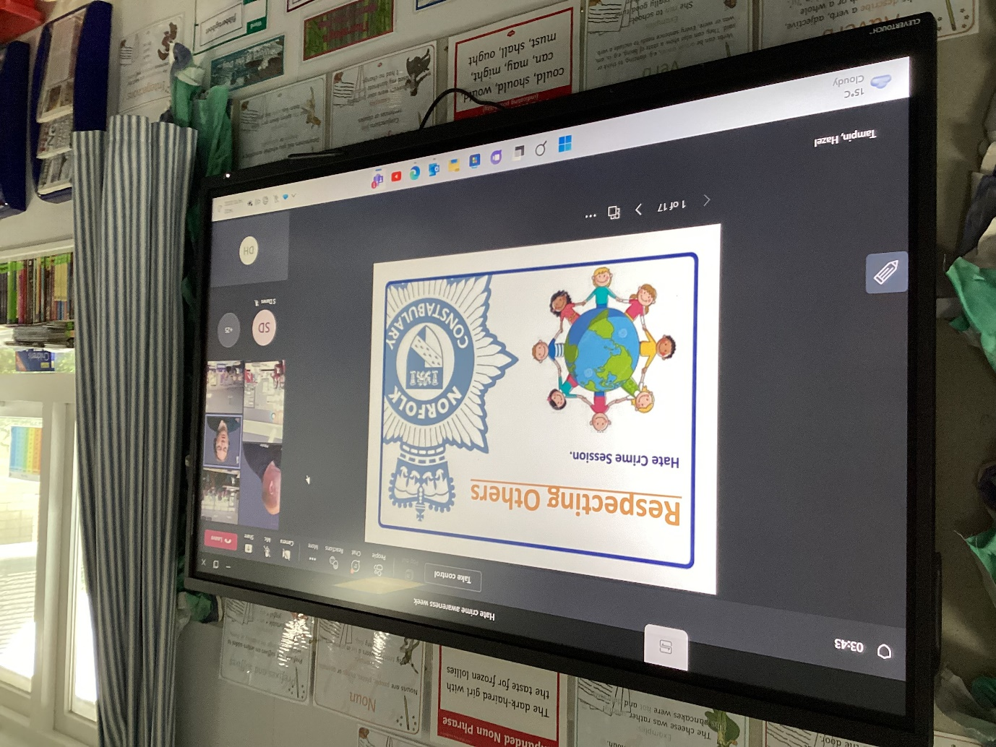

We learnt that children have some criminal responsibility and can be arrested from the age of 10.

Hazel explained which crimes can constitute a hate crime if the crimes are committed against the five characteristics that are protected by law. The crimes are these: threatening behaviour, assault, harassment, criminal damage and anti-social behaviour (also known as nuisance). The characteristics that are protected in law are: religion, race, disability, transgender identify and sexual orientation.


At the end of the session there was a chance for questions and signposting to organisations such as Childline.

