Class 4 begin to learn the ukulele
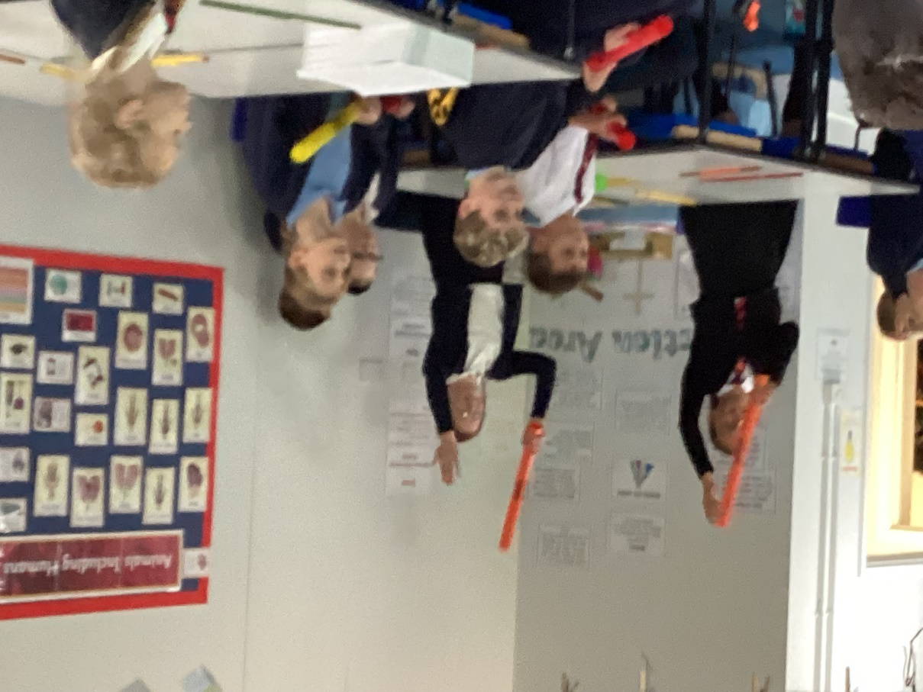
On Thursdays from this week onwards, Class 4 children will be learning to play the ukulele with Mrs Bartrum. This will support our music curriculum to allow the children to all have an opportunity to learn to play an instrument.
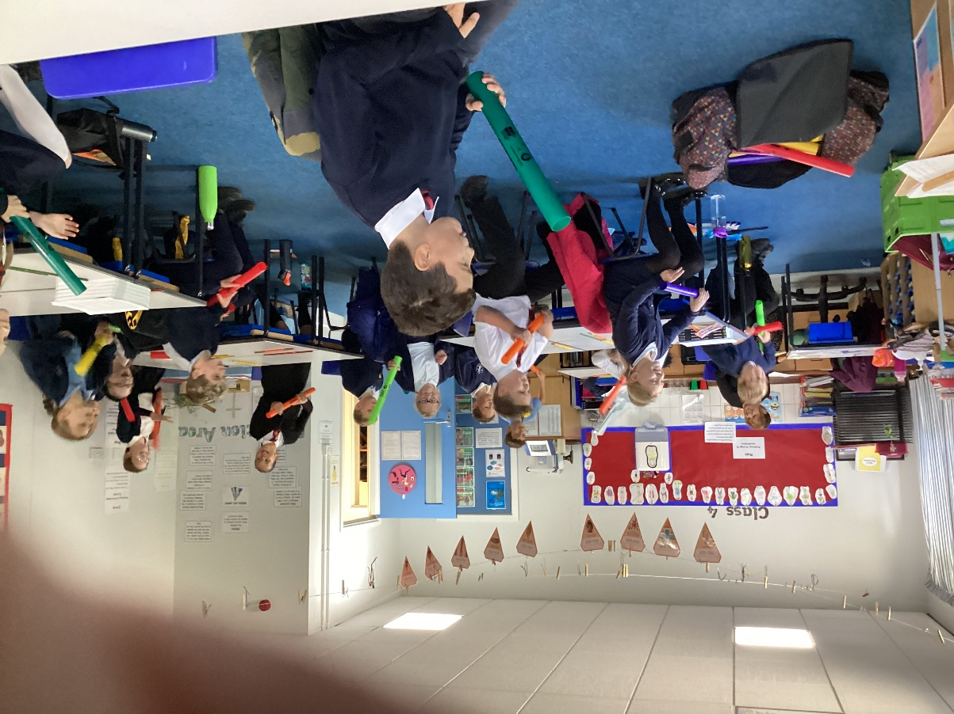

They enjoyed the first session and are looking forward to making more noise next week!



