Downham Market Library Visit

Tuesday 11th October. Year 1 and Y2 went on a visit to Downham Market Library. They went on the coach and were very excited. They were given a talk by Fran about how long they could have books, how many they could have, how much it cost to join and learnt all about the activities that take place in the library. You can even use your library card as a key to access the library when it is closed!
They took part in an activity to find particular books and completed a questionnaire about what Fran had told them. Those who were members of the library were able to take out a book. They had a lovely time and are all keen to keep going to the library.
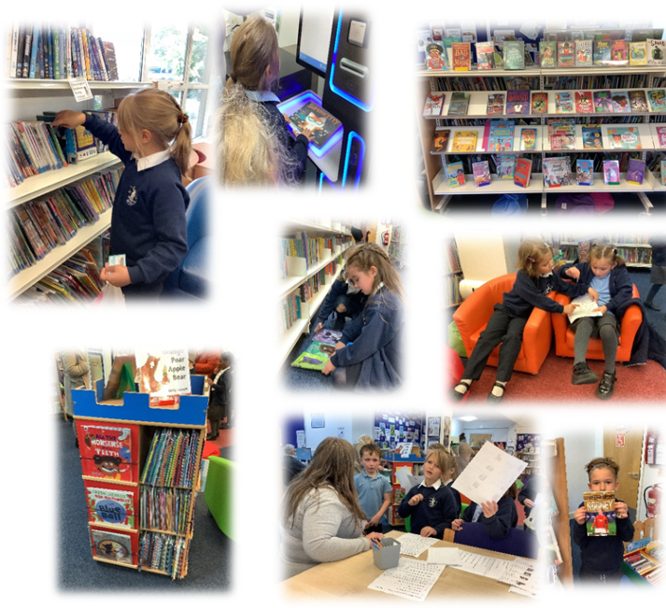

They were all extremely well behaved and should be proud of themselves as representatives of Denver School.

