
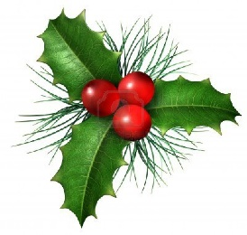
Decoration Day

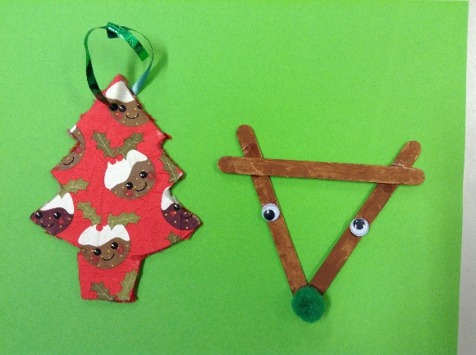
Friday 27th November 2020 was Christmas Decoration day in school. This is a day when the children have lots of fun doing art and craft activities to produce Christmas decorations and cards.
This year the made hanging decorations for the tree: one using tissue paper and one using lolly sticks.
Their favourite activity was making the paper chains which nearly reach right across the room.

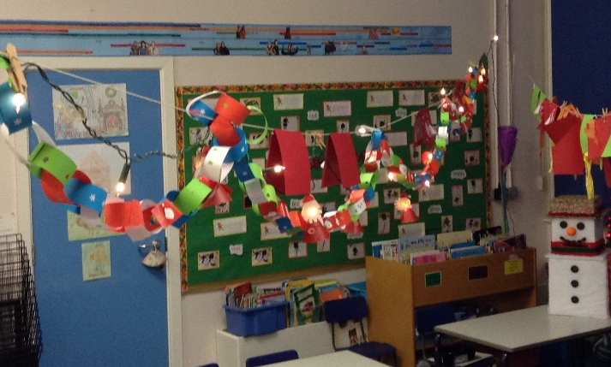
They also made stained glass windows which are on display for everyone to see.
They had a lovely day and joined in singing with our Christmas songs.
They are proud of their work and we hope you get as much pleasure from their efforts as they did from making them, as you celebrate Christmas this year.
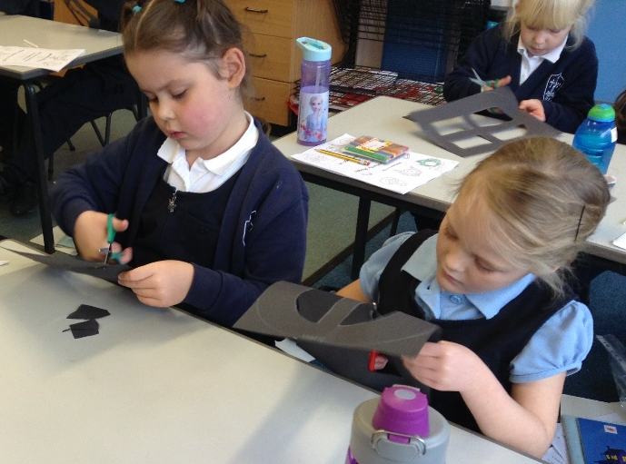
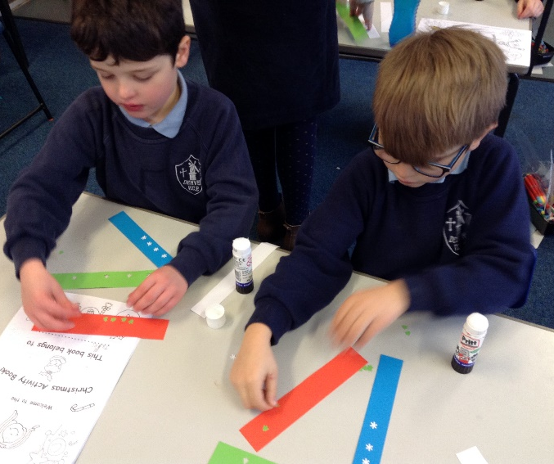

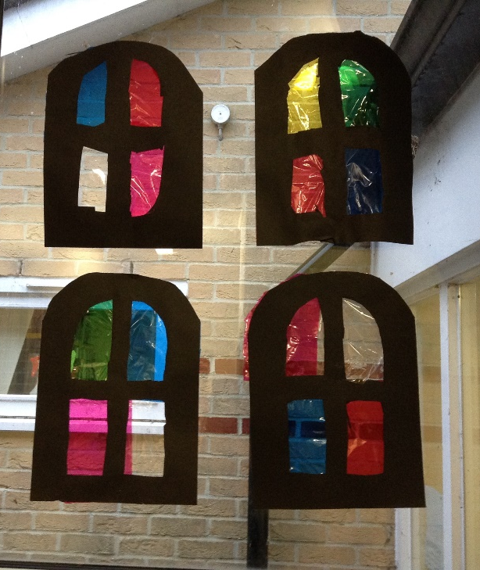

Stained glass windows have brightened up our December days and made us feel more cheerful.

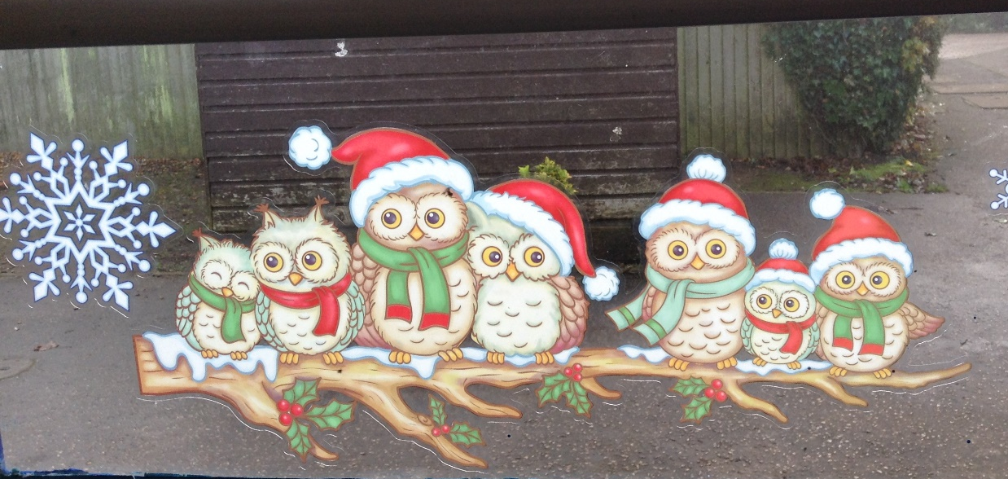

Knowing my love of owls, one of the parents brought me a lovely decal for my window!! Thank you!!

