NEW MENU
On Tuesday 18th October 2022 some of the children were given the opportunity to try some of the new foods that will be on the menu after the half term holiday.
There was a lot to choose from: Greek chicken, teriyaki chicken, butcher’s sausages, pizza, lemon muffins and cherry Bakewell cakes.
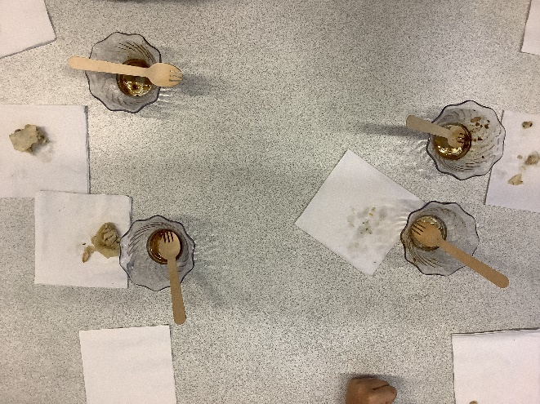
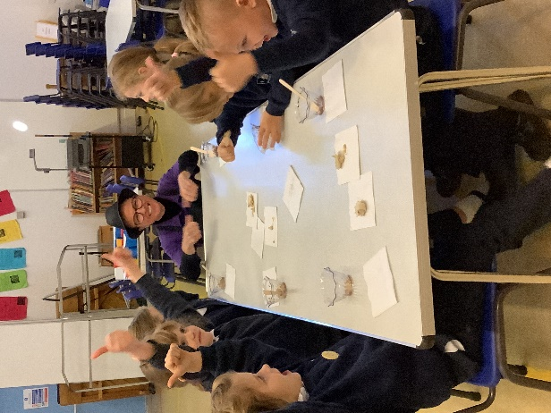

Chicken Teryaki

Mrs Fenn looks on
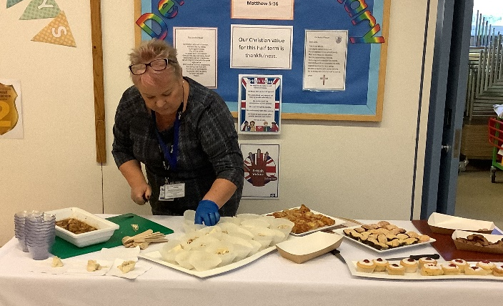
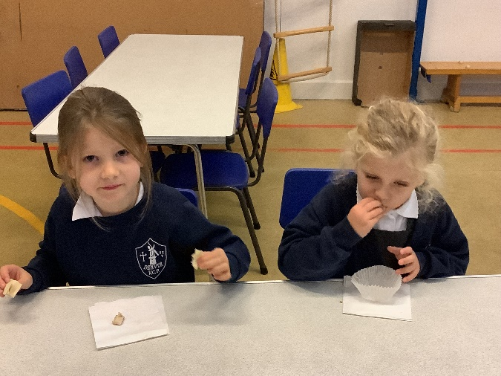
Both the cakes were met with great delight, as were the sausages and pizza. The chicken dishes were also quite popular and some of the children said they would have them when they were on the menu

