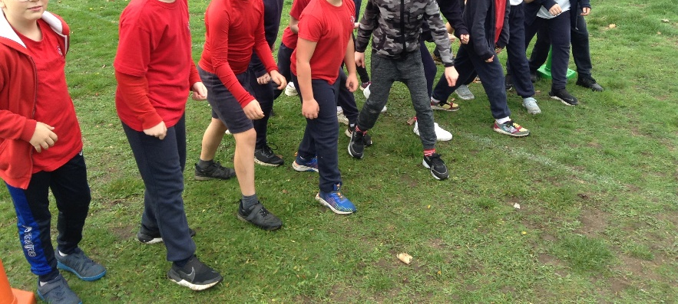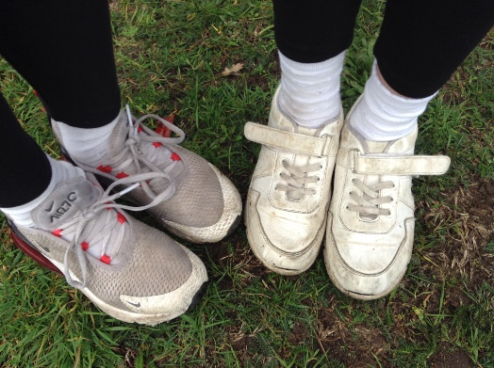

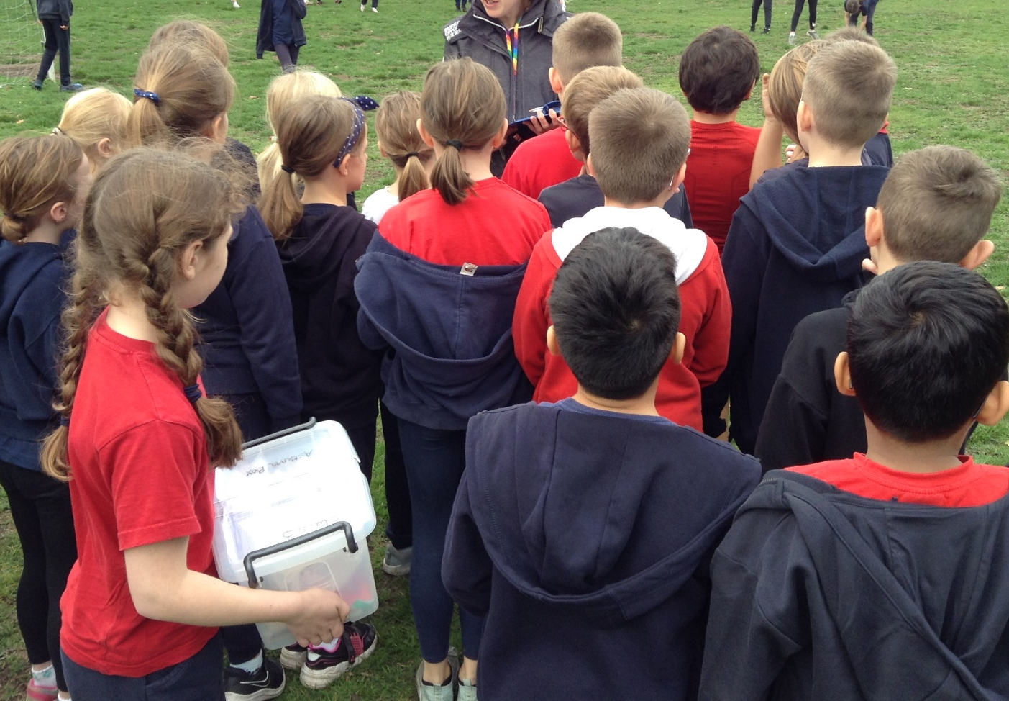
Intra Cross-Country Class 3 2022

On Friday 21st October, Class 3 tried took part with the rest of the school in out Cross-Country session. This was to see who would go forward to the Cluster Event in November. The following children have the opportunity to go on further.
Year 3 – Esther, Lyla, Lorelei, Rowan, Flynn and Arthur
Year 4 – Hope, Rosie, Amelia, Eric, Alfie and Max
There will be more activities and opportunities throughout the year for those whose sporting talents lie away from running.

