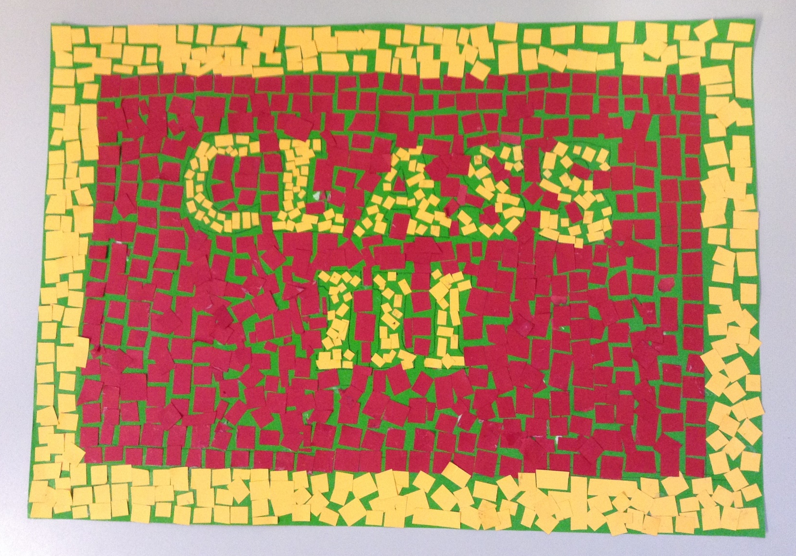
The Romans
During the Autumn Term Class 3 looked at the Romans.
Here is our attempt at a mosaic like the ones used to decorate buildings.
This is now on the front of our class door.

