Class 4 children prepare for the Christmas Fayre
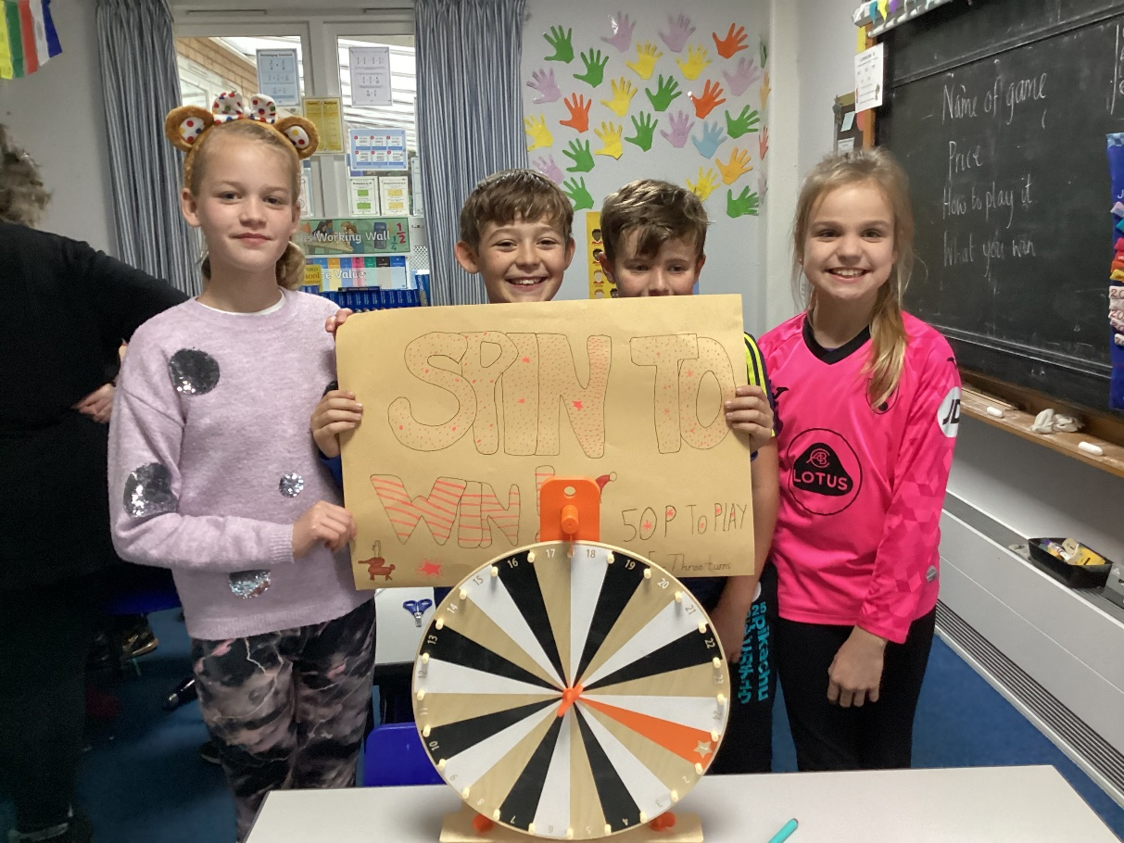
On Friday 18th November, the children organised themselves into groups and planned the stalls that they will be offering at the Christmas Fayre on November 24th.
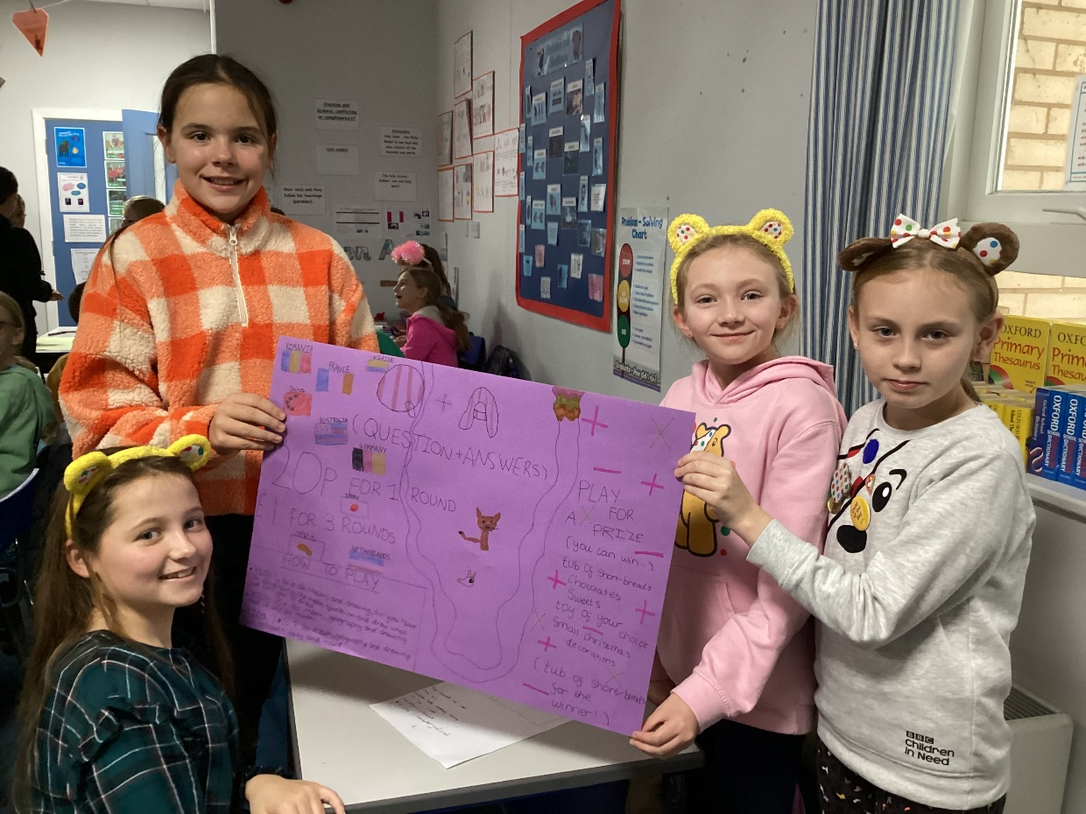
Once their ideas had been approved they were tasked with deciding on prices, making any games or scoreboards they needed, advertising their stalls and writing instructions so players know what to do.
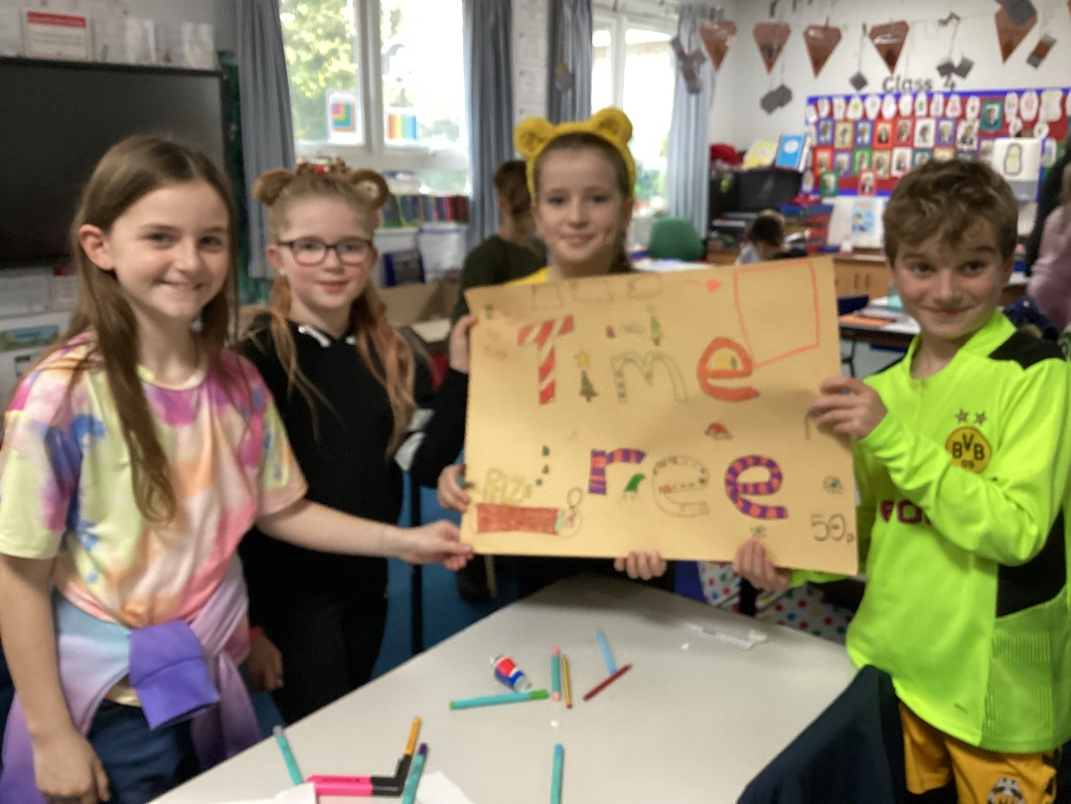
They have also contacted local supermarket community champions in the hope that they will kindly donate some things that can be used as prizes.


