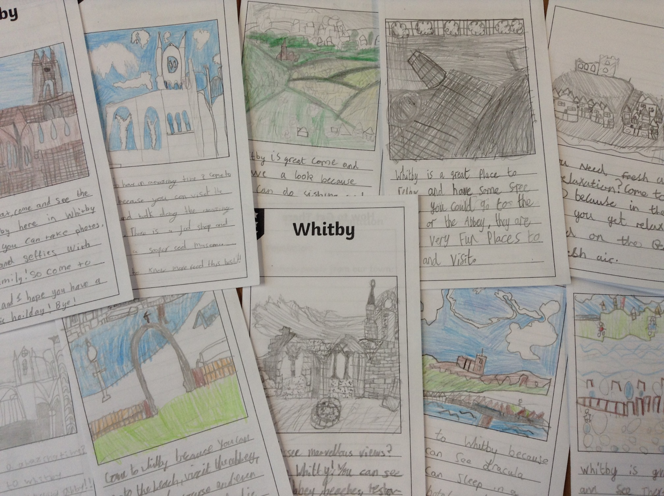
Whitby
During the Autumn Term Class 3 looked at Whitby.
We compared this location to our own, looking for differences and similarities.
We created our own information booklets using what we had found out.

