Decoration Day 2022 in Class 4
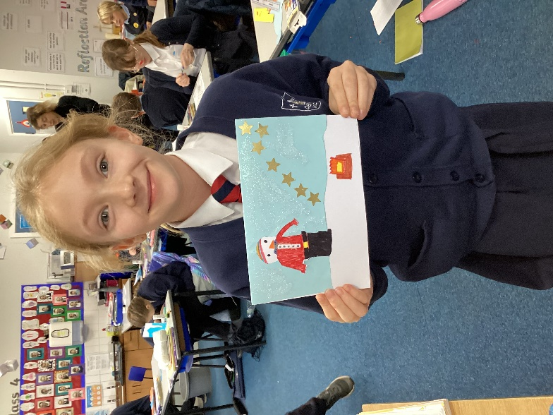
Our annual off-timetable Decoration Day took place on Friday 2nd December and was a great day full of festive arts and crafts.

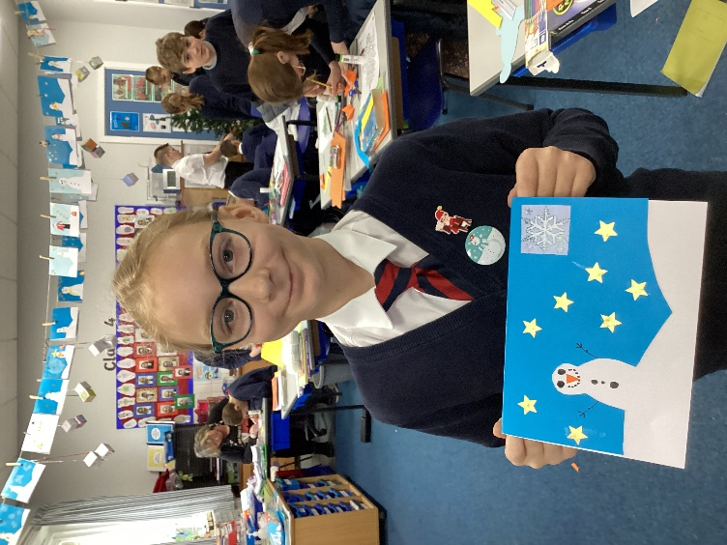

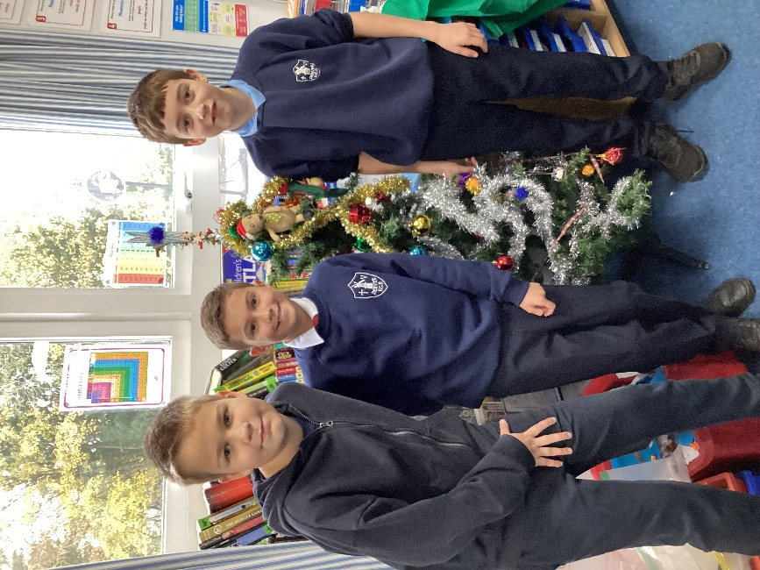

We enjoyed singing along and dancing to Christmas music as well as making crackers for the forthcoming Christmas dinner with the Friends of Denver School.
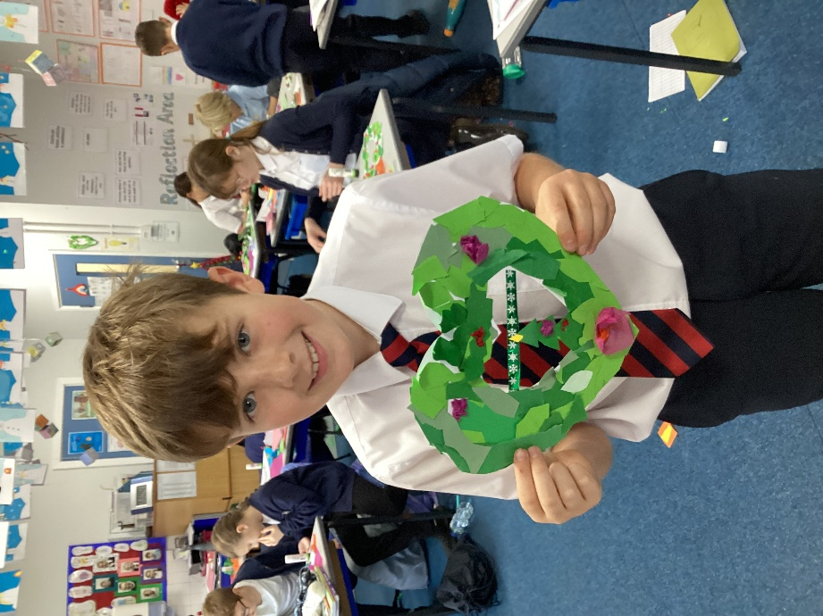
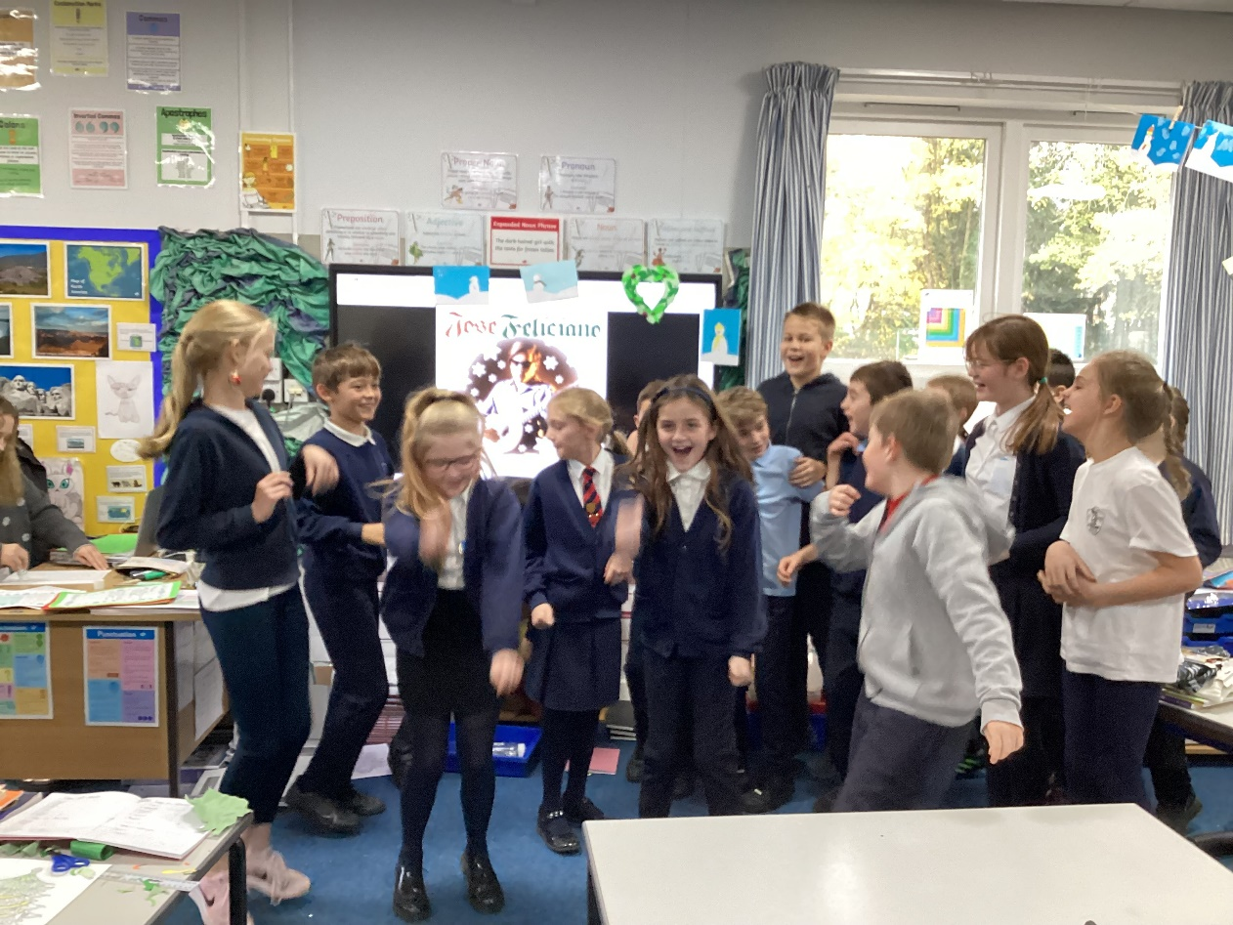
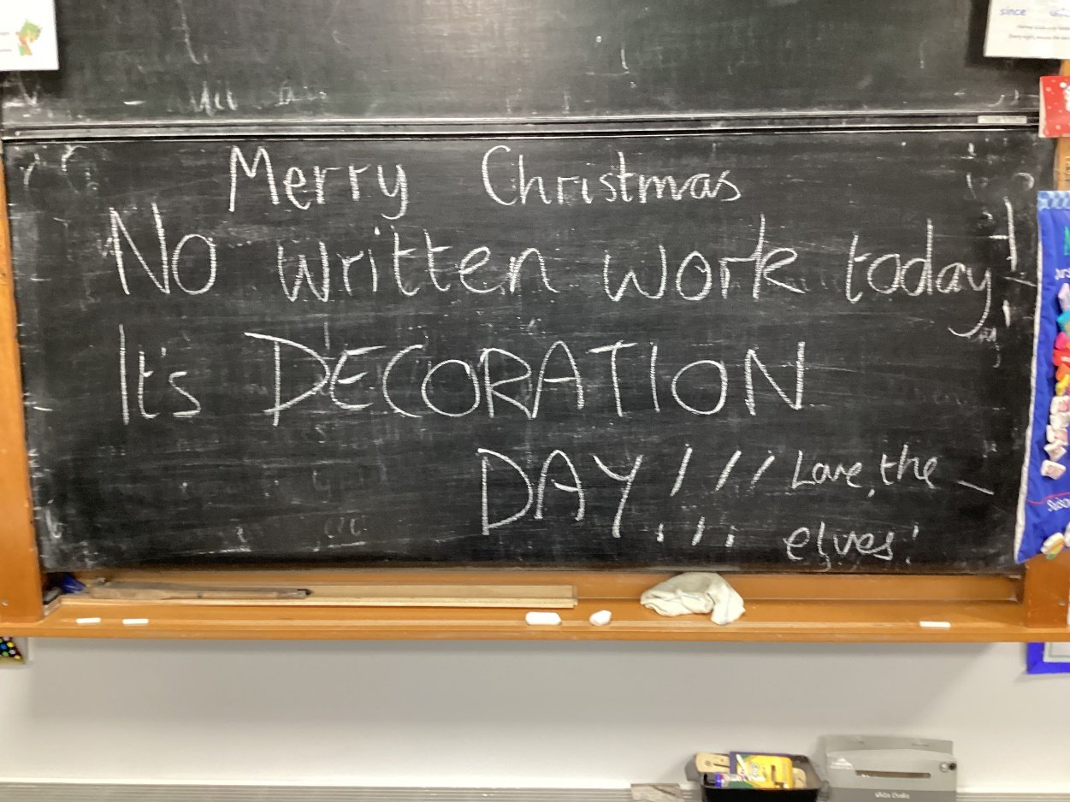

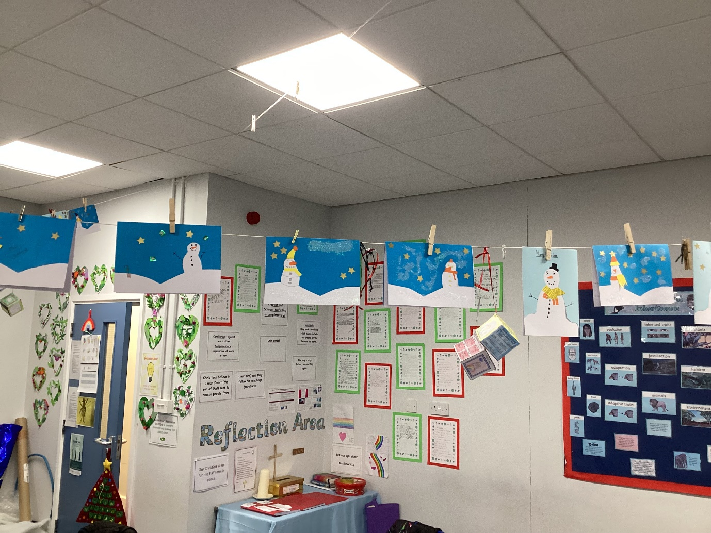
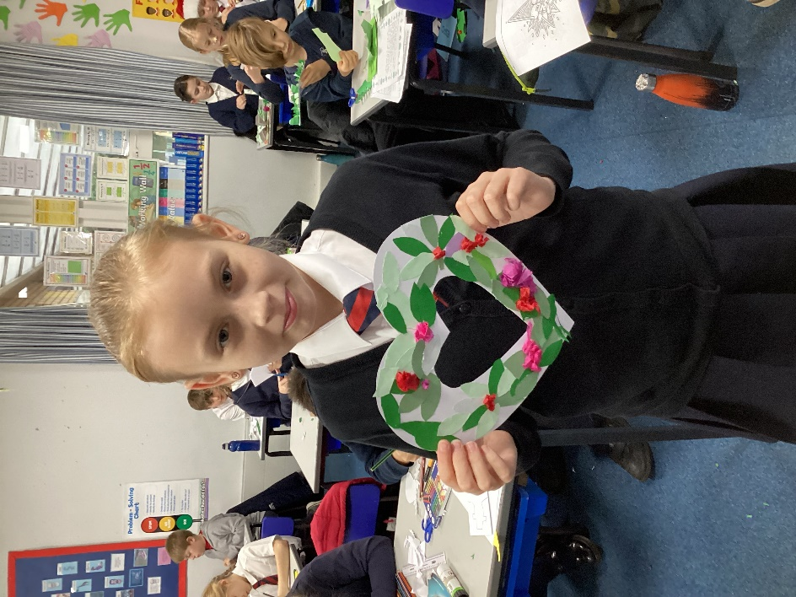

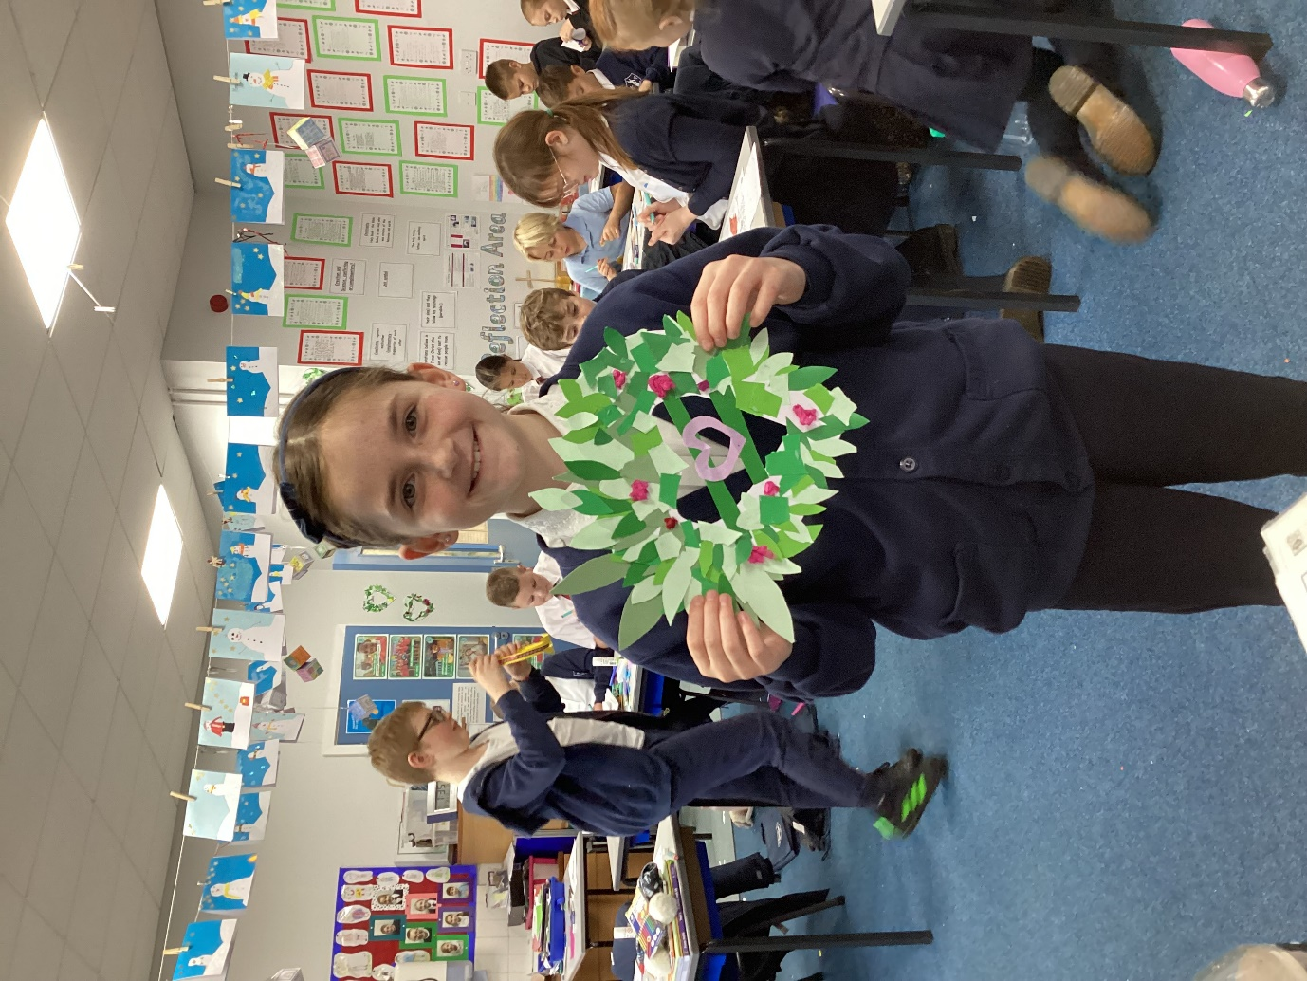

Many thanks to Miss Waters for preparing the templates and Mrs Collins and Danielle (Mrs Henden’s daughter) for helping out on the day.

