Cinderella Pantomime at Ely Maltings
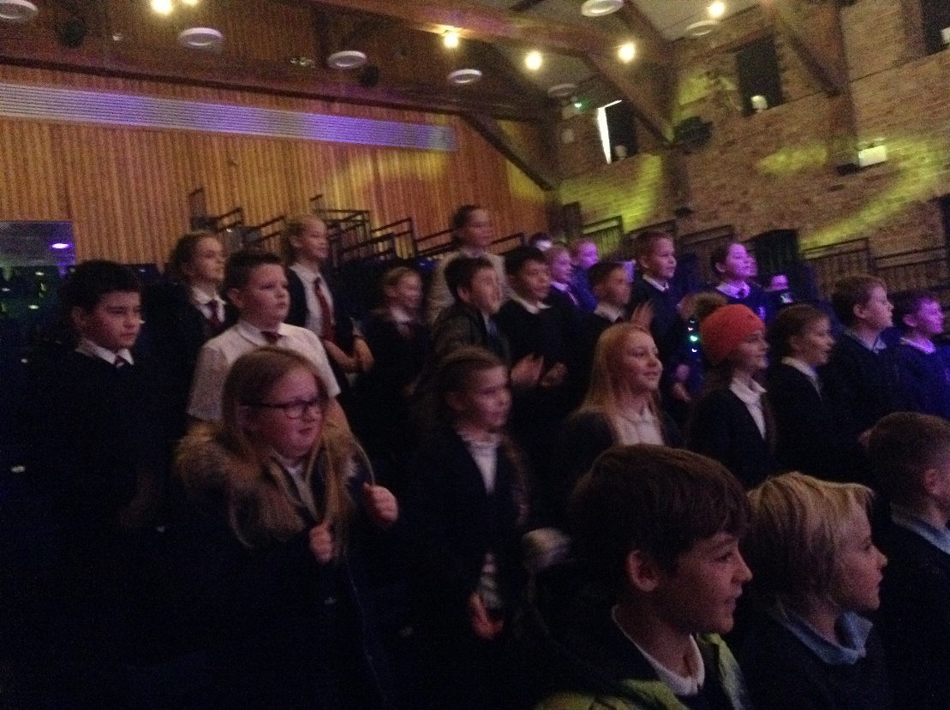
On Friday 9th December we were very fortunate to see the first ever ‘live to an audience’ performance of Cinderella at The Maltings in Ely.
The event was very generously funded by the Friends of Denver Primary School whose efforts have been amazing, coupled with parents’ and carer’s generosity in supporting their endeavours.
We were really lucky to have the entire theatre to ourselves. You can see from the pictures (taken by Mr Bonham) what an exciting time we all had.
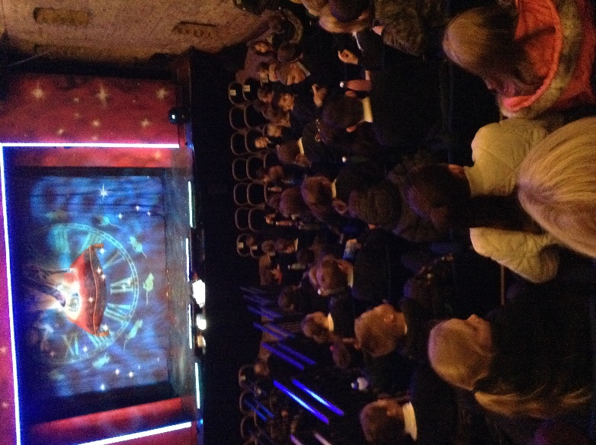
Thank you to everyone who made this possible.

