Christingle 2022
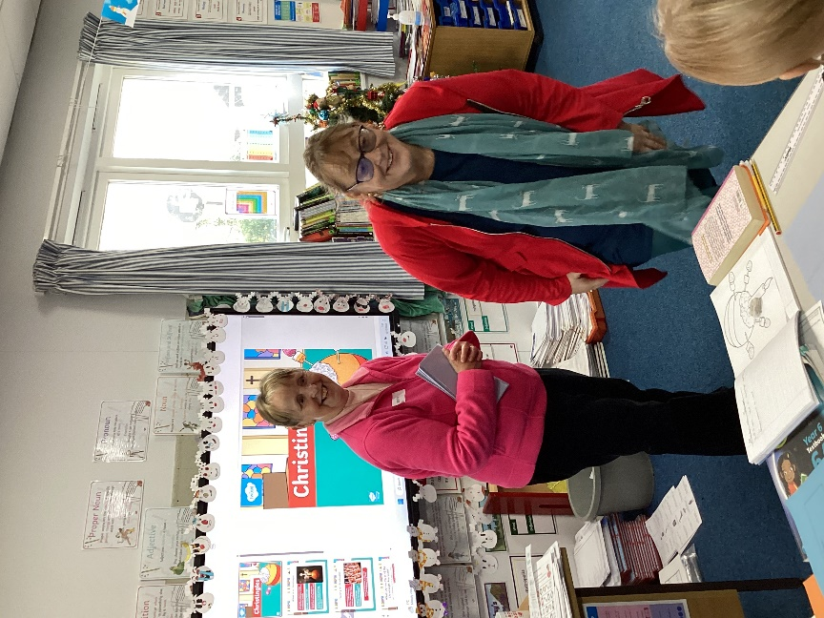
To celebrate the coming of Christmas, Class 4 were delighted to welcome back the ladies of St Mary’s church, Denver.
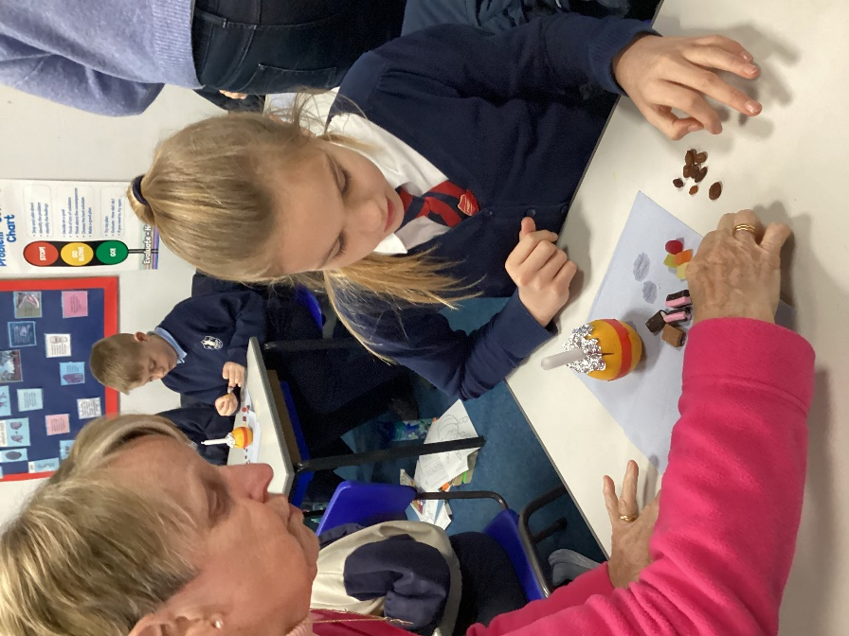

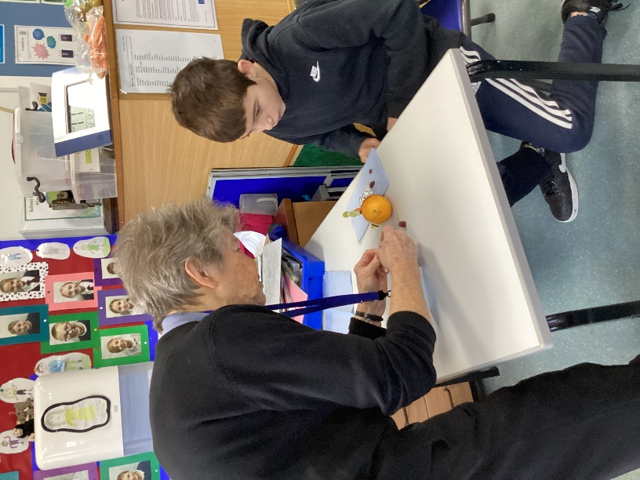

We found out about the meaning of the different parts of the Christingle. We made our own to take home and many of us generously donated Christingles full of money to support the Children’s Society charity. 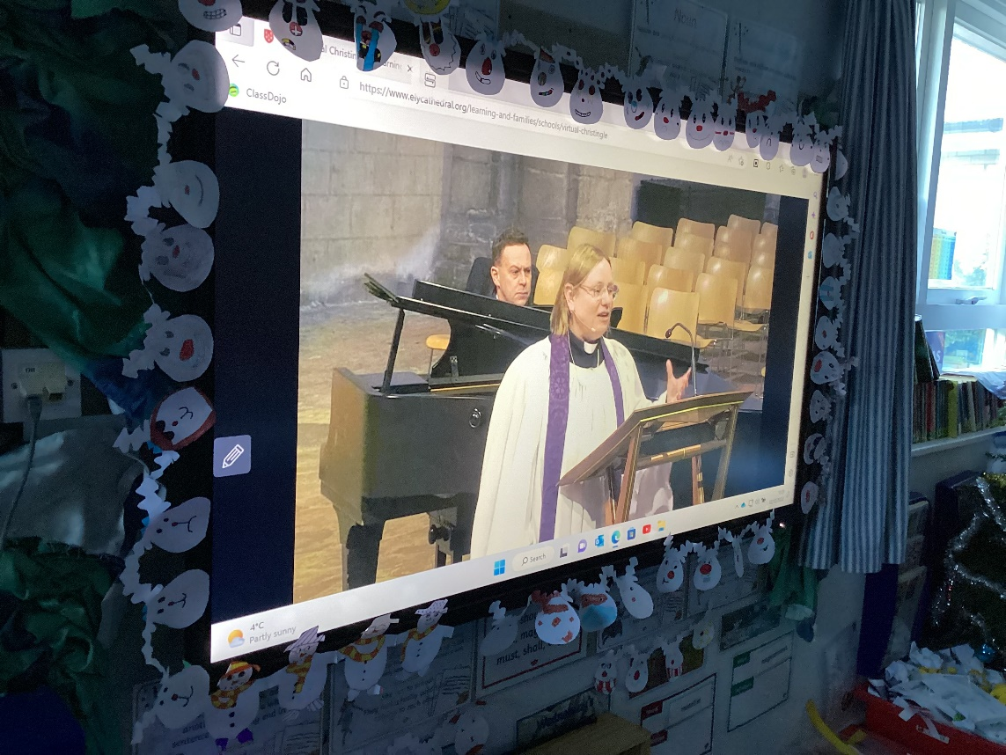

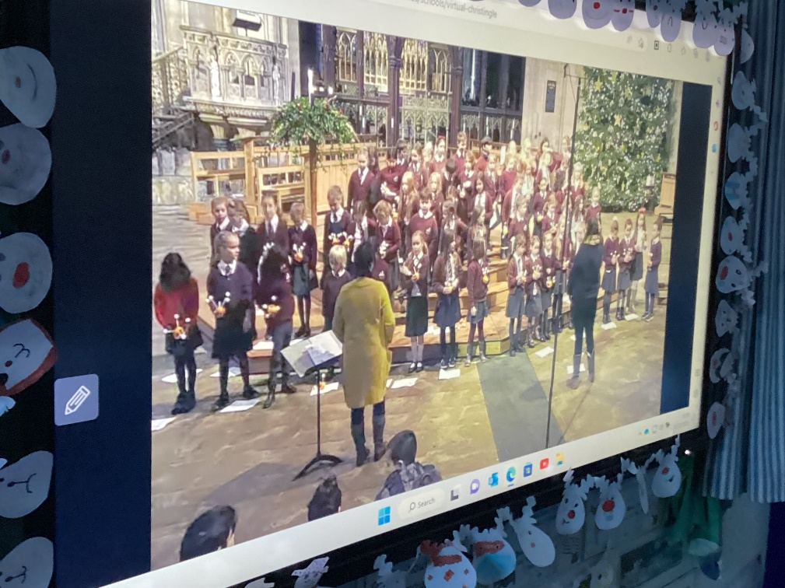

In the afternoon, we joined other schools in the Diocese of Ely in Ely Cathedral’s live Christingle service.


