Class 4 Christmas Party 2022
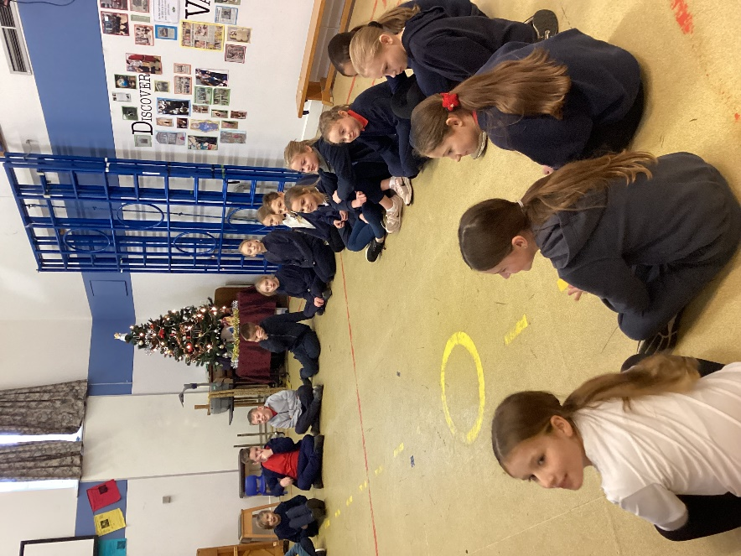
Tuesday 13th December was the date for Class 4’s annual Christmas party held in the school hall.

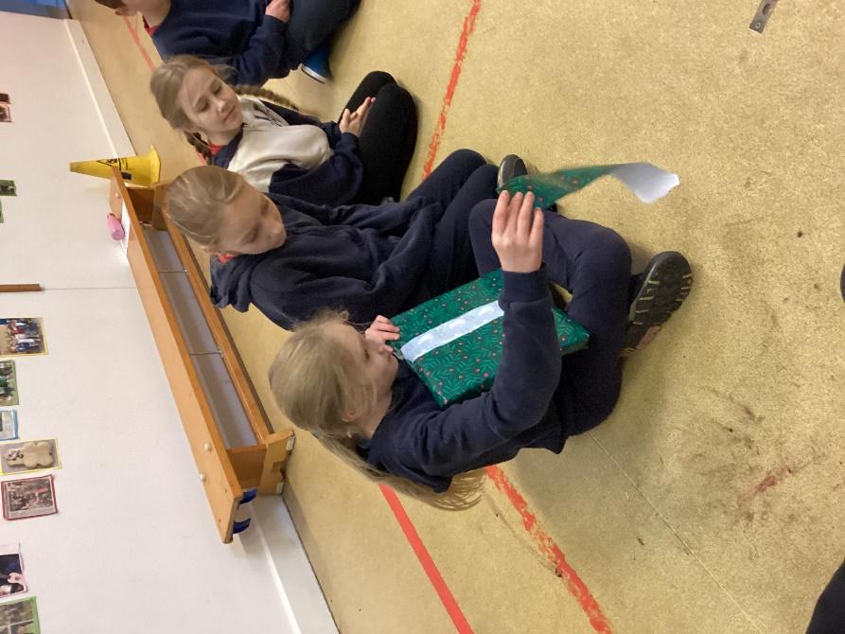
We played a range of traditional party games which were great fun.
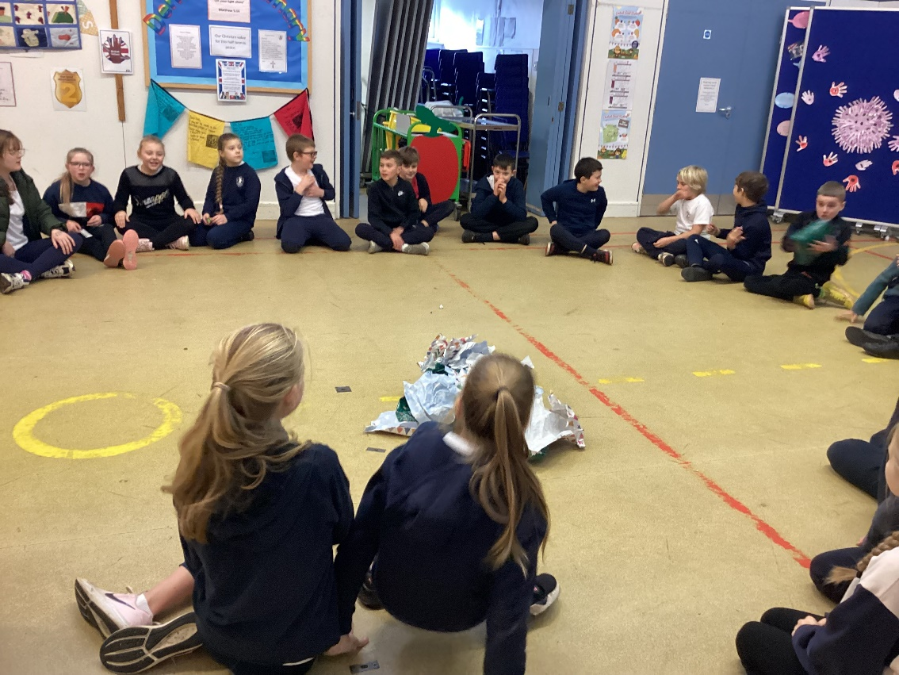
We are very grateful to the Friends of Denver Primary who provided the prizes and spent an enormous amount of time preparing a pass the parcel for all 31 children.


