World Book Day 2023
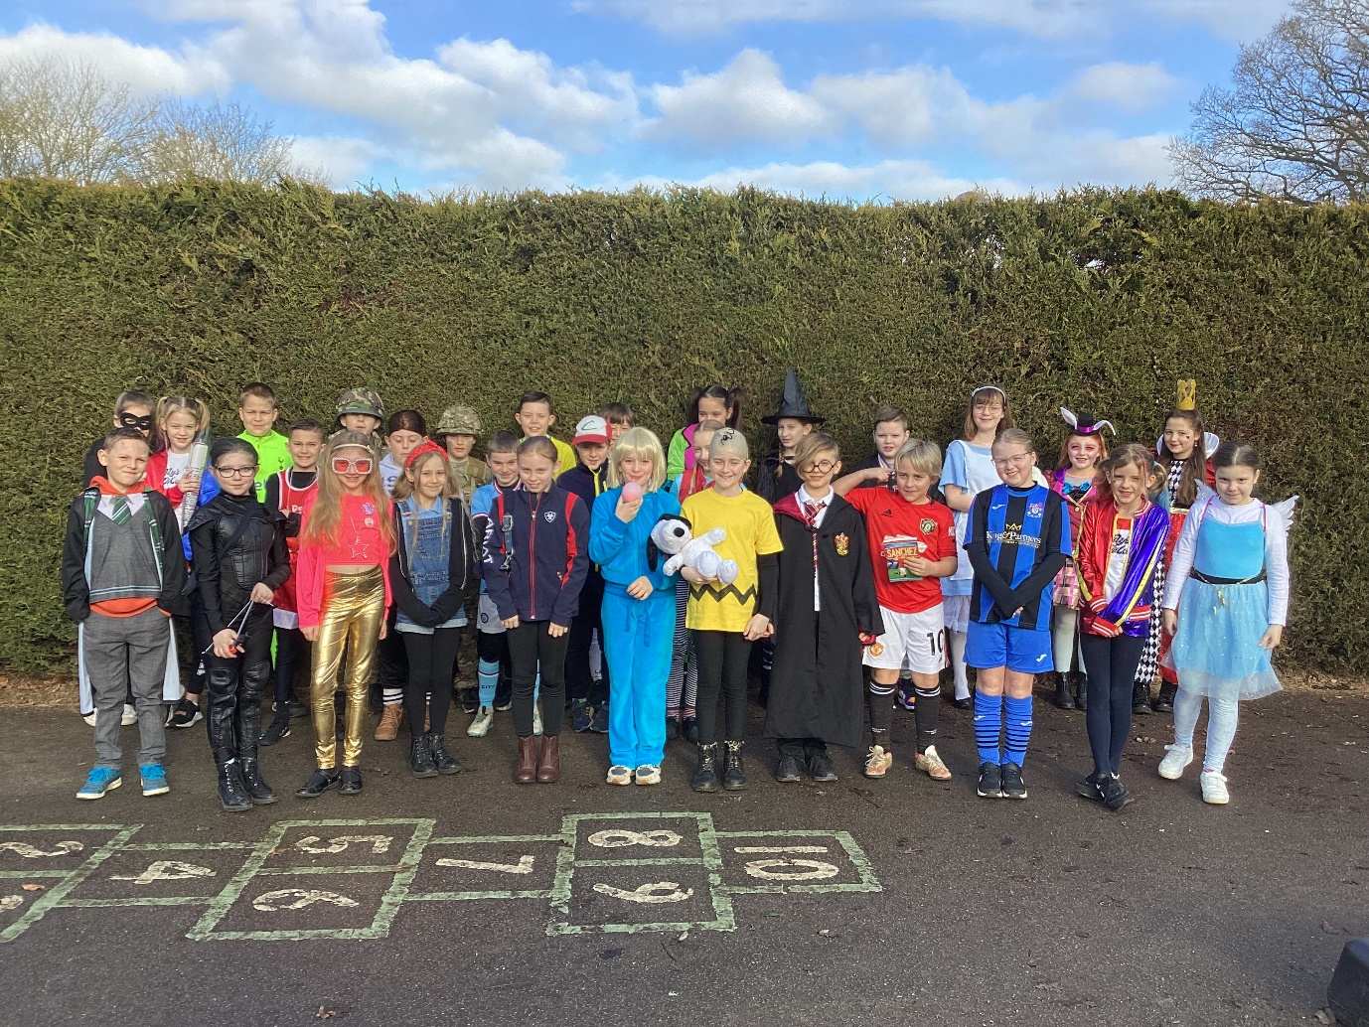
Children in Class 4 marked the annual World Book Day in some wonderful costumes.
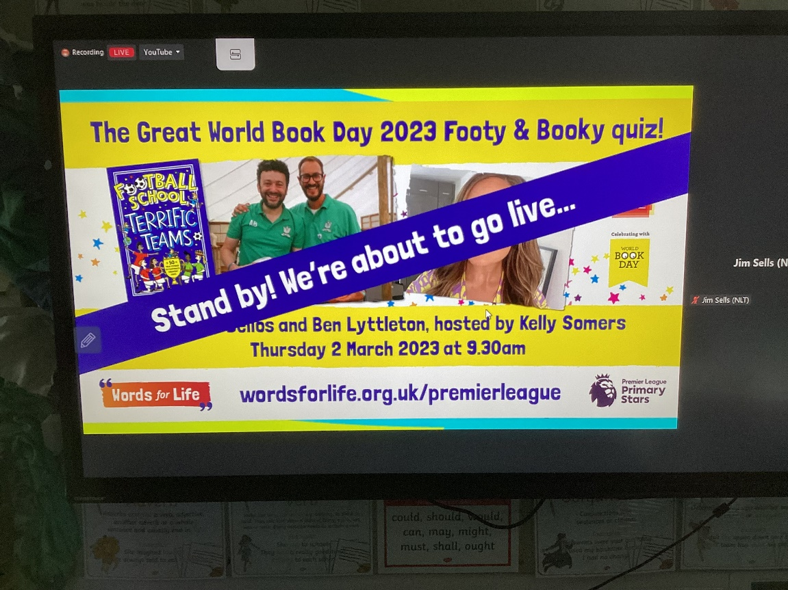
We began with making a bookmark display of our favourite books for our new library.

At 9:30, and because we are largely a football crazy class, we joined the National Literacy Trust and Premier League online ‘Great Footy and Booky Quiz 2023’.
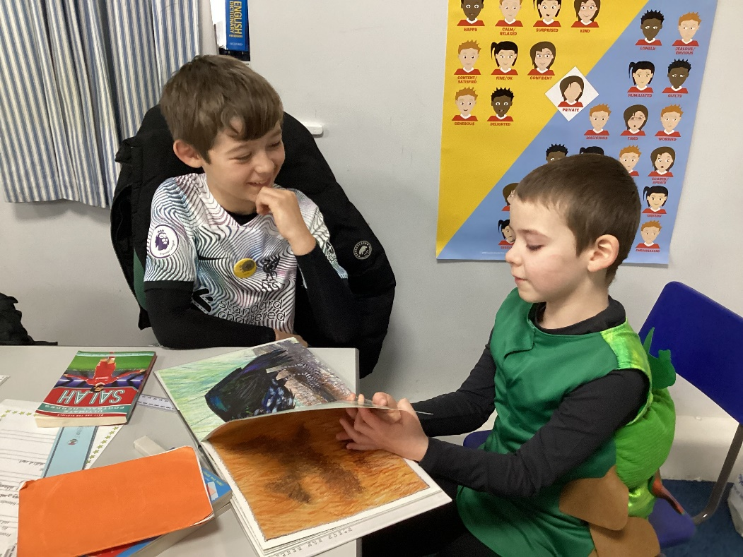
Soon after, we enjoyed shared reading with Class 1 children and Mr Cawley, the Smartest Giant in Town. How his legs and back must have ached!
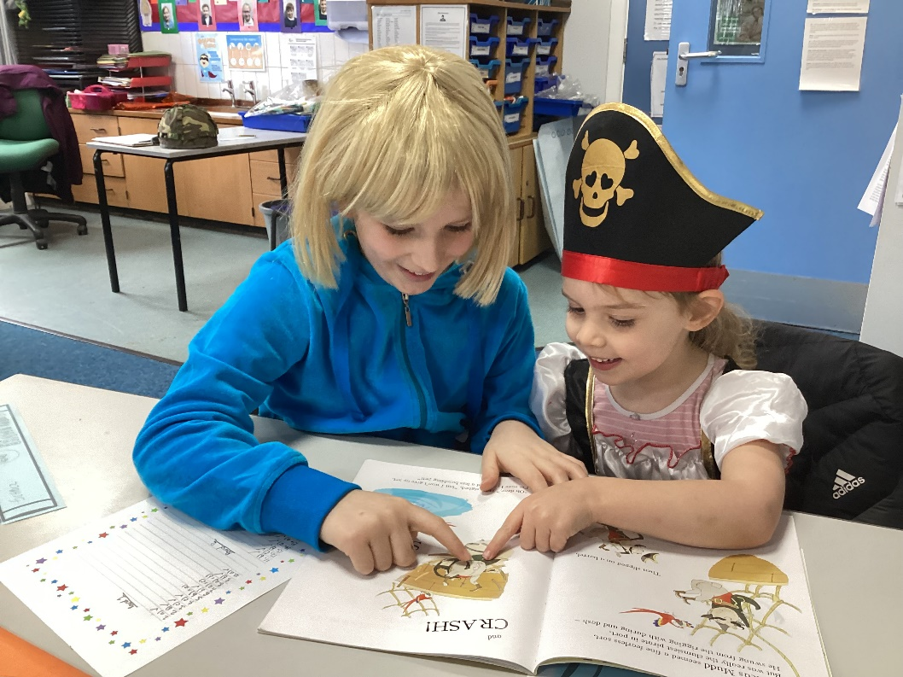

After break, we spent some time with Class 3 on the official World Book Day Quiz. Well done to everyone for taking part. The winning team will receive their prizes in our Celebration Assembly tomorrow.
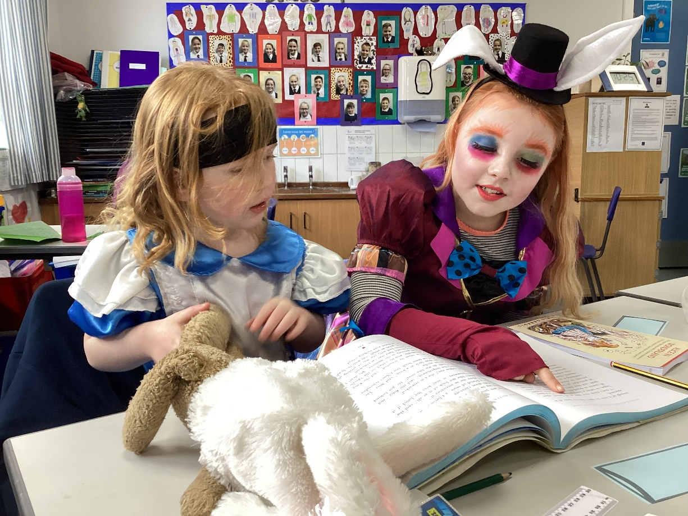
The afternoon was spent with Miss Cronin on our DT shelters projects. Then we were joined by parents who were able to come to share some reading time with us.
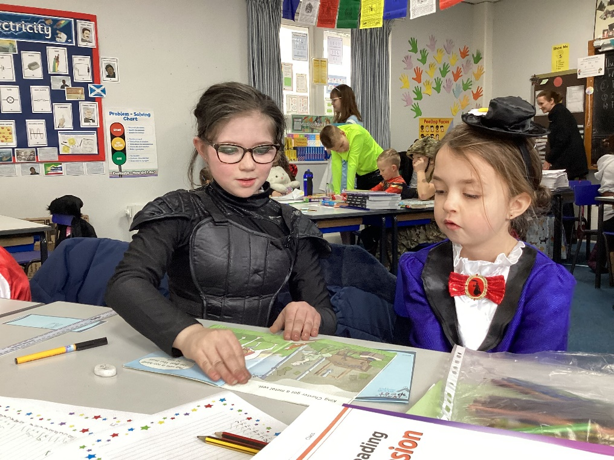

Thank you to everyone who made today possible. Great costumes!


