British Science Week 2023
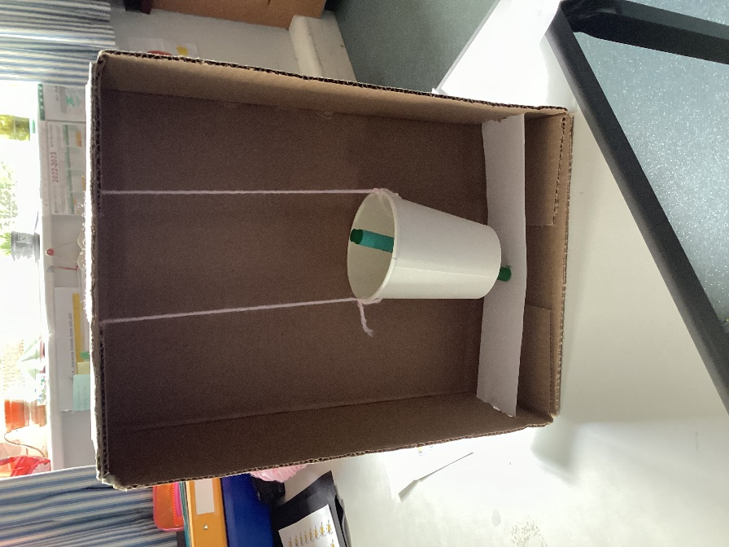
The theme for British Science Week this year is ‘Connections’.
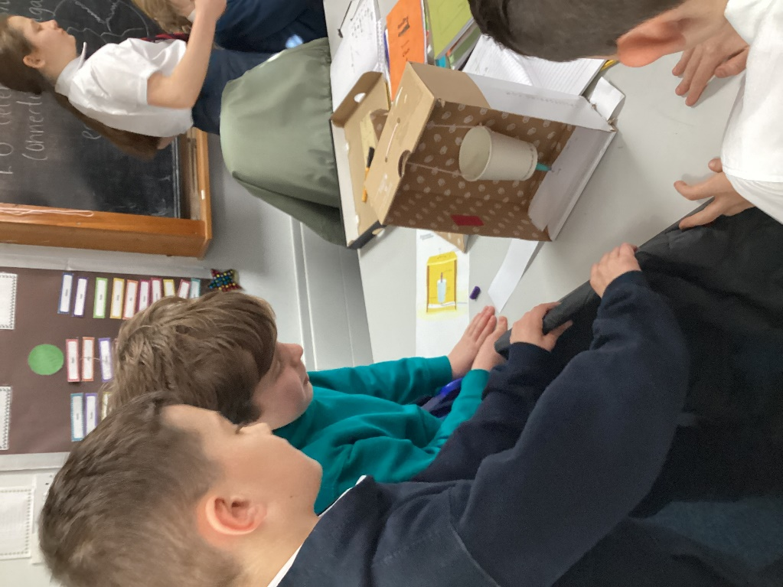
In Class 4 we have been learning about South America for our geography studies. This has included learning about the Andes mountain range. This range includes many volcanoes.
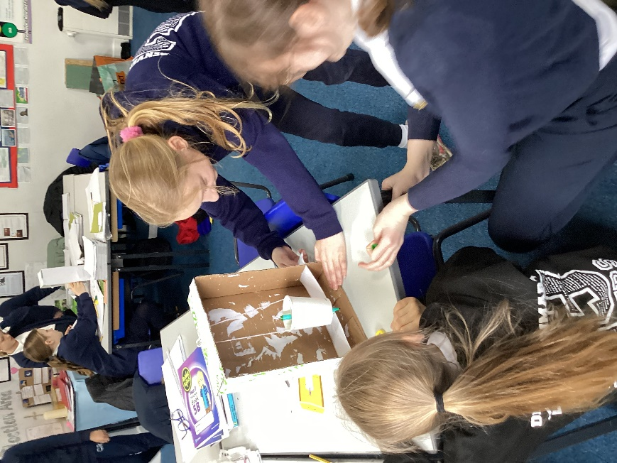
We learnt about how volcanoes are sometimes formed due to the collision of tectonic plates. We also learnt about how earthquakes are caused.
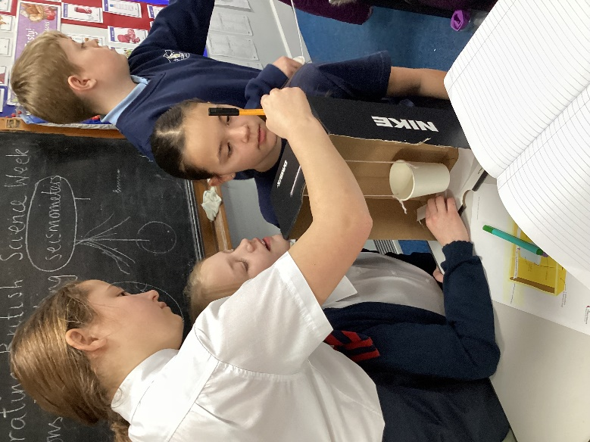

We looked at the role of geologists and scientists in helping to predict when and where an earthquake or volcanic eruption is about to take place. This involves using scientific equipment such as seismometers.
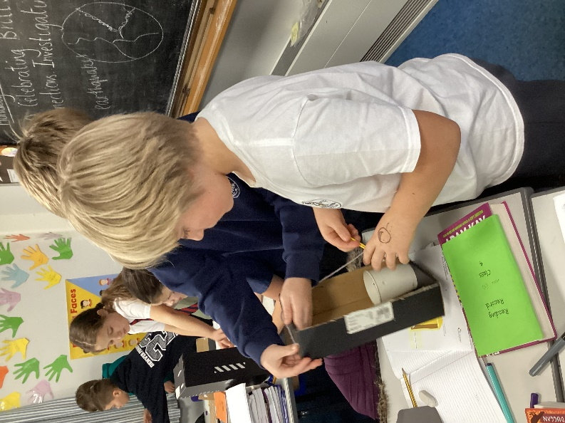
Using craft materials, we made our own versions of seismometers which we then tested by creating vibrations (clapping, stamping, rocking, blowing etc).


