Game Changers

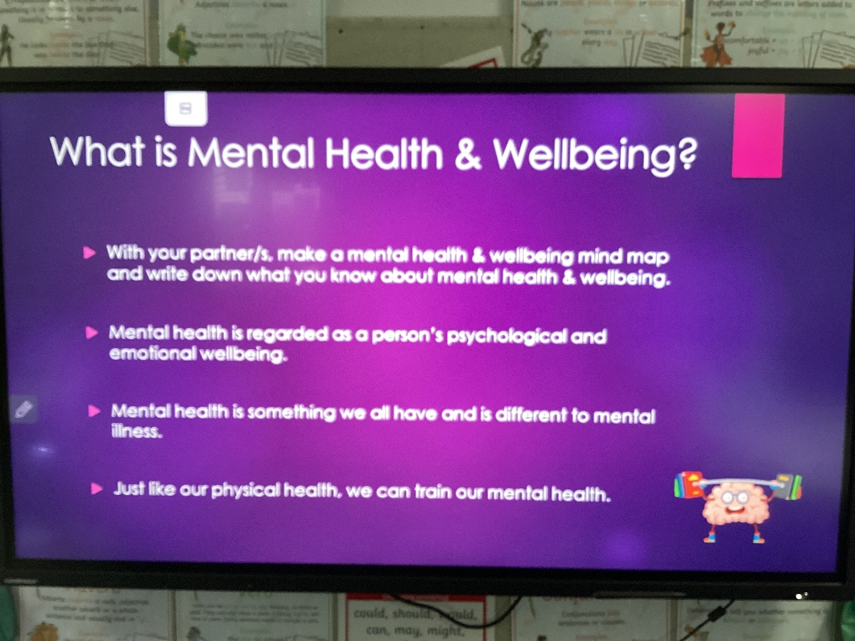
On Tuesday 14th March, Class 4 began Game Changers. This is to learn about the interaction between physical and mental health and wellbeing and is being delivered by Sean from Alive KLCF.
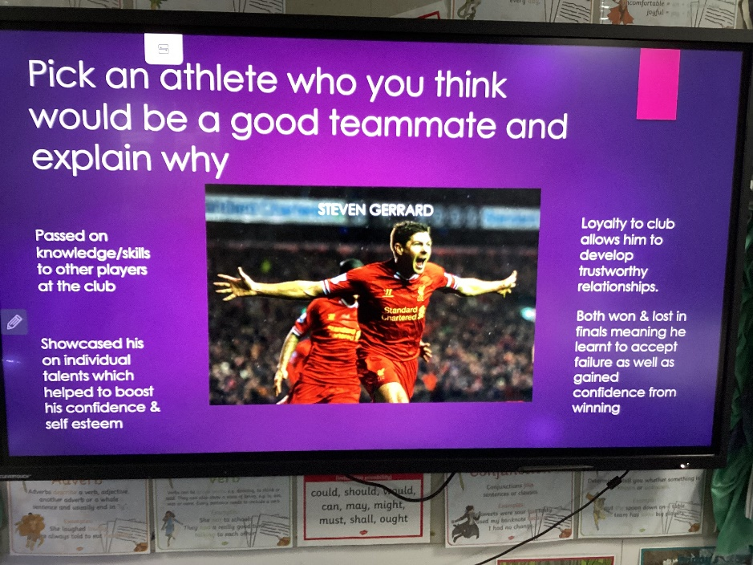
On this first session we considered the things that make us feel good, the people who inspire us and the people who we felt would make great team members.

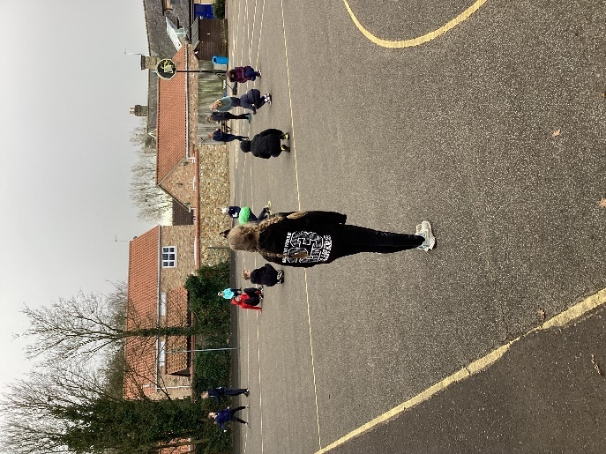
This led on to a series of physical team building challenges out on the playground and a reflection on how being part of a team can boost our self-esteem. 

