Comic Relief and Mother’s Day 2023
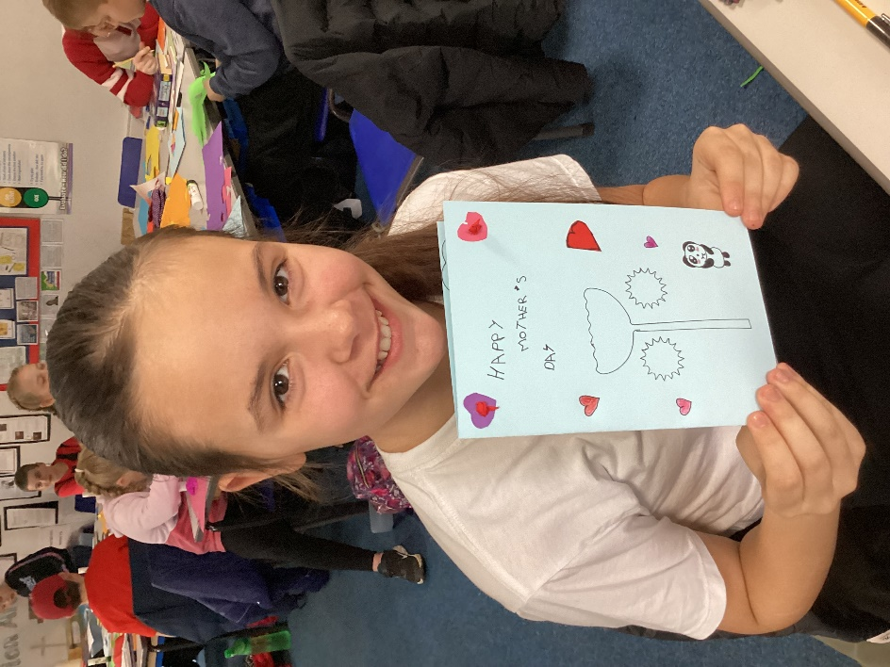
To mark Comic Relief, we wore items of red clothing and made donations to the worthy cause.
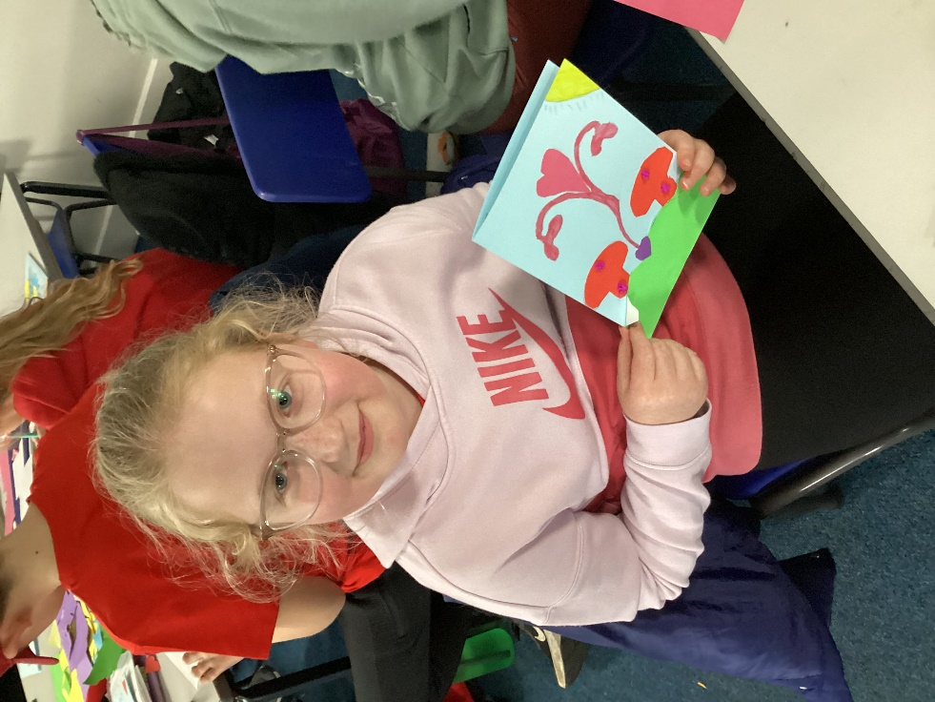
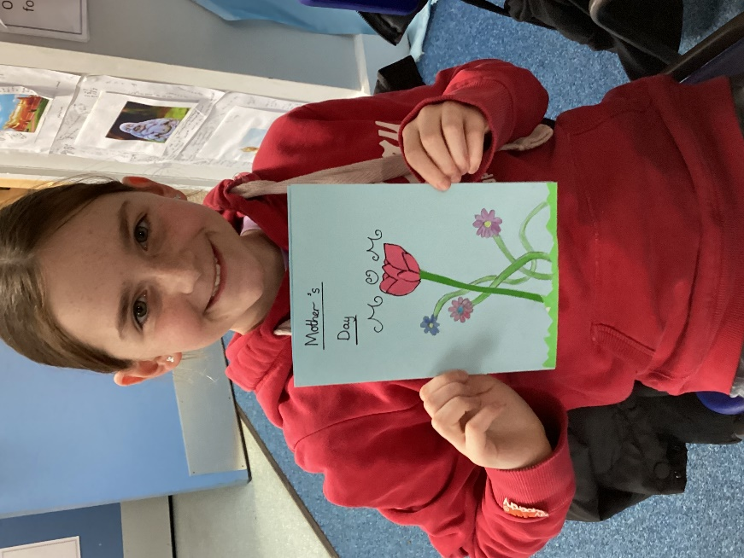
We were delighted to be joined once again by the ladies of St. Mary’s Church, Denver to make posies for Mothering Sunday. The posies turned out beautifully.
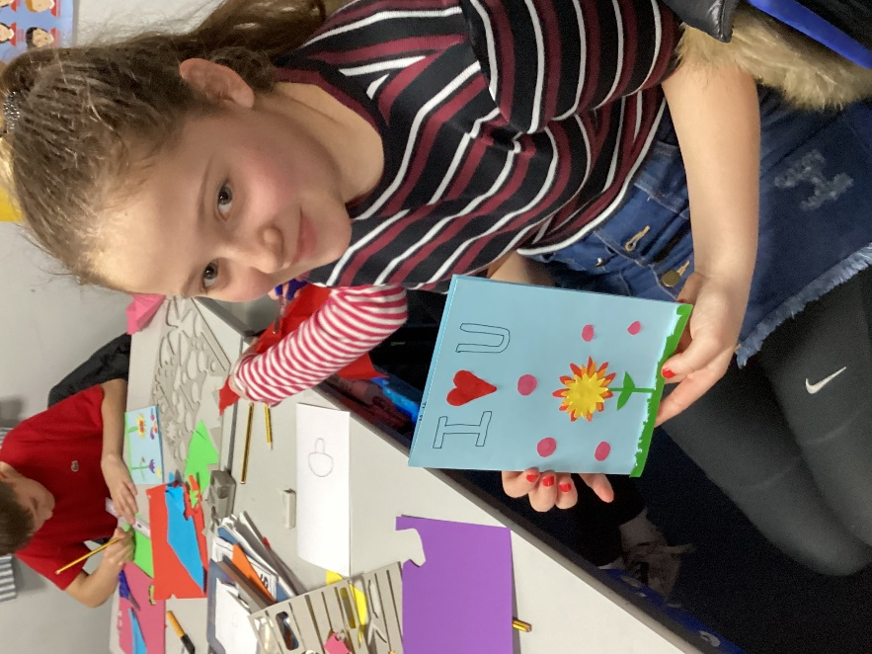
Back in class, we made cards and we also designed hats for Bishop Stephen’s Lent Challenge which is living life to its fullest. The hats reflect the things that make our lives full.



