Class 4 visit to the Victorian School
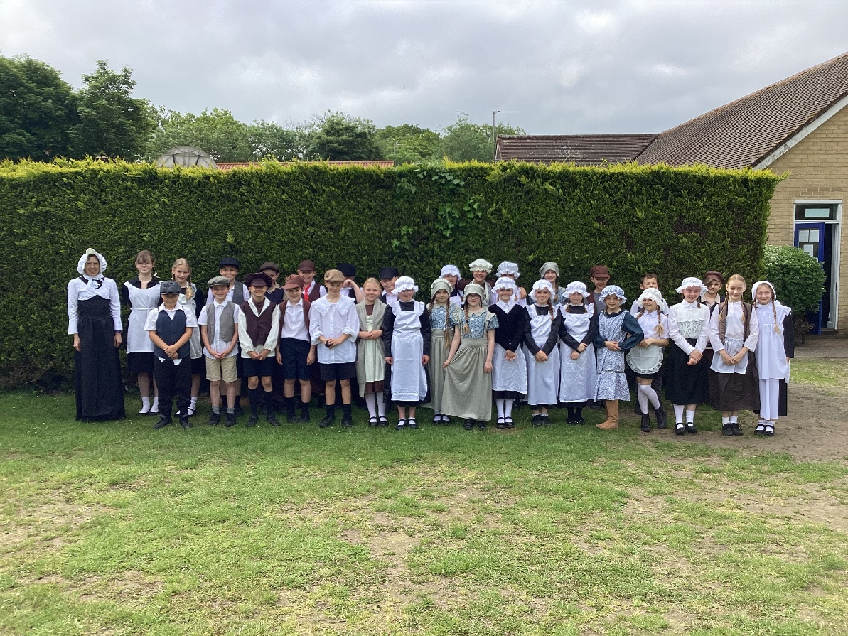
On Thursday 25th May, Class 4 travelled to the Victorian School at Great Cressingham, near Swaffham.
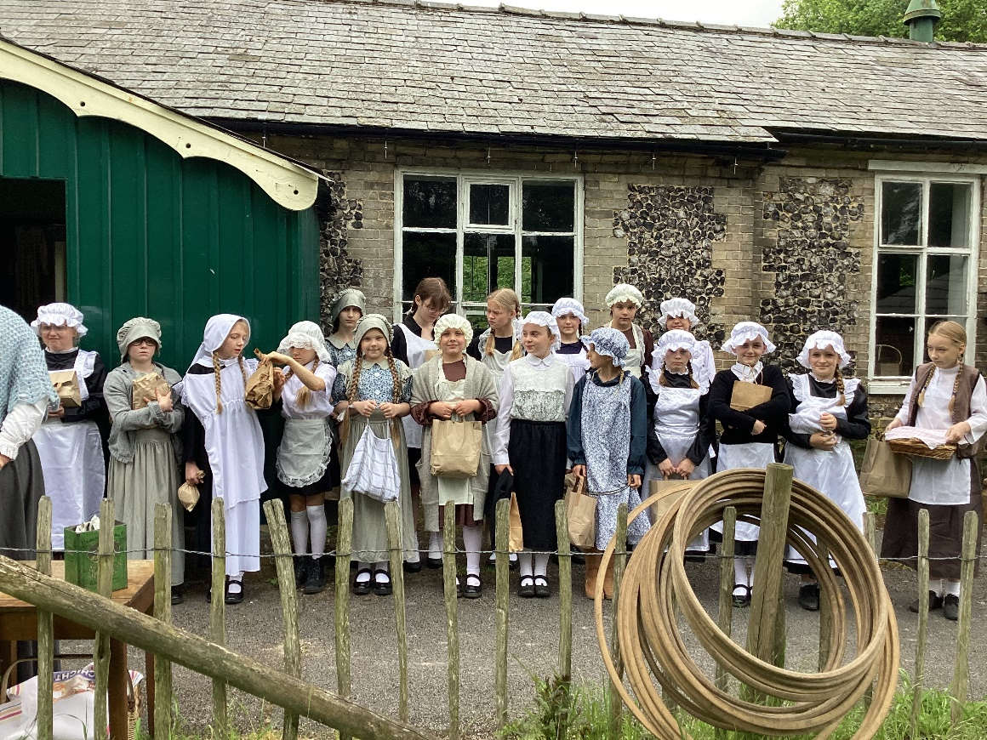
The visit was an excellent opportunity to immerse themselves in role as real Victorian scholars with authentic surroundings and objects. The aim of the experience was to feel like a genuine Victorian child for the day.
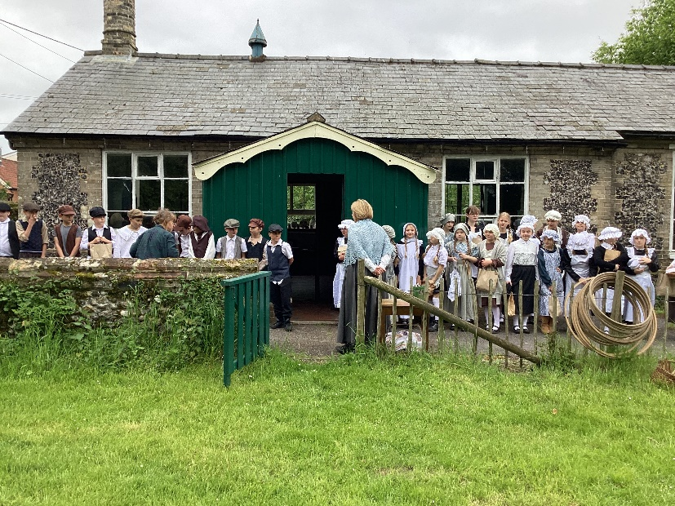
The children arrived to the sound of the bell tolling the beginning of the school day. After greeting their teachers for the day (Miss North and Miss Samson), they were separated into gender groups to enter the school building.
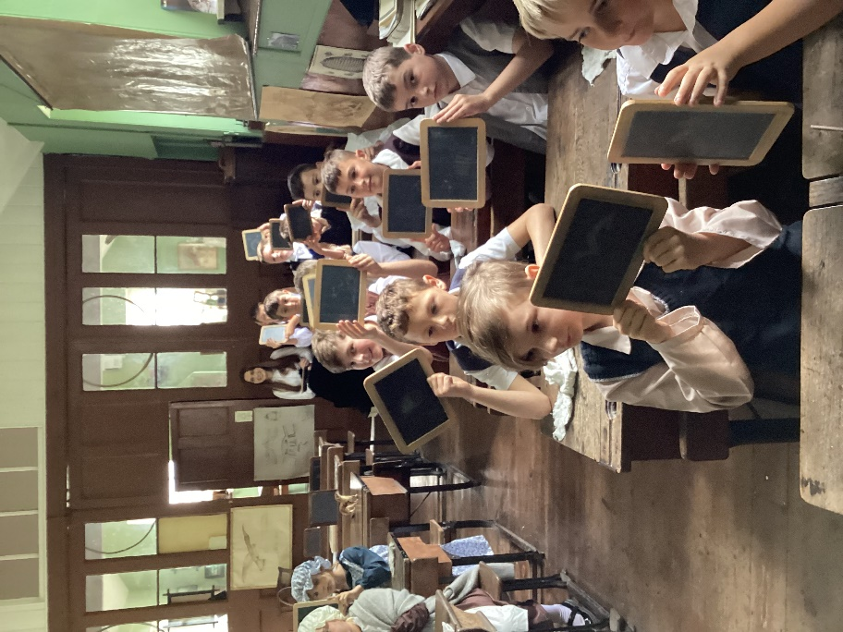
Many interesting activities followed: hymns and prayers, Victorian style; reading, writing and arithmetic lessons and close-up science/art observation lessons. We learnt many Victorian sayings: ‘Time is the enemy,’ ‘Practise makes perfect,’ and ‘If at first you don’t succeed, try and try again!’
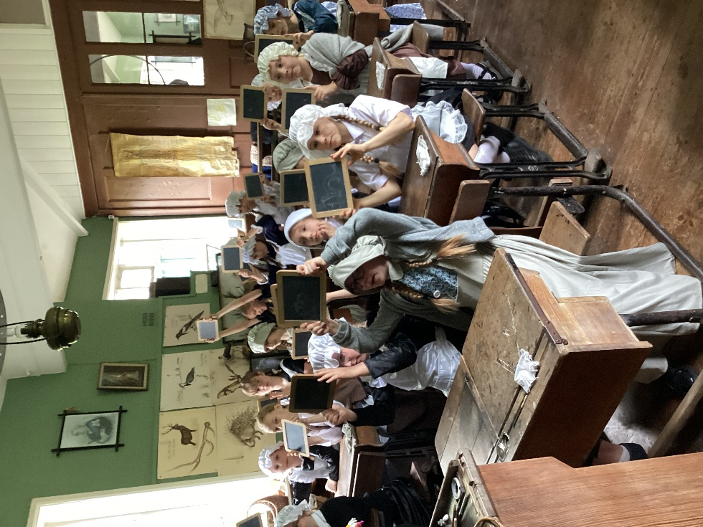
It wasn’t all work! Playtime allowed the children to learn how to spin tops, roll hoops, use kaleidoscopes, play wooden quoits, use Zoetropes, flick books, use skipping ropes and many more novel skills…
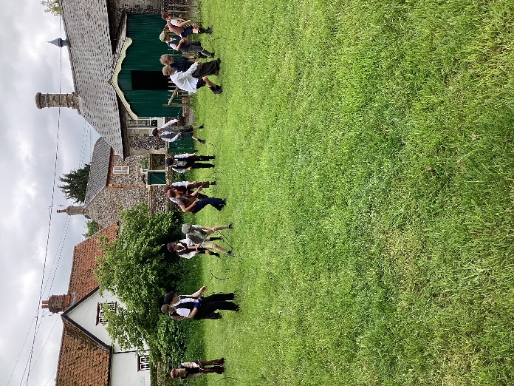
After a traditional packed lunch, Victorian style, and endless complaints about the tin cups of water (!) there were more things to discover. The boys closely observed and drew scientific objects while the girls sewed lavender bags.
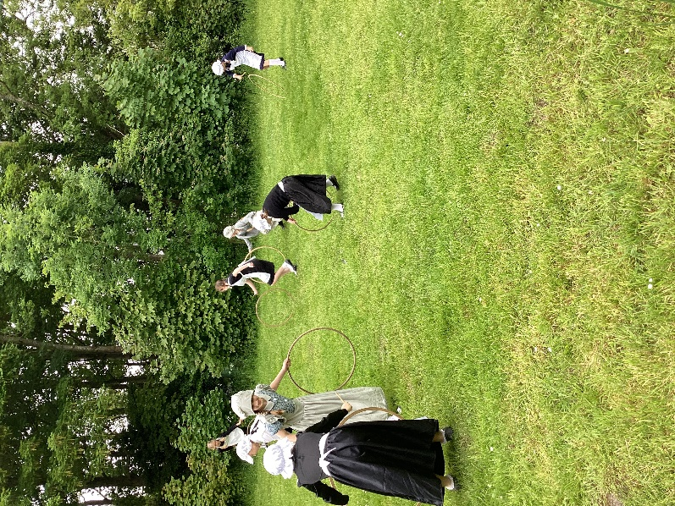
After a final handwriting lesson using dip pens and blotting cloths there was a closing hymn and farewell.
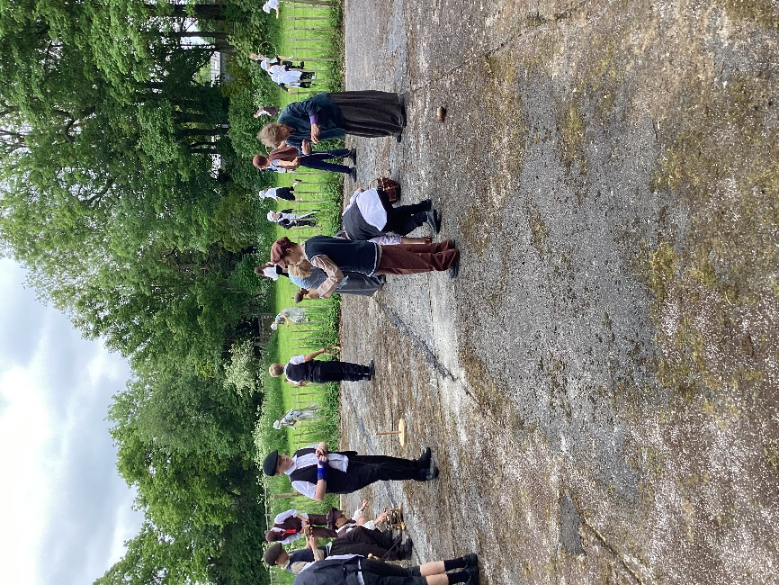

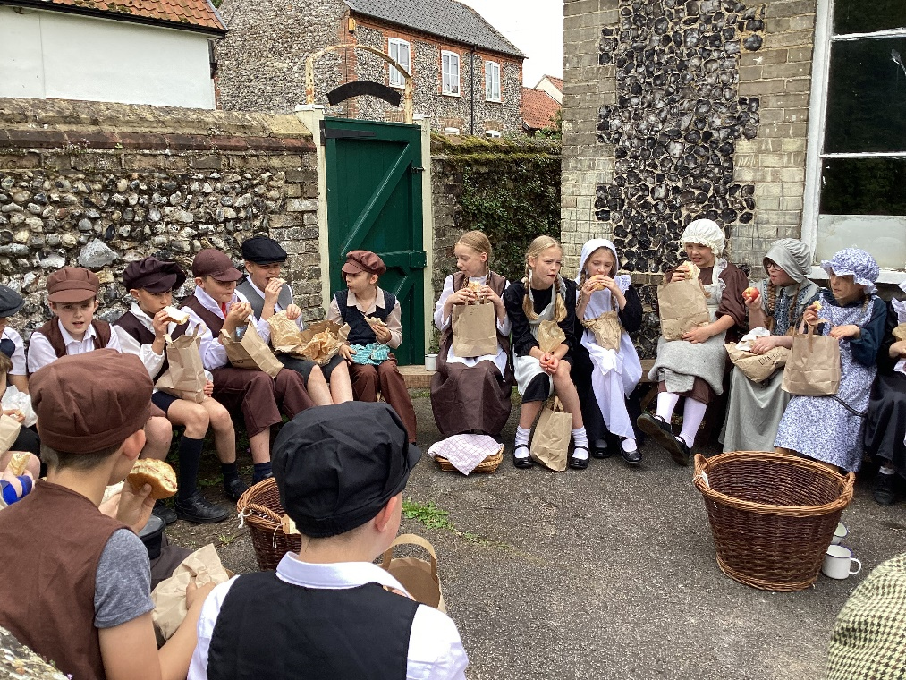
This was a brilliant experience. We are truly grateful to Miss North and Miss Samson who provided the experience, the Friends of Denver School who funded the coach, the parents for providing amazing costumes and Miss Cronin and Miss Loveridge for supporting the visit. What a day! One that we will treasure for years to come.


