Year 6 Secondary School Transition Preparation
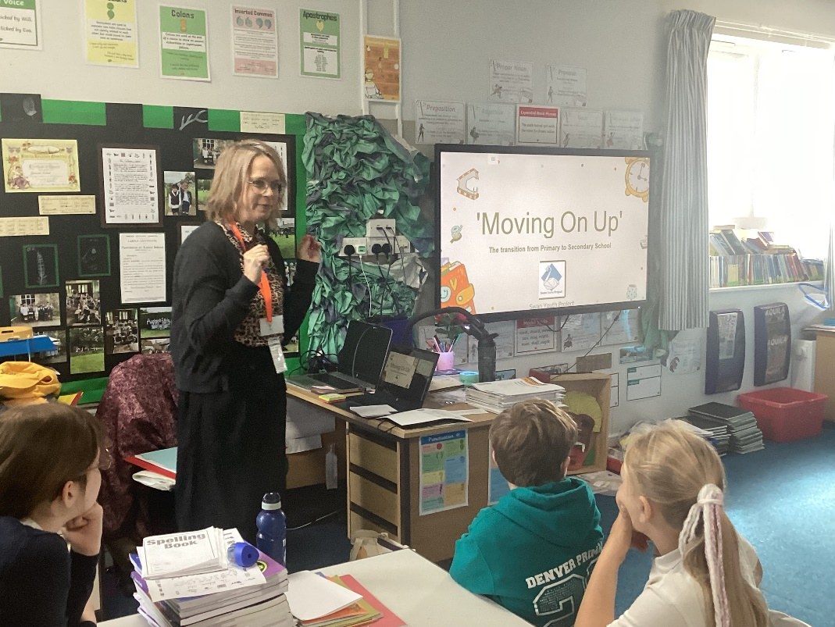
A representative from The Swan Youth Project in Downham Market joined Class 4 today (8th June) for the first of 4 sessions to help the Year Six children feel prepared for the move to secondary school. Year 5 children also joined in with this first session, just for today.
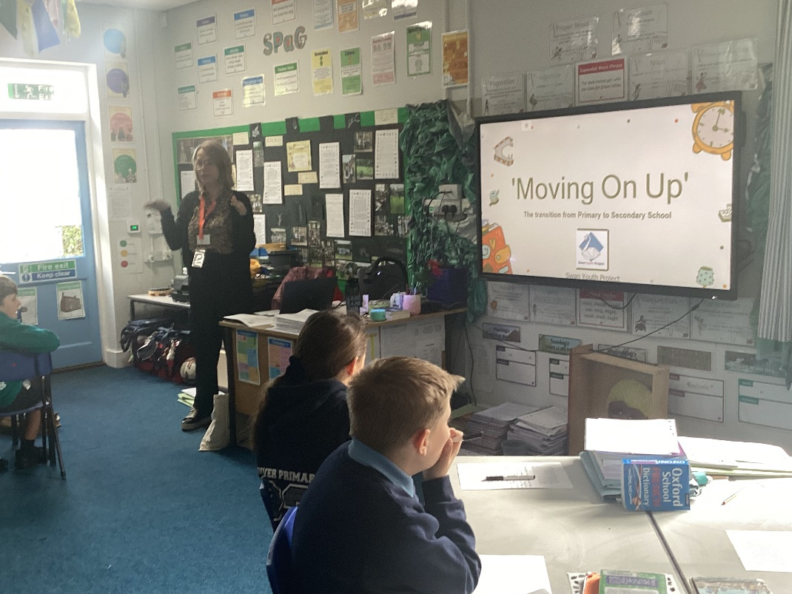

The children were asked to reflect on their feelings and to write down questions that they would like to be answered in the next three weeks.
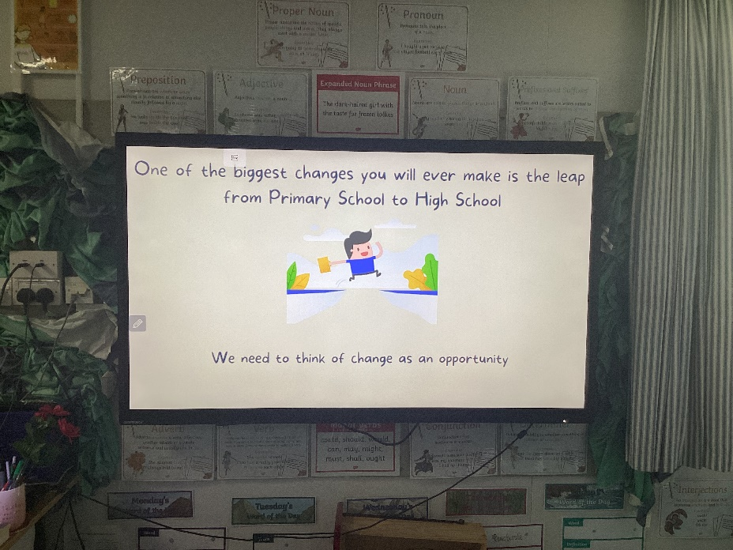
They also considered who they feel are the five key people in their support network and what they could turn to them for in times of need whether it be a negative or a positive thing to share.
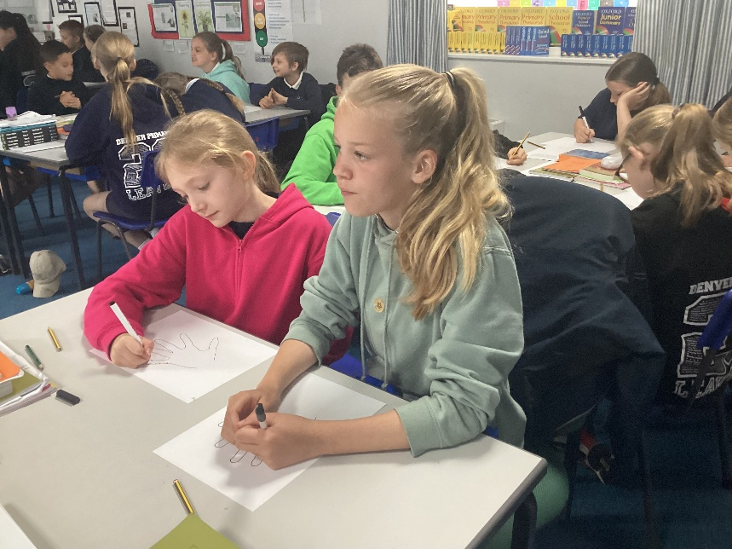

Finally, positive and negative emotions were related to what they might experience at secondary school. The session ended positively with things that they are enthusiastic about as they move on.

