Mothers Day Posies
The ladies from St Mary’s church in Denver came into school to help the children in Class 2 to make posies of flowers to take home for their mums.
They went into the hall and were given everything they needed and were supported to make their flower arrangement.
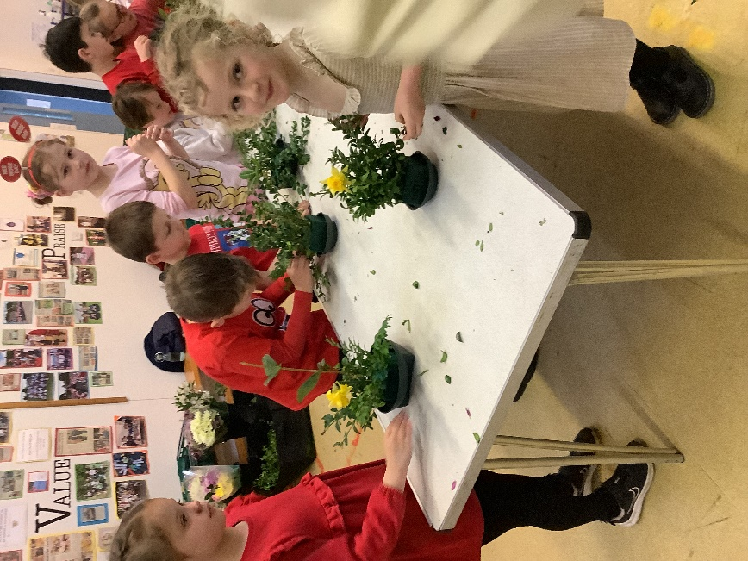
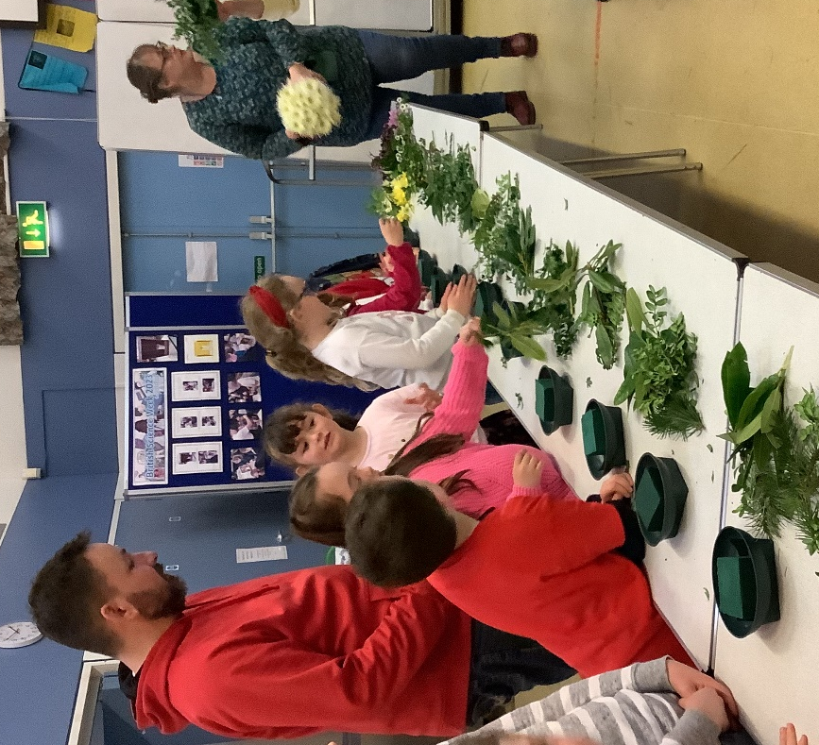

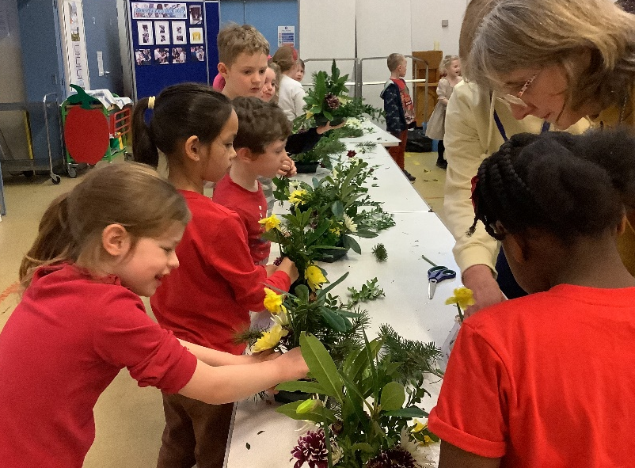
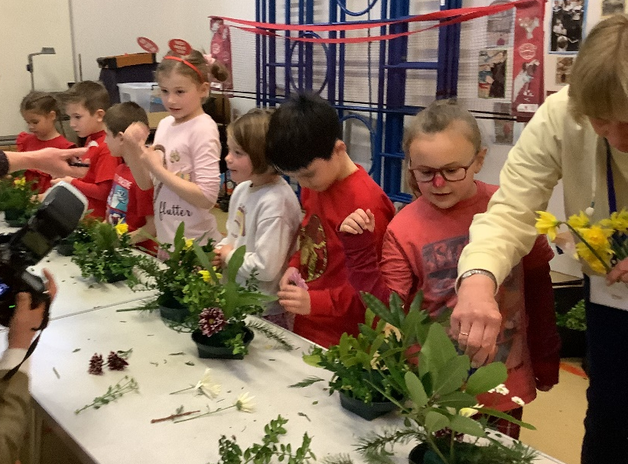

The children enjoyed making the posies and were proud to give them to their mums.
A huge thank you to the ladies for yet again, coming in to help the children.

