A visit from the fire brigade
On Monday 12th June 2023, Class 2 had a very exciting visit from the local fire brigade. The appliance was parked on Denver Playing Field and the children walked over to listen to the fire fighters and learn all about the equipment.
It was a very hot day and the appliance had to be called out just before they were due to visit the school. Fortunately, it was not for anything too serious.
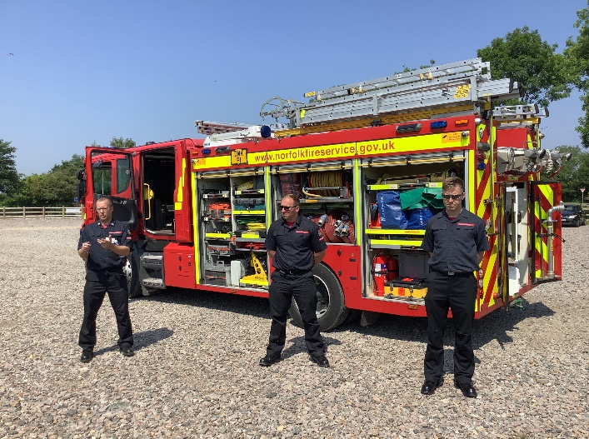
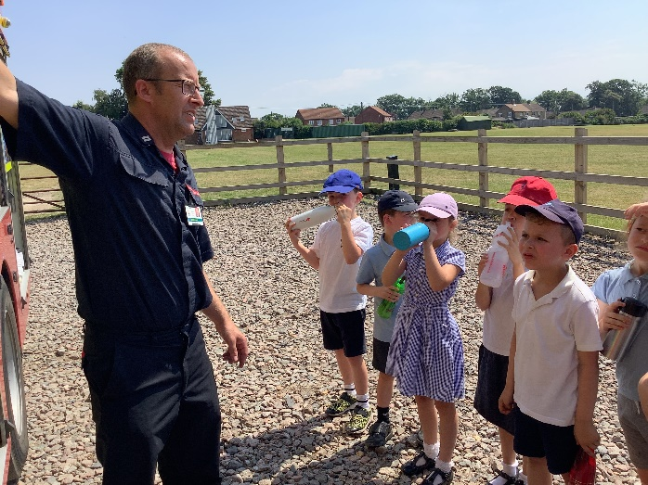
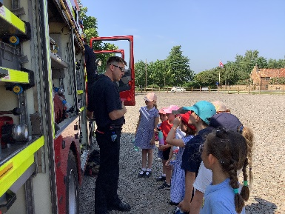
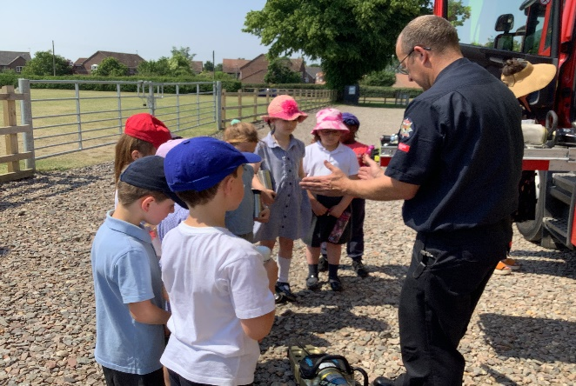
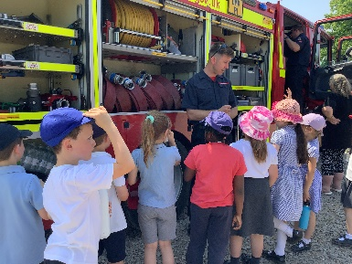
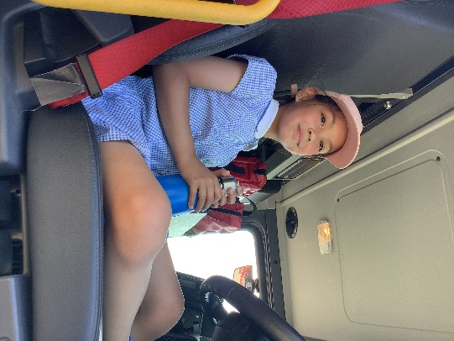
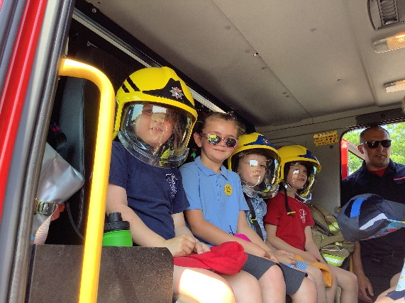
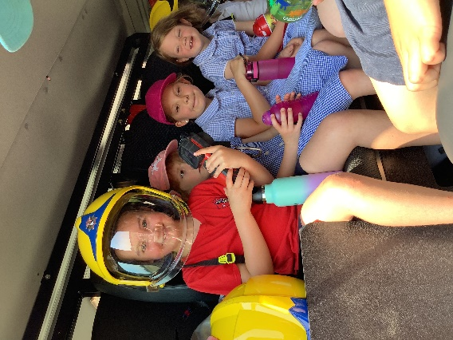
The children were thoroughly engaged and listened attentively to what they were told, and there were lots of interesting stories and questions. They found out that a cow had been rescued from the river at Denver Sluice last year. They thought that was very funny!

A huge thank you to Justin, Ben and Richard for giving up their valuable time to give the children a chance to learn about their very important profession and how they help the local and wider community.

