Living for the Future Competition

Today, Friday 13th October, Class 4 took part in the Borough Council of King’s Lynn and West Norfolk’s ‘Living for the Future’ competition.
In groups, the children took part in a range of activities which were graded out of 5. The winners would be the team with the best overall score at the end of the competition.
This is the outline of the competition that the organisers provided:
The main aim of Living For The Future is for students to create a "green" idea for their town and to make a prototype out of recyclable materials to showcase this. They will work in groups with their peers to create the best ideas possible. Students will participate in a showcase displaying the ideas from the whole year group in their school where one winner from the year will be chosen. The winners will then need to create a short video or 'trailer' of their idea and submit this by email by the 13th of November. The county-wide final will be held virtually on the 24th of November - all schools and the full year group are welcome to join to see their school's ideas displayed and even catch a glimpse of themselves on screen!
We began by learning about entrepreneurism, the skills and attributes that make some people able to have success. The children were asked to consider finding people with different skills and attributes to themselves when forming a group so that the range of talent was more diverse.
To practise being able to be innovative the children were set a practise task of thinking of an idea that would have helped a stone age person thinking about how it would be funded and how it would be beneficial.
Next, it was on to the task itself. The children had to think of an environmental issue affecting their local town (such as energy, waste and transport) and develop this into a problem statement.
The problem statement was the basis for planning and designing an idea to remedy the problem which was eco-friendly and sustainable. This led onto an afternoon of practical activities to assemble, then explain and demonstrate the idea with a prototype. This resulted in some great inventions which are now on display in the main corridor.
Before the final result is announced there is one final task remaining: pitching in the style of Dragon’s Den. We’re looking forward to this next week!

Here are the end products from each of the teams:
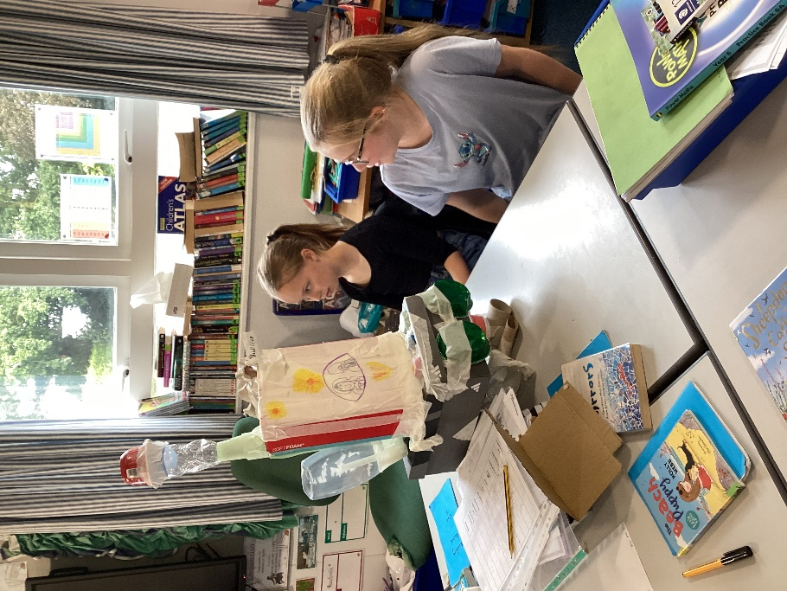
Team name: The team that saves the world!
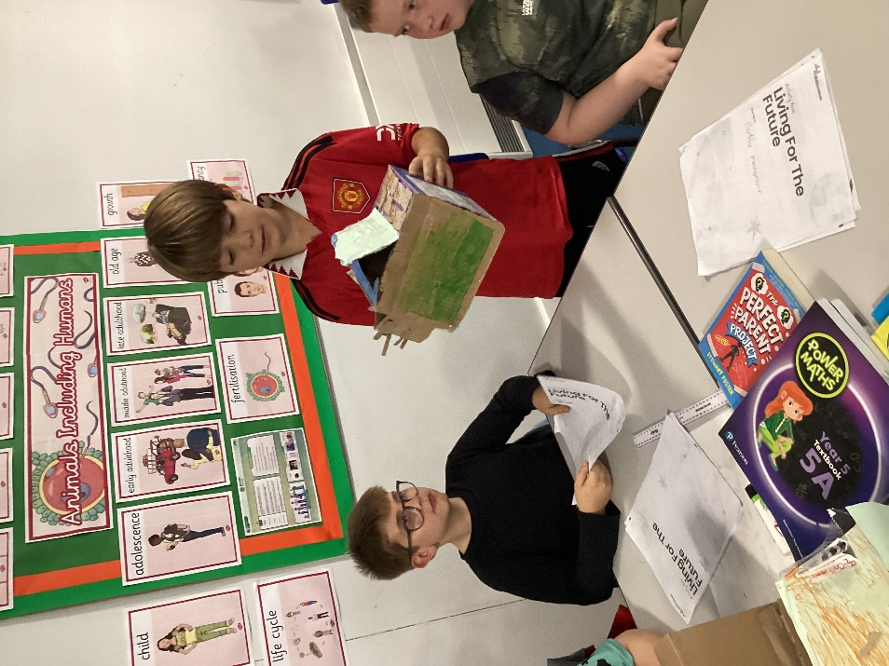
Team: The Power pods

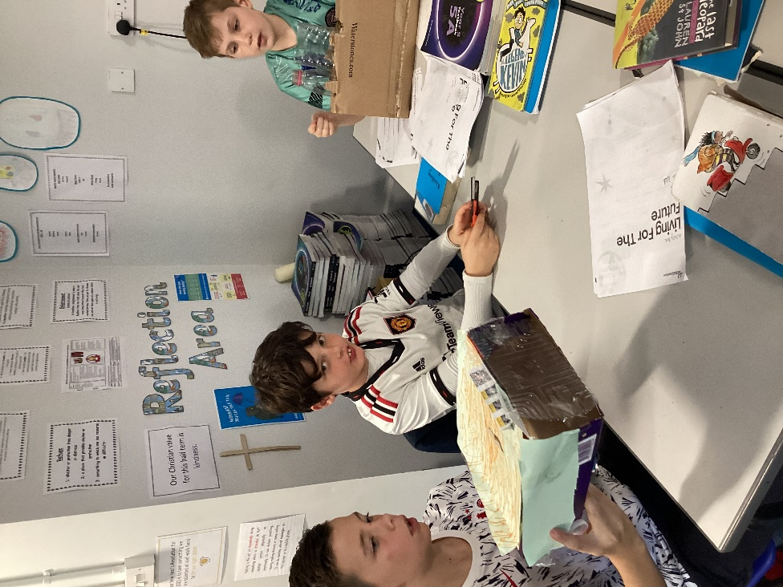
Team: Transport Zoom
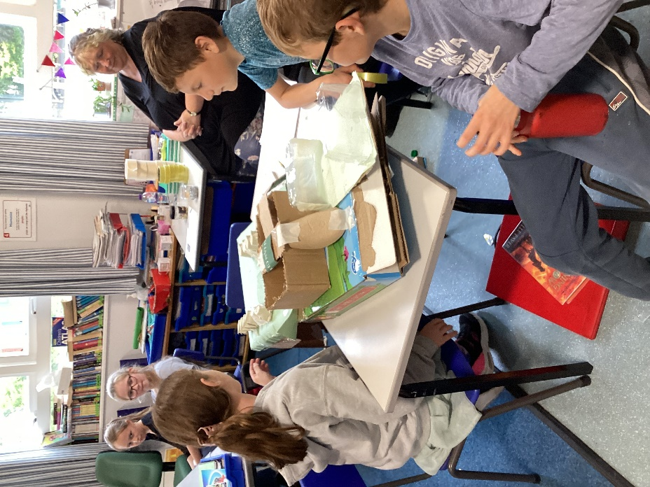
Team: The Natures
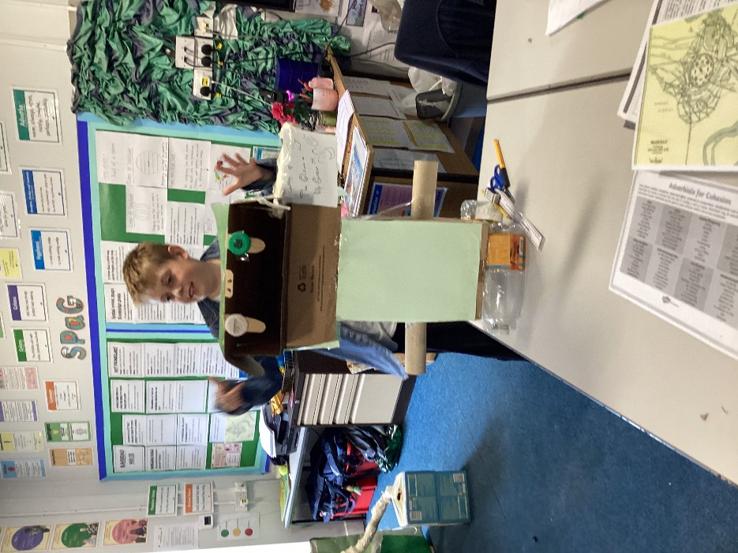
Team: The Clean-up Crew
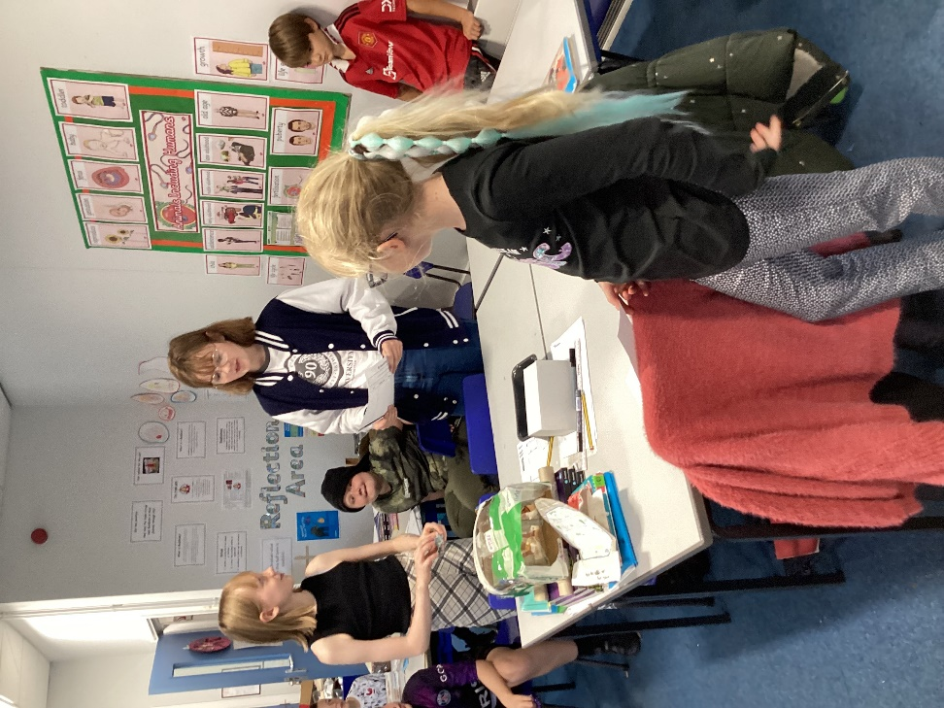
Team: Green Ride
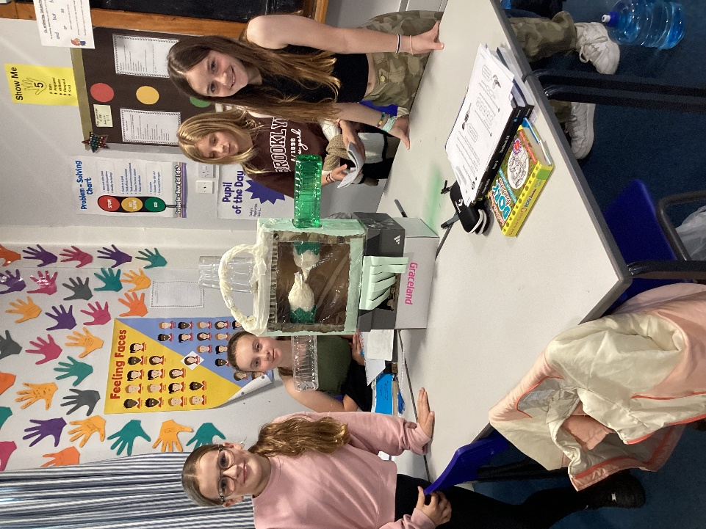
Team: The Four Eager Ecos
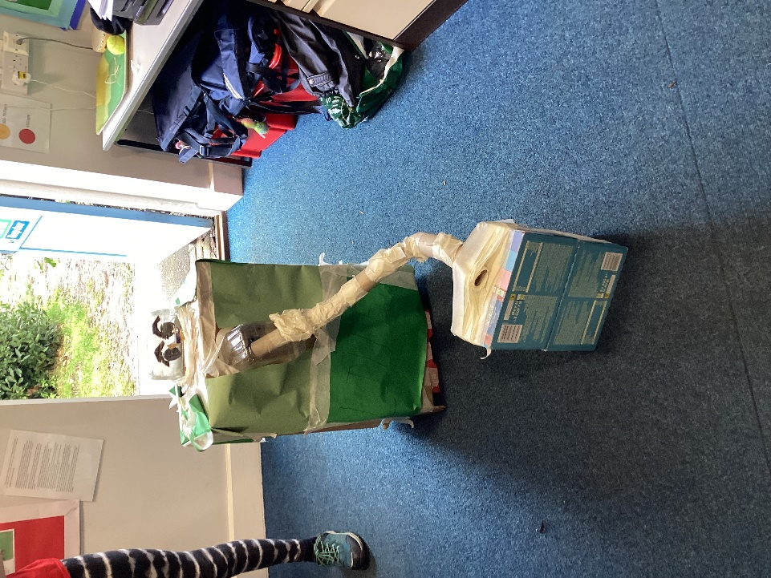
Team: The Eco Amigos
So much was learnt about teamwork, resilience, acting on feedback and entrepreneurial skills. We are very grateful to the families that provided the resources and to our excellent helpers Mrs Stansfield, Mrs Collins and Mrs Williamson.

