A special Visit
We had a special visitor this afternoon (9th November) to help us to understand the role of horses and other animals in the two World Wars. We now know that the lives lost by the animals are remembered when people wear purple poppies.
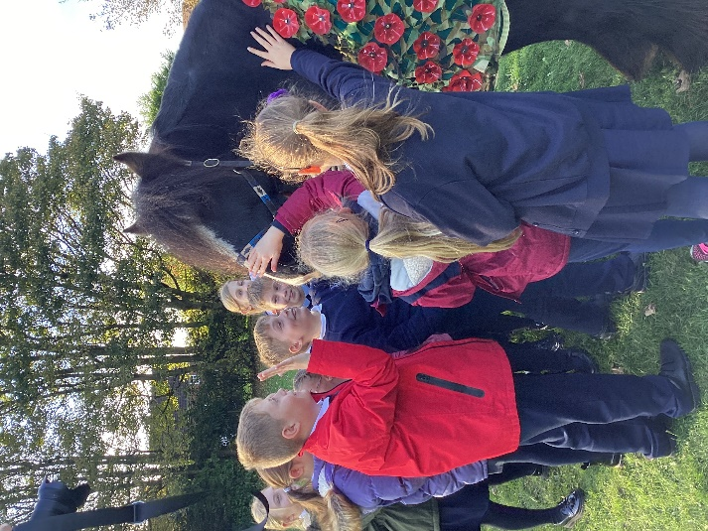
Trigger, the poppy horse, arrived on the school field this afternoon and enjoyed the fuss. His owner also explained the role of horses in war situations and how to take care of Trigger.


