Young Leaders Training – Class 4
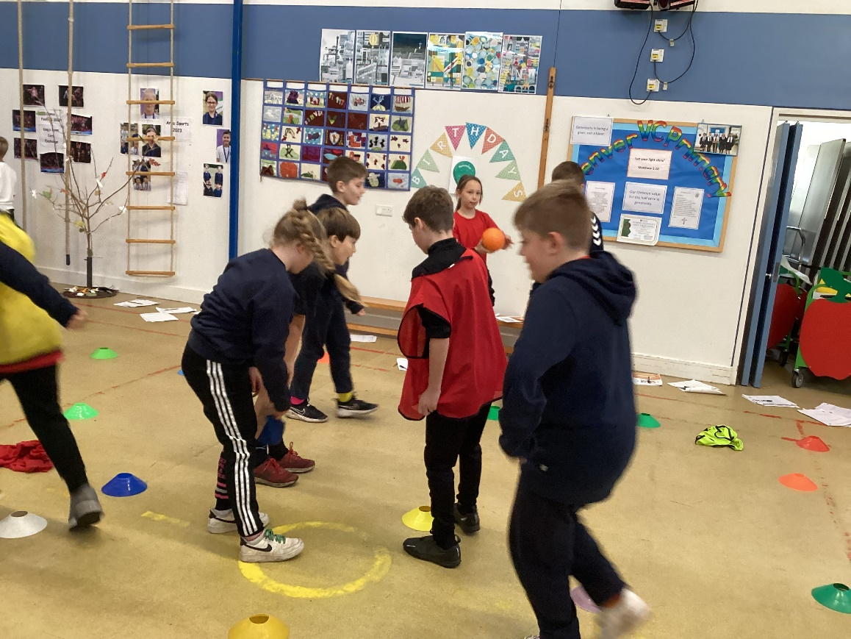
All too soon our Young Leader training with Shaun has come to an end. In our final session, groups had to consider how to keep the interest of the people they are leading (communication) and how to use equipment effectively.
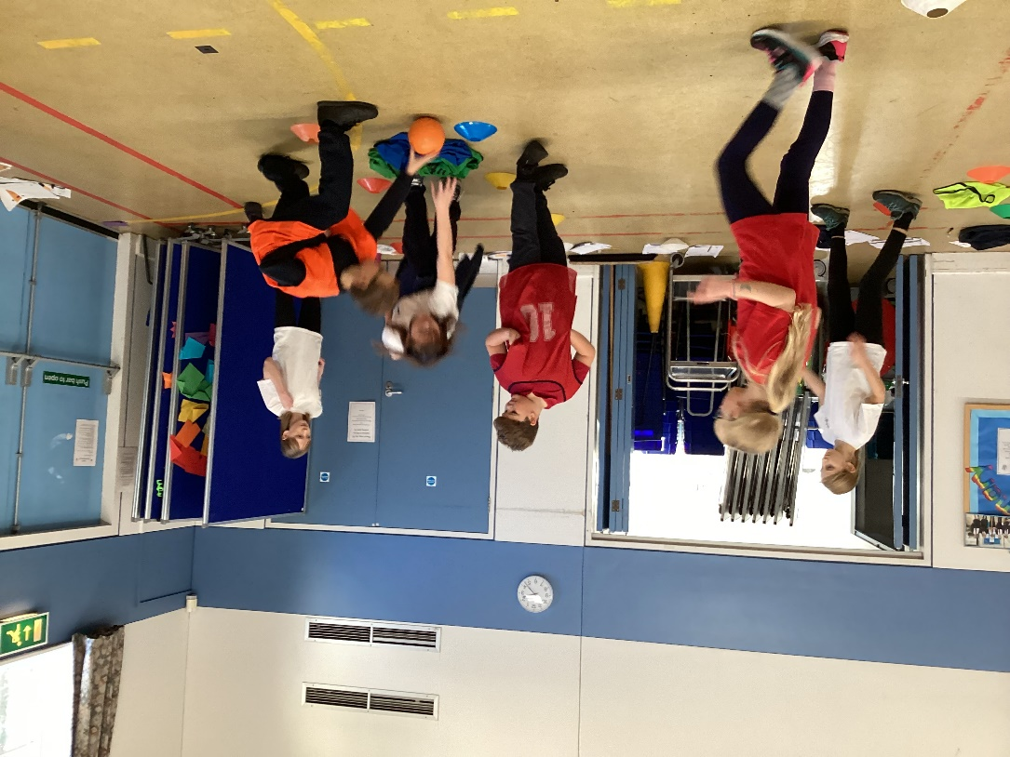
This was achieved by asking the groups to work together to invent a game with a specific amount of equipment and time available. Groups were also asked to consider which equipment was strictly necessary to deliver the game.
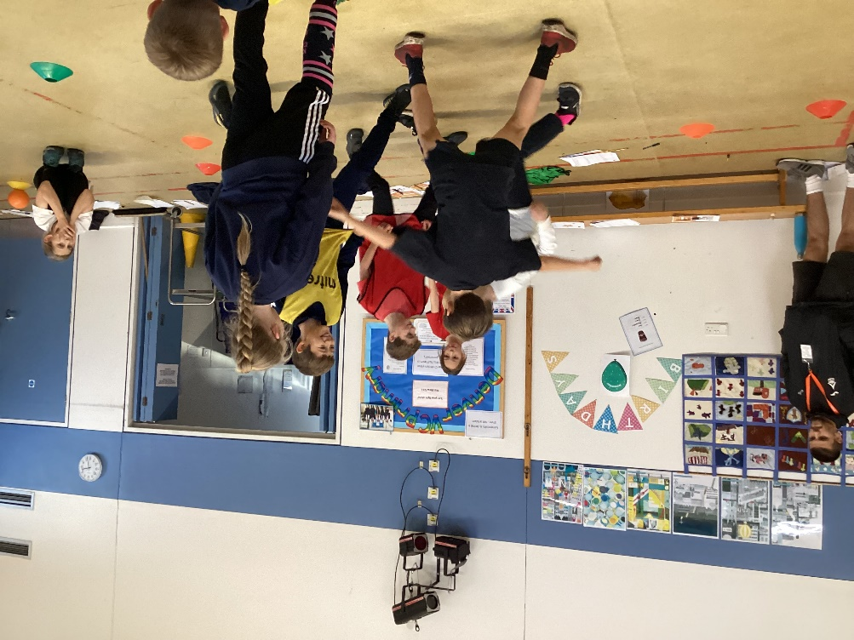
Once the groups had spent time testing out their games, they pitched and demonstrated them.
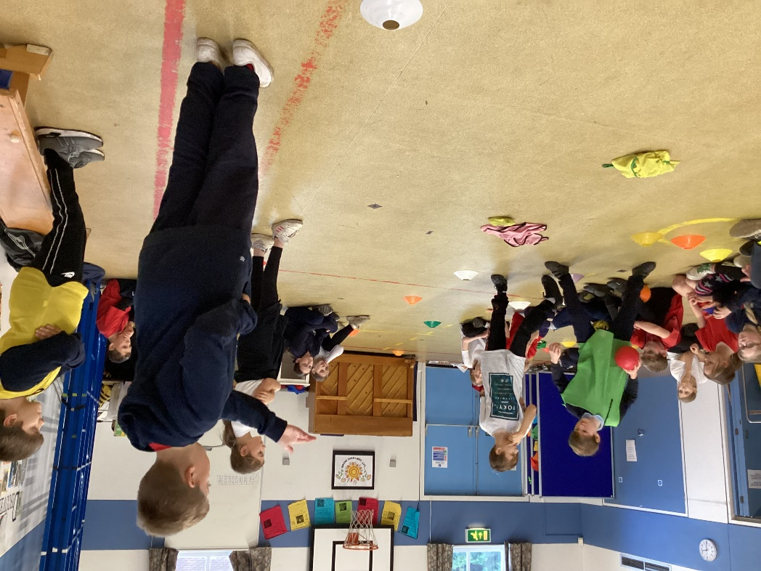

Feedback was given by Shaun and members of the other groups regarding safety considerations and how to get people back involved in the game is they have been caught out so that they don’t get bored. Many of the ideas were so good that they are to be rolled out to after school clubs and for playground games.

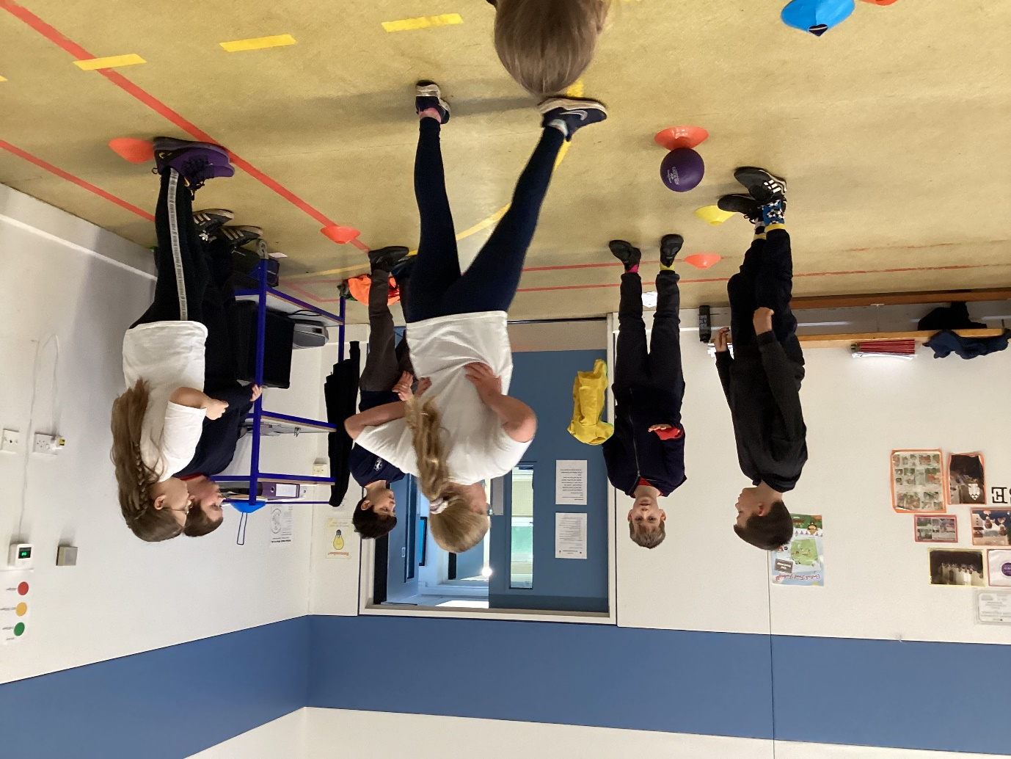

Beyond this, the skills and ideas explored throughout the training programme will be used to develop activities at playtimes, and support the planning of and organisation of festivals, inter-competitions and sports days. The children have been encouraged to use these skills in the wider community. They have a number of stars to work towards filing in to continually improve their playmaker skills.

