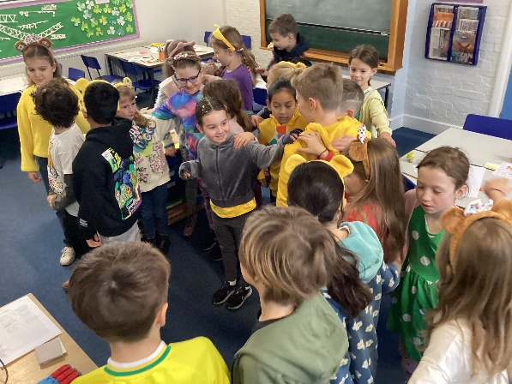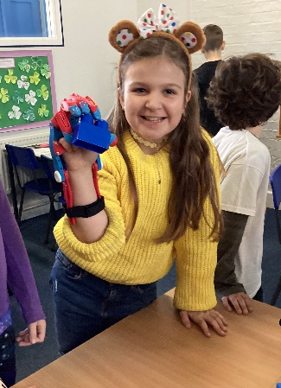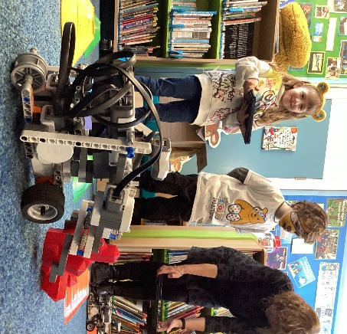
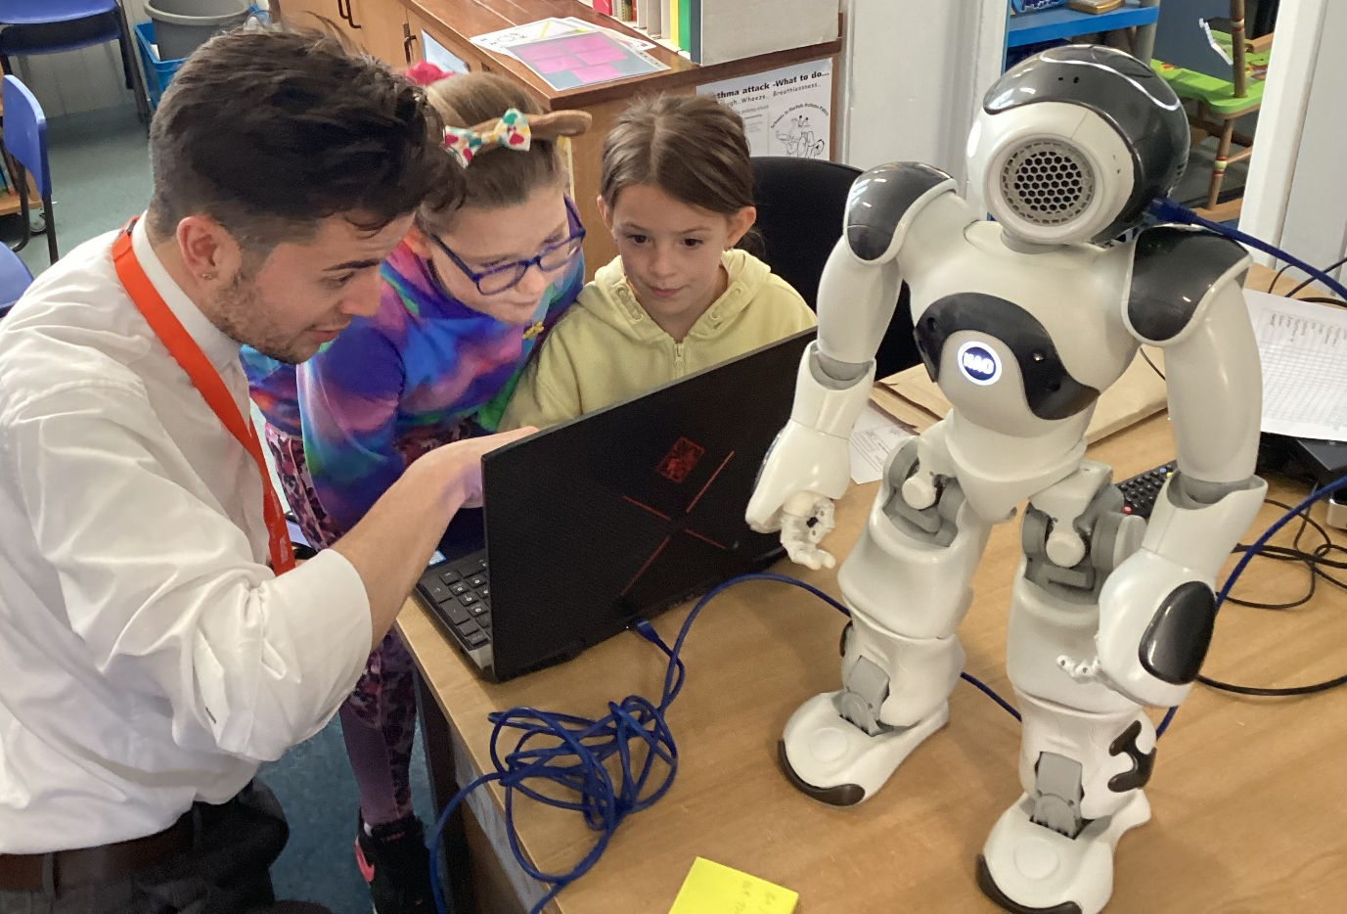
DT Day – ‘A Safari through Robotics!’
On 17th November Class 3 (Year 3 and Year 4) children had a ‘A Safari through Robotics’.
Ben Allen, who is part of the University of the West of England visited and brought along a collection of devices and robots which help improve people’s lives.
After trying them out the children were then be asked to think about their own ideas for ‘robot helpers’. The children then presented them to a panel of judges including Ben and Sarah Dungay, one of the school’s Governors.
Each child got a certificate of participation and the winning group each got a trophy designed and created by Ben.
‘I had a fun day and found out that people can use soft robots.’ Olivia
‘I absolutely loved it!’ Ellie
‘I think it has been fun and cool and I liked that they could do gorilla moves.’ Chase
‘It was a good adventure and one was my friend.’ Katie

