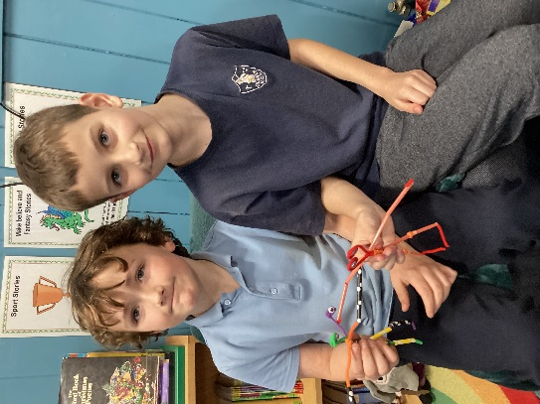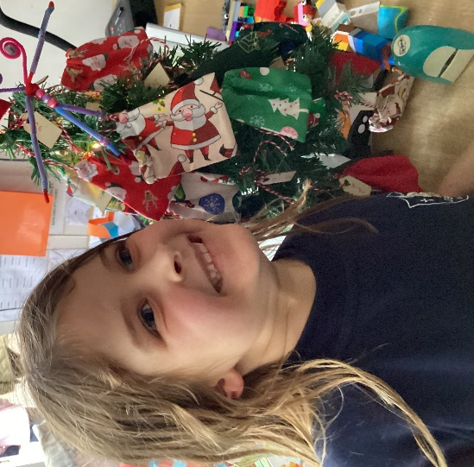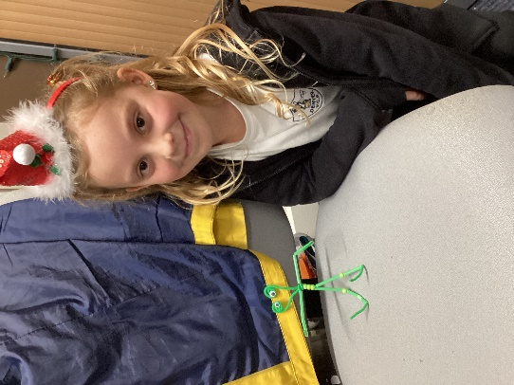
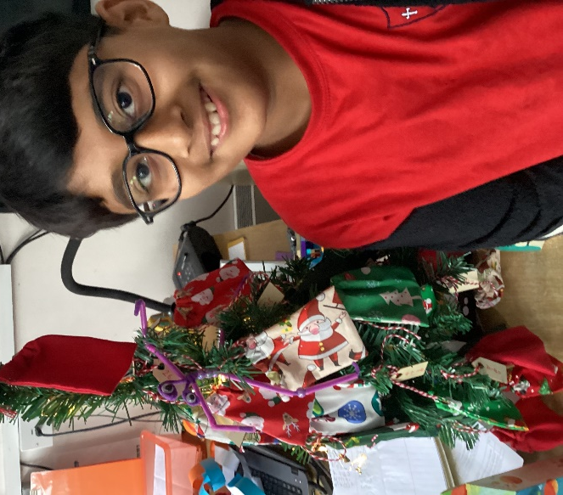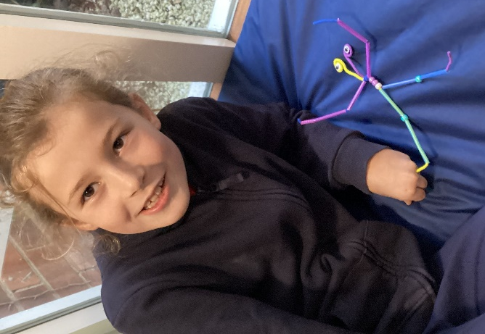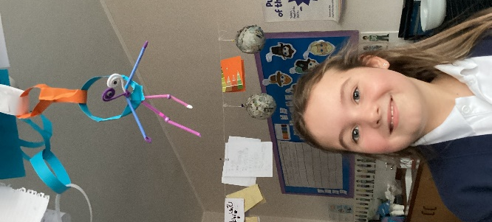
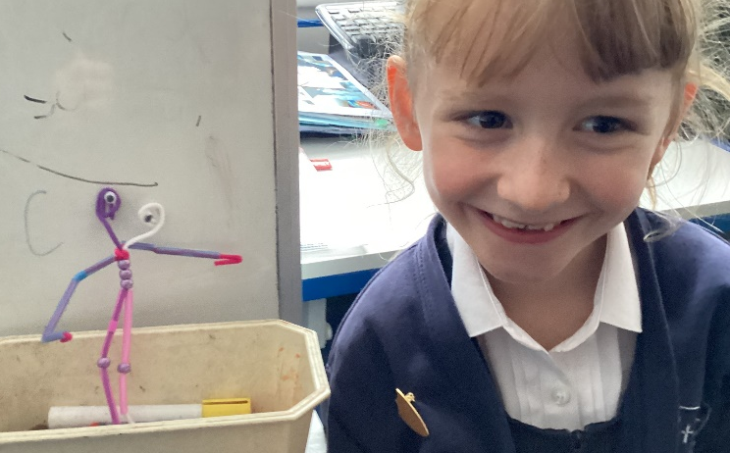
Class 3 Space themed Christmas Party
Class 3 had their Christmas Party on Friday 8th December. They had a tournament of Rockets and Meteorites (Snakes and Ladders) and the winners were Katherine, Drew and Katie who all won a prize. Everyone then created their own alien which they then took home. The children took their aliens around the school to show that we had been invaded. We coloured in more aliens as friends for our new creations and played ‘Hello, I am not an Alien!’ The children had a great time.

