ODD SOCKS DAY
Monday 13th November was the start of Anti-bullying week. The children were encouraged to wear odd socks to show that we are all unique.
We talked about what we think bullying is and how everyone is different and that we should embrace these differences.
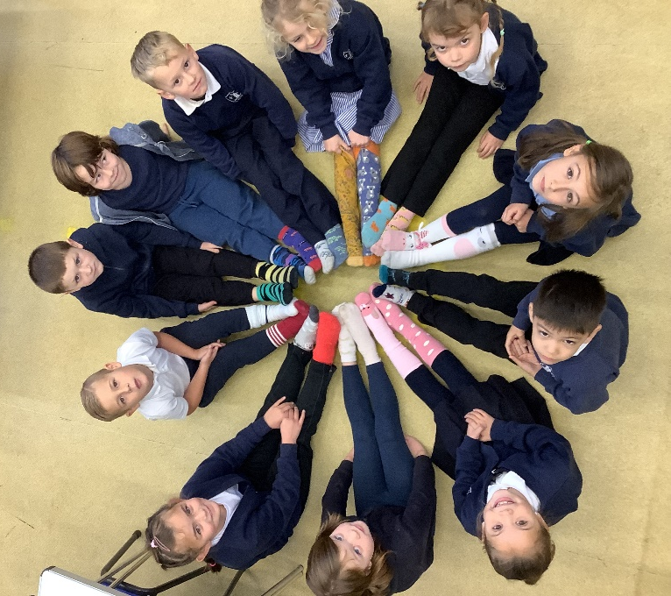
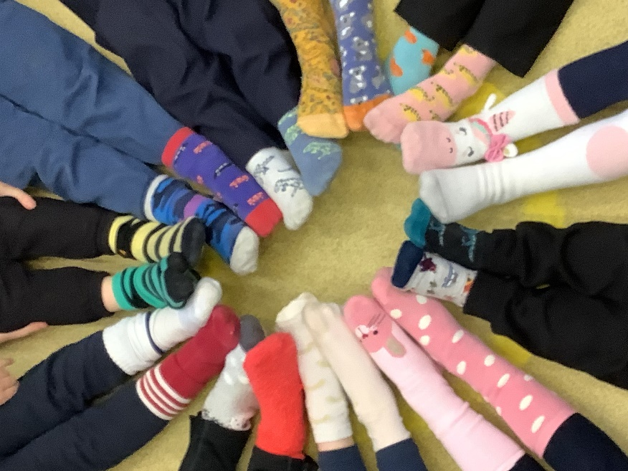
They made a good effort with their socks and have a better understanding of bullying.

