Class 4 Technology Day with Downham Market Rotary Club
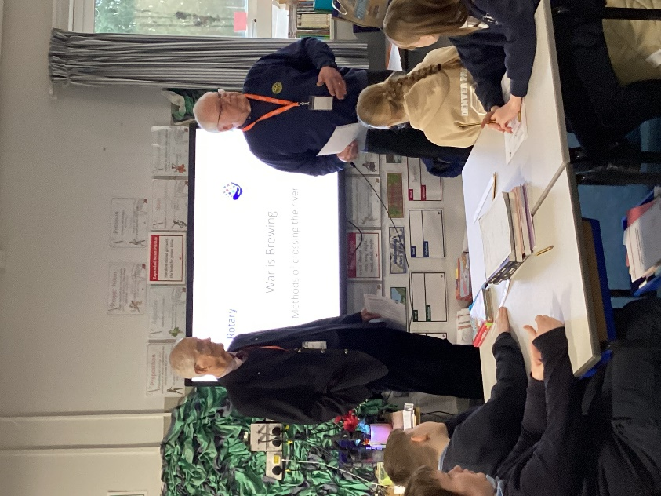
On Tuesday 23rd January, eager learners in years 5 and 6 at Denver V C Primary were joined by Alan Culley and Bryan Bradley from Downham Market Rotary Club for their new Junior Technology Challenge, ‘War is Brewing’.
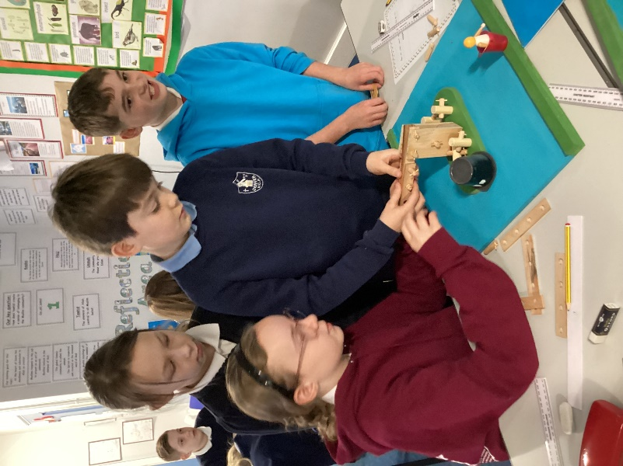
The challenge was to imagine being back in 1540 with the following scenario: Invading forces are approaching, and the king sends a messenger who must return with 300 men as reinforcements within 2 days or be executed. The messenger comes across a piranha infested river with a dilapidated crane in the centre. With a limited number of resources, the messenger must think of ways to successfully get himself and his army across the river.
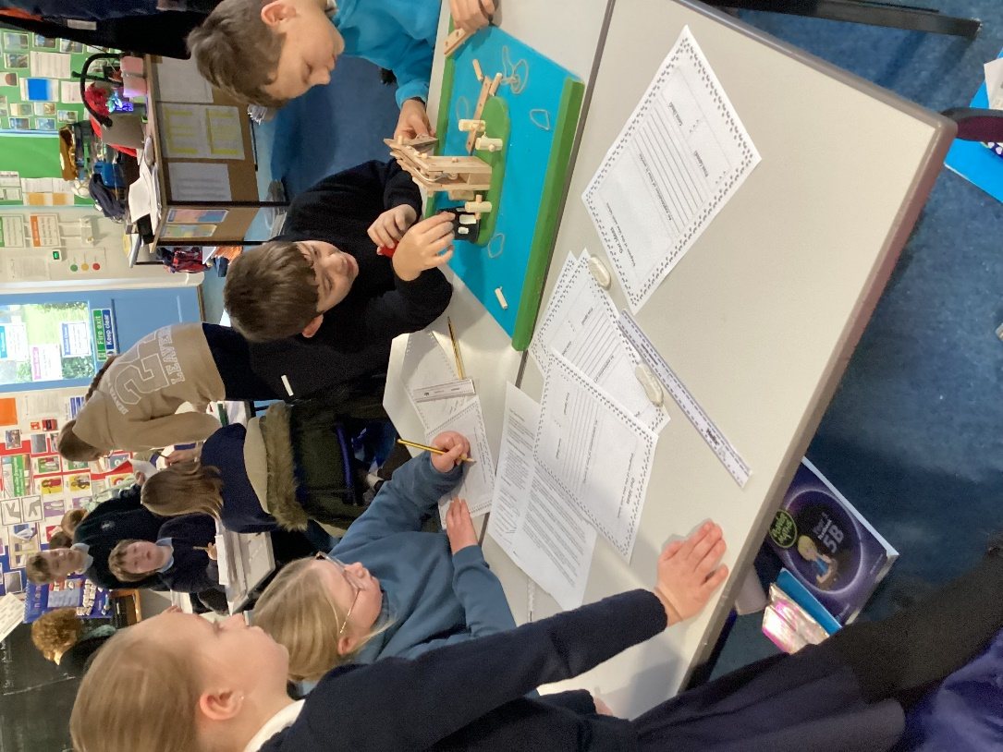
Small groups used their imagination and the physical resources provided by the Rotary Club to explore and create a portfolio of different ideas. These were scored against the specific criteria outlined at the start of the task. The budding engineers produced some excellent and very inventive ideas.
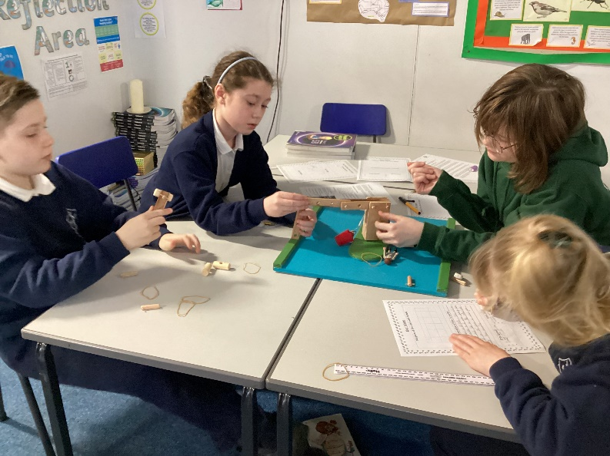
The technology day was to enrich the children’s learning in the STEM (Science, Technology, Engineering and Maths) subjects. Rotary Technology Tournaments are one day events involving an unseen challenge to develop team building and communication skills, planning and time management skills, and give them an opportunity to apply their skills. The aim of such events is to inspire students to consider careers in these areas. This was certainly the case at Denver Primary whose children rose to the challenge and had a fantastic and memorable learning experience.


