Mother’s Day 2024
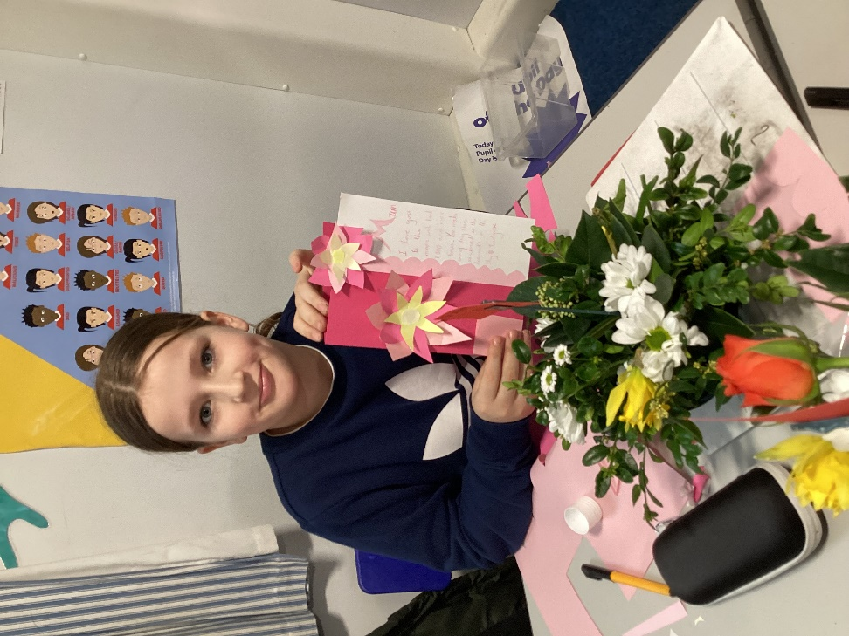
We were delighted to again be joined by ladies St Mary’s Church, Denver to make some beautiful posies for Mother’s Day.


