World Book Day 2024
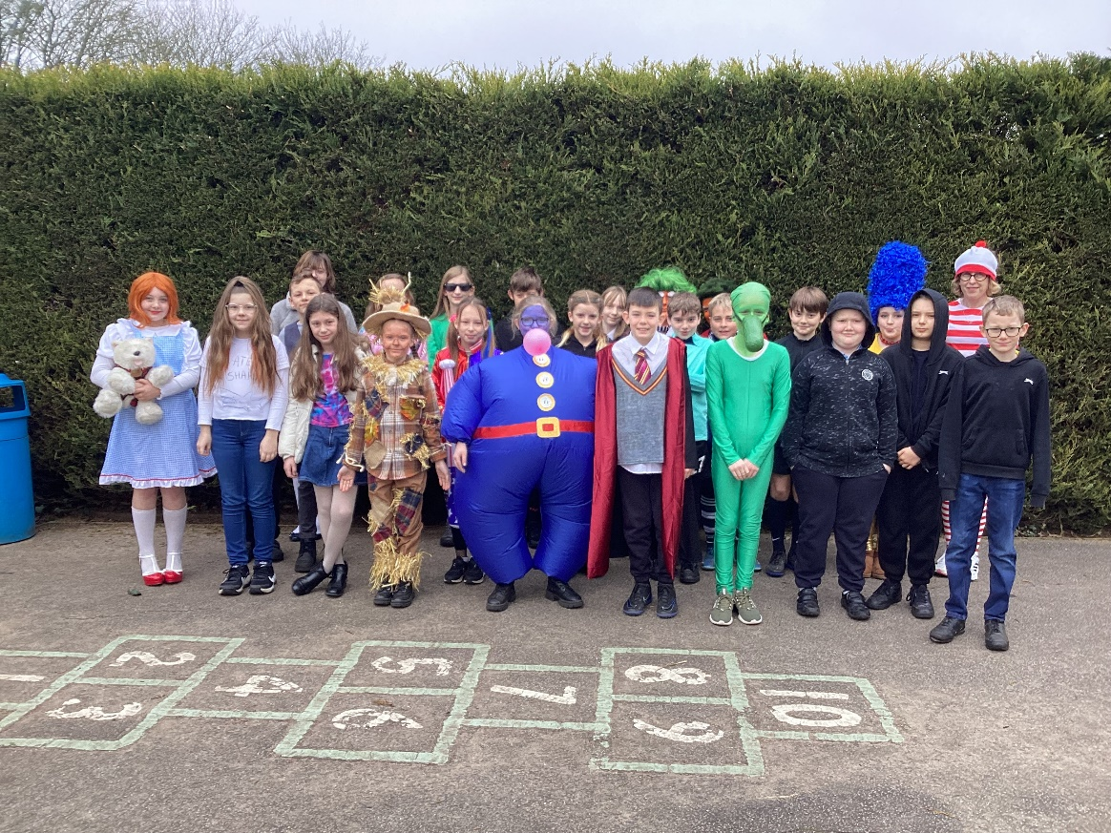
We marked this year’s World Book Day with an array of excellent costumes as our favourite characters.
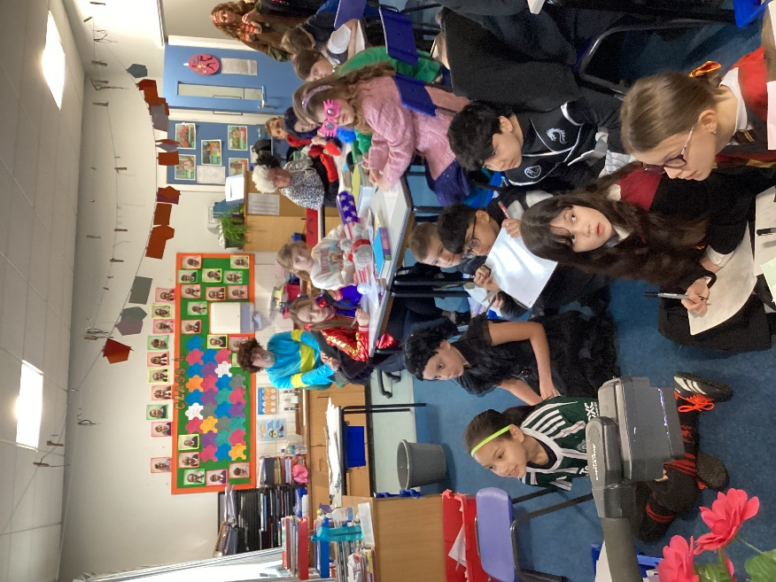
Other events to mark the day were biscuits shaped as books generously made by Mrs Fenn in the school kitchen and shared reading with children in Class 1.
Class 3 joined us to take part in the National Literacy Trust and Premier League Primary Stars online Booky Wooky quiz with a whole host of other schools nationwide.
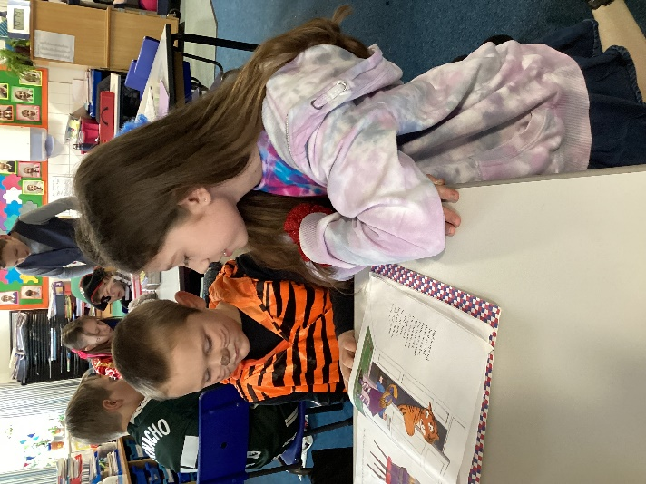
The day ended with families joining the children for shared reading in classes and the library. Children from Class 4 also circulated around classes 1, 2 and 3 to ensure everyone had a partner for reading.
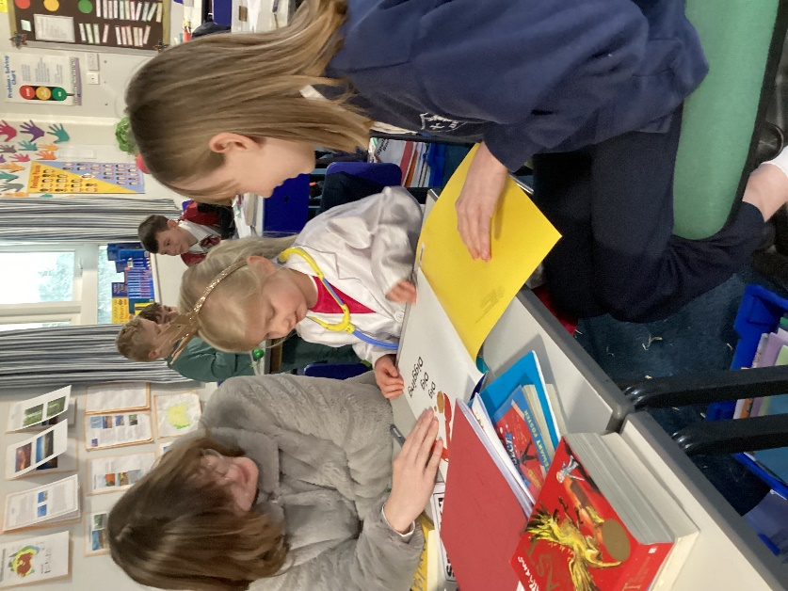

The ‘Lucky Listener’ reading ambassadors also complemented a busy and enjoyable day of collaborative learning.

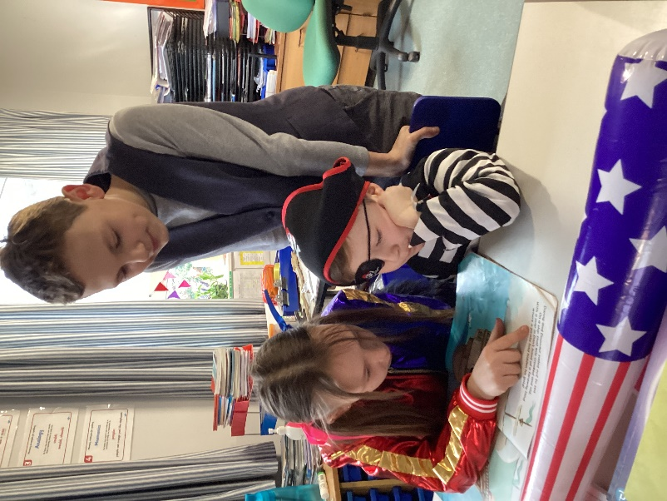

Thank you to the families for the superb efforts you have put into the fantastic costumes.


