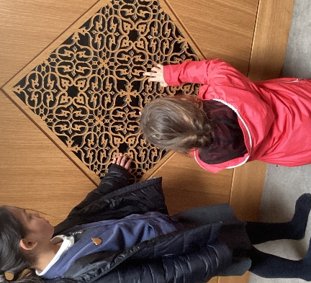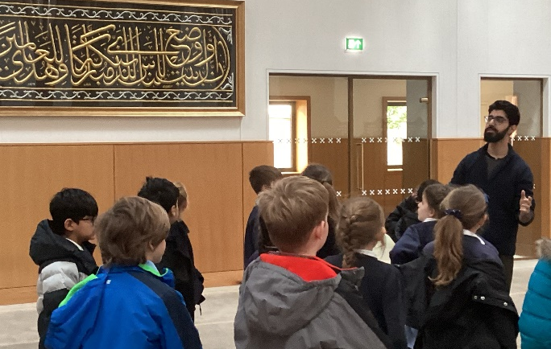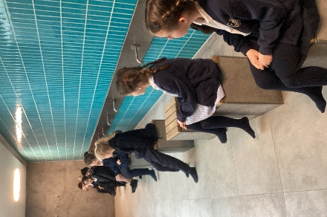
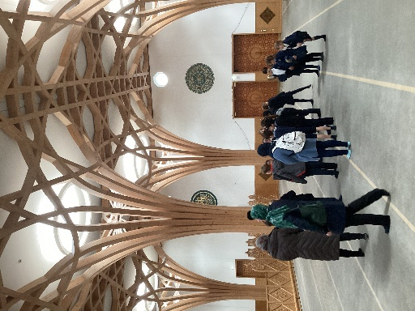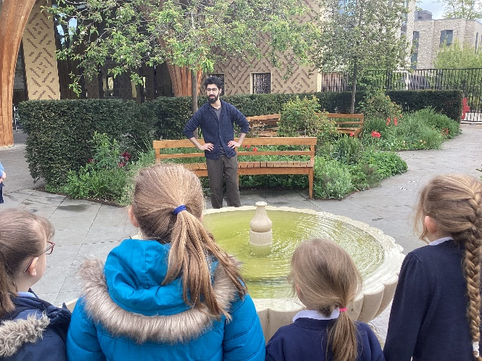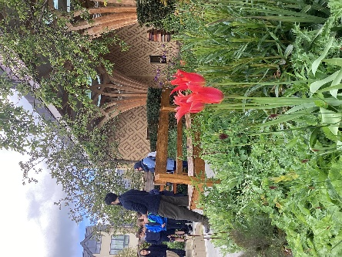
Class 3 visits the Cambridge Central Mosque
On Friday 26th April class 3 visited the Cambridge Central Mosque. It was an amazing building which really seemed to impress the children and adults. We learnt that it was designed by the architects who created the London Eye. Our guide, Mohammad, explained all about how they use recycled materials and that they use collected rainwater for the washrooms. The children were very impressed by the motion-activated taps! We learnt about the different prayer times, the items on display and that they host over 400 weddings a year!
Comments from the children included:
“The prayer hall is really cool and the other rooms were really impressive.” Hugo
“It was very clean, it smelt nice. I liked the idea of the Mother and Child room.” Isabella.
“The Mosque was gigantic! There was a fountain and we had to take our shoes off.” Osian
“The Mosque was fun and we went onto the balcony.” Matthew W
“I think it was cool because they used rainwater for wudu and to water the plants.” Katherine
“The Prayer Hall was beautiful. It was great. I would recommend a visit!” Katie
“Amazing. I had to take off my shoes to show respect. I learned so much. I want to go back!” Lorelei

