Vocal Coaching
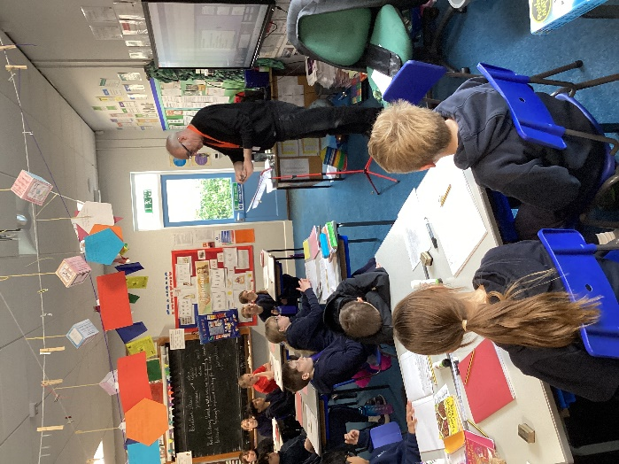

Fraser Reich came to Class 4 on Friday 18th October to do some vocal coaching. He explained how important it is to warm up our voices before singing by massaging our necks and using vowel sounds to a pitched tune. He explained how and when we need to breathe so that our sound quality is better.


We then practised a collective worship song, ‘Together’ to practise when to pause and breathe and how to make sure our words are pronounced with clarity. It was great session and we look forward to more sessions in the future.

