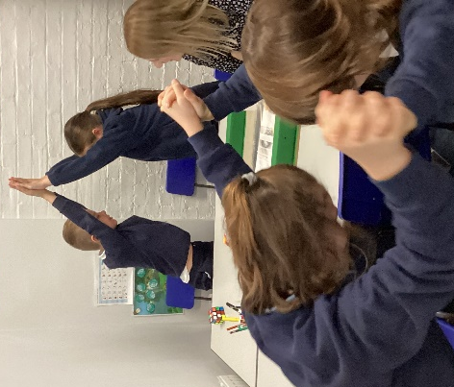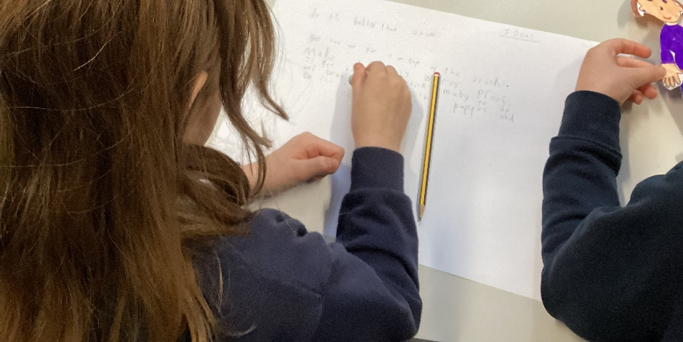
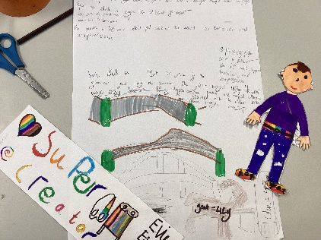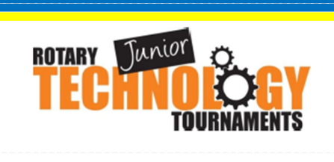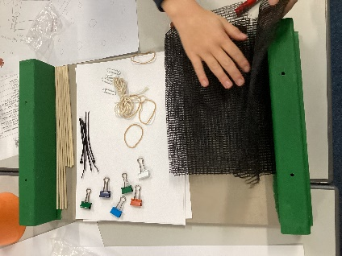

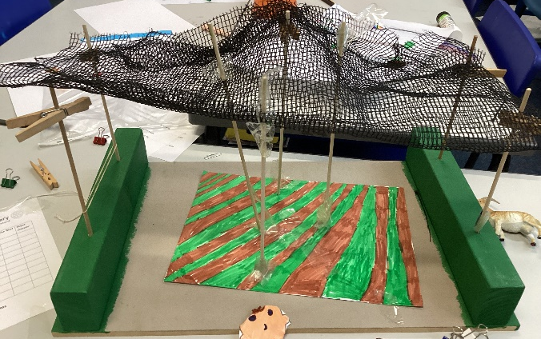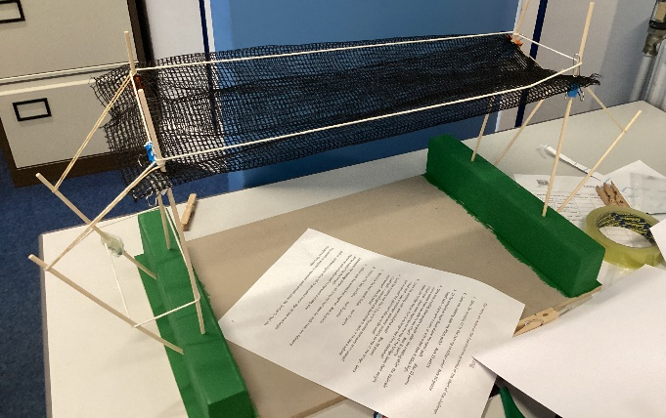

Class 3 Design & Technology Day

Wednesday 6th November Class 3 had a visit from Alan and Howard from the Downham Market Rotary Club. They helped set up and run a Junior Technology Tournament. The challenge was to build an Animal Crossing across the ‘Denver Village Nature Reserve’. There was a brief to be followed and the design had to be made as a scale model and then tested. The teams were Super Fireworks, Space Animals, Team Jello, Team Creative, Team DT, The Best, Super Creator and the winning team were the Cats, Dogs & Hamsters who were awarded medals. Everyone who took part got certificates to celebrate their fantastic ideas and enthusiasm. The day went very well and the children made the following comments about the experience.
I loved it, we got to design the bridge and do maths! Katherine, Cats, Dogs & Hamsters
I loved making the bridge and meeting Howard and Alan. Olivia, Space Animals
I think next time we would make it look even better. Isabella, Team Creative
The day was brilliant because we worked as a team. Jonessa, Team Jello
I think it was a good day because I like engineering. Monty, Space Animals
I liked today because we did such creative things. Ottilie, The Best

