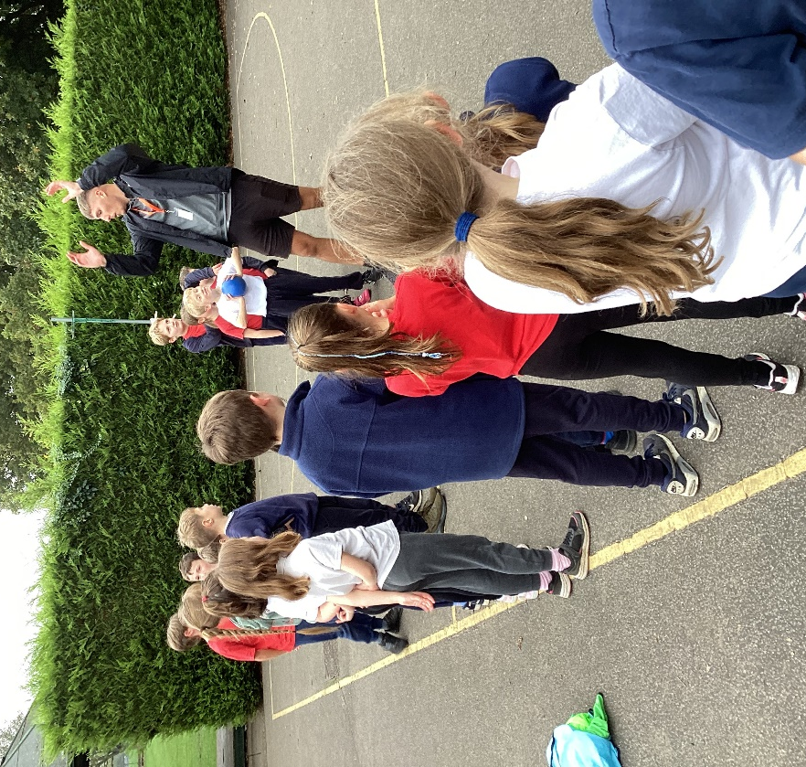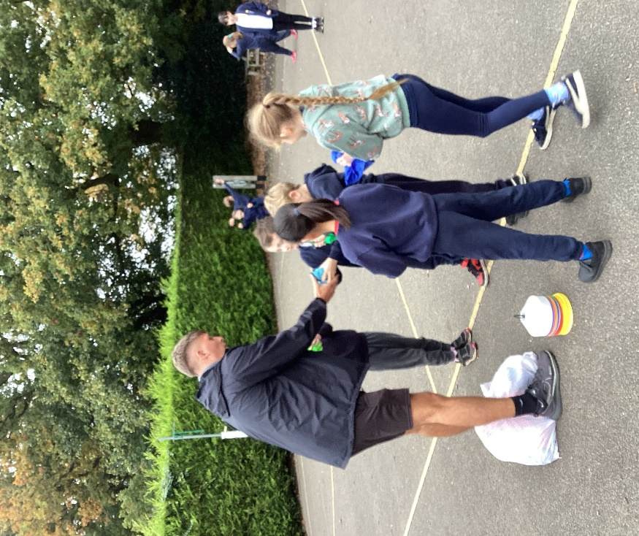

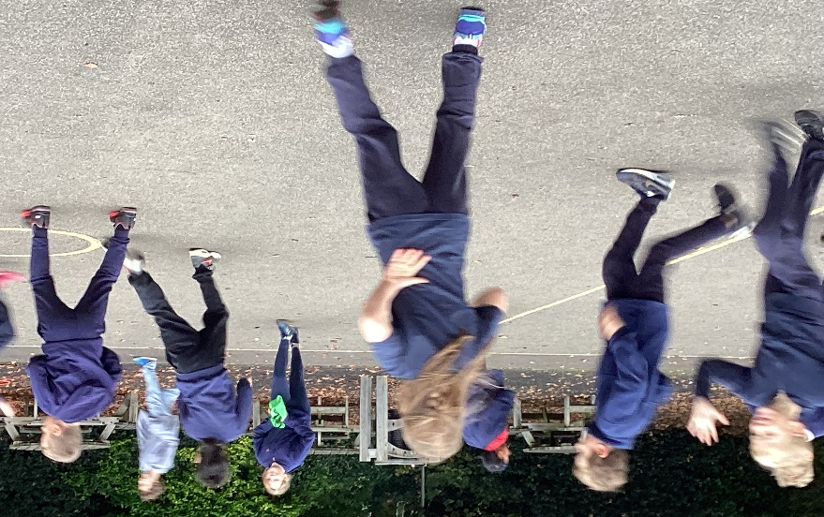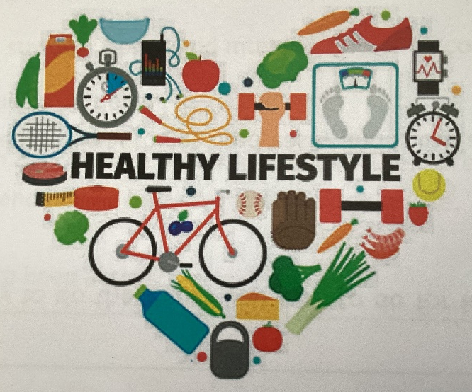
Healthy Body and Healthy Mind
In the Autumn Term, Class 3 were lucky enough to take part in a series of lessons designed to improve our health in a fun and exciting way. These sessions were based upon the theme of Healthy Body, Healthy Mind. The sessions were run by King’s Lynn Alive Active Schools group and were made up of classroom sessions and physical activity sessions.
The lessons included learning all about healthy eating. We learnt what foods were better to eat and what foods we should eat less of. We also learnt the importance of a balanced diet and regular drinking to keep our bodies healthy. Living active lives can mean leaner bodies, stronger bones and muscles, improved coordination, better posture and fewer health complications. In addition to the physical benefits, concentration is better, increased self-esteem, less likely to be anxious and have a better overall outlook on life.

