More Vocal Coaching and Children in Need 2024
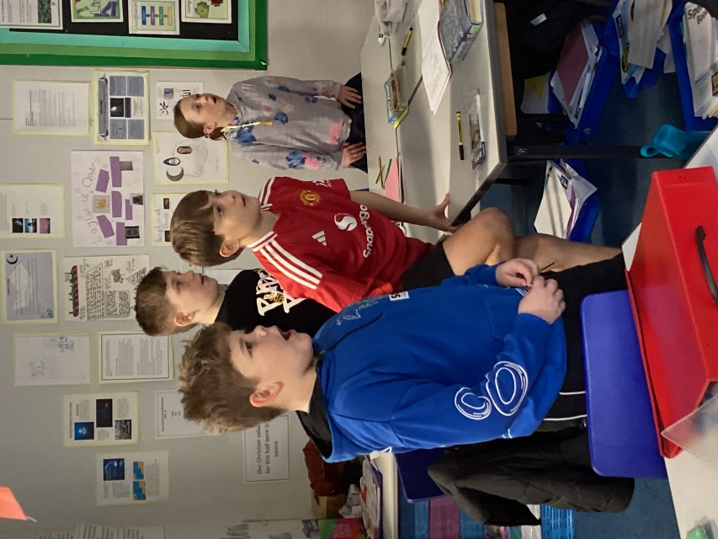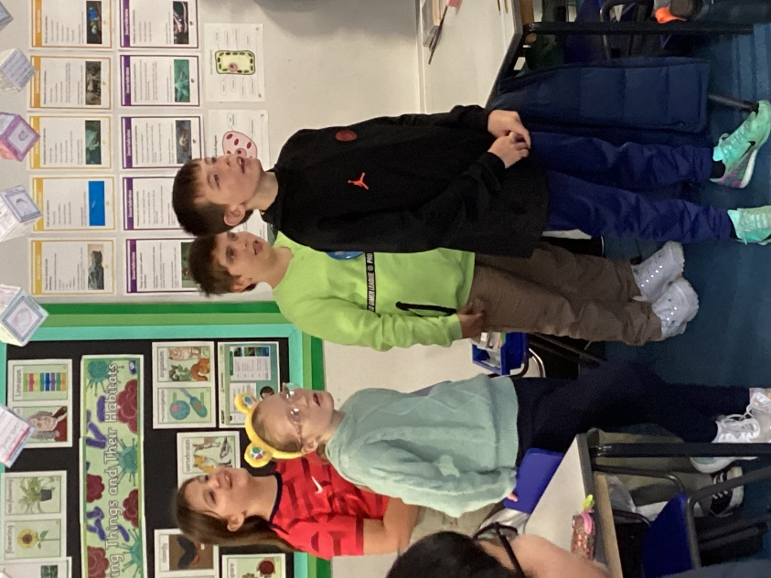
There was much excitement in Class 4 on Friday 15th November as it was non-uniform day in return for a donation to the Children in Need charity. Cakes were also sold to help raise more funds. A total of over £130 was raised across the school. Great effort!
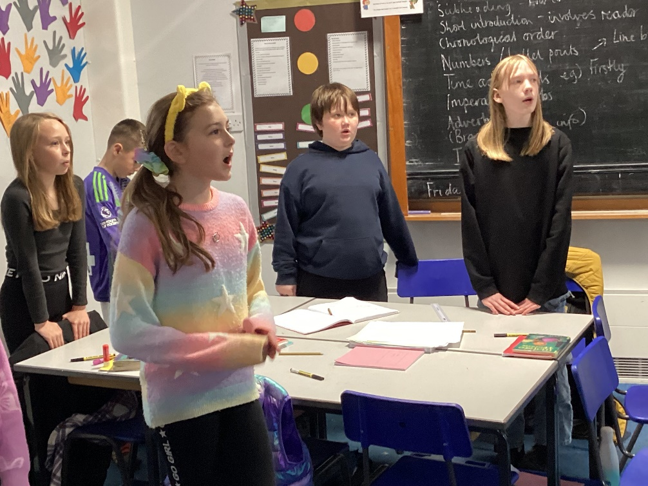
A scavenger hunt also took place where children had to find an assortment of letters hidden in the school grounds, unscramble them to unlock the missing words and then claim a prize.
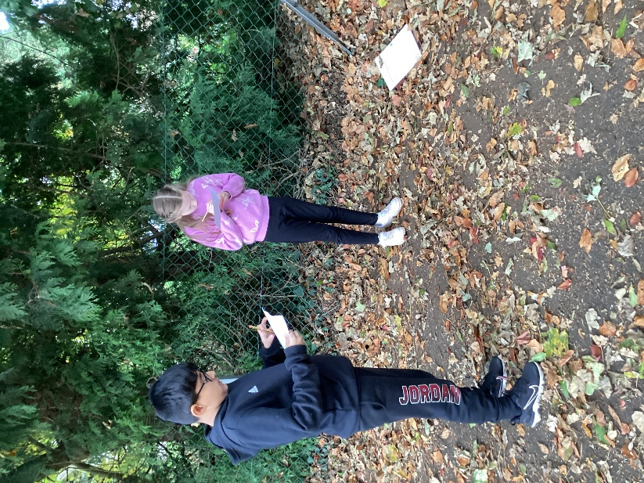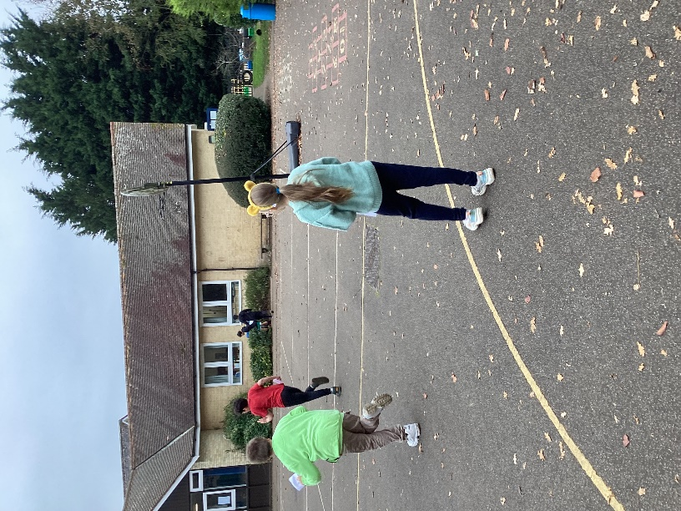

Fraser Reich returned for another rousing vocal coaching session. He was impressed with how the children maintained the rhythm and varied their volume. He will return in two weeks.



