Norfolk Constabulary anti-social behaviour webinar 22.11.24
To mark anti-bullying week, we joined schools across the county on a TEAMs meeting with members from Norfolk Constabulary to learn about what anti-social behaviour is.
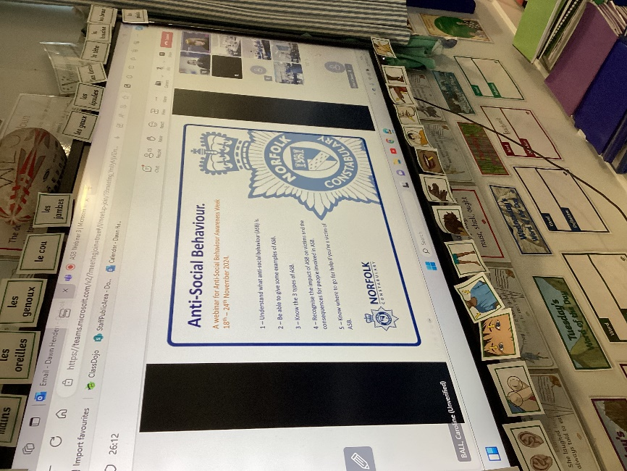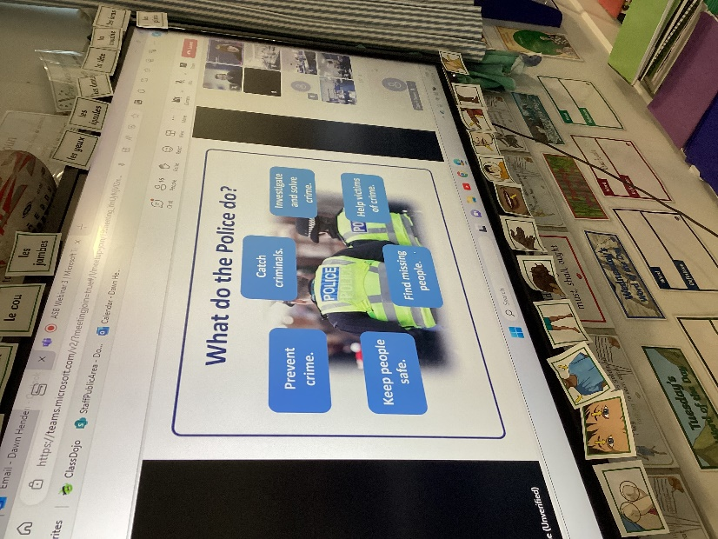
We learnt about the different types of anti-social behaviour.
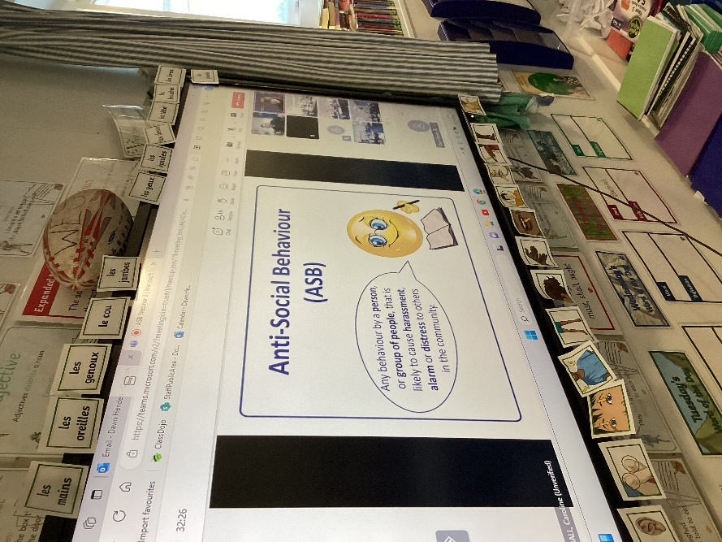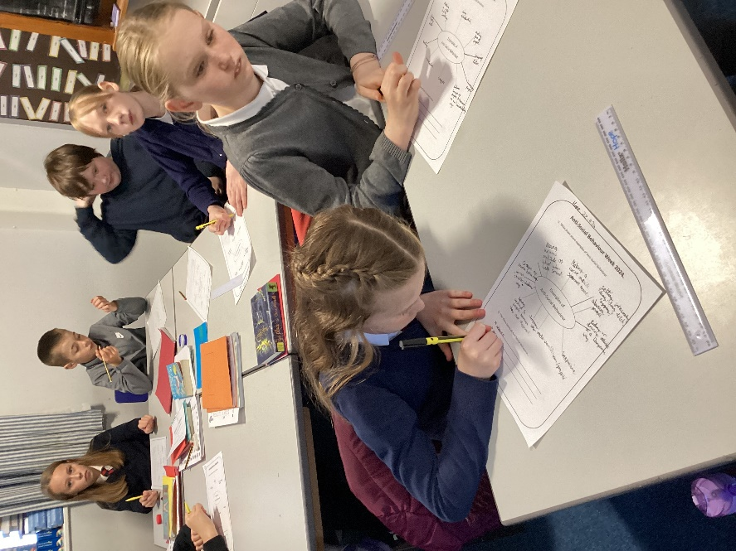
Then we explored case studies to identify the impact that anti-social behaviour has on individual people, the community and the environment.
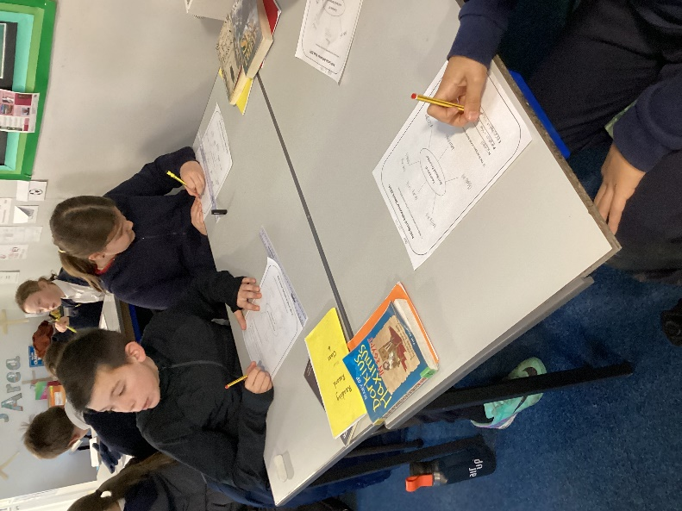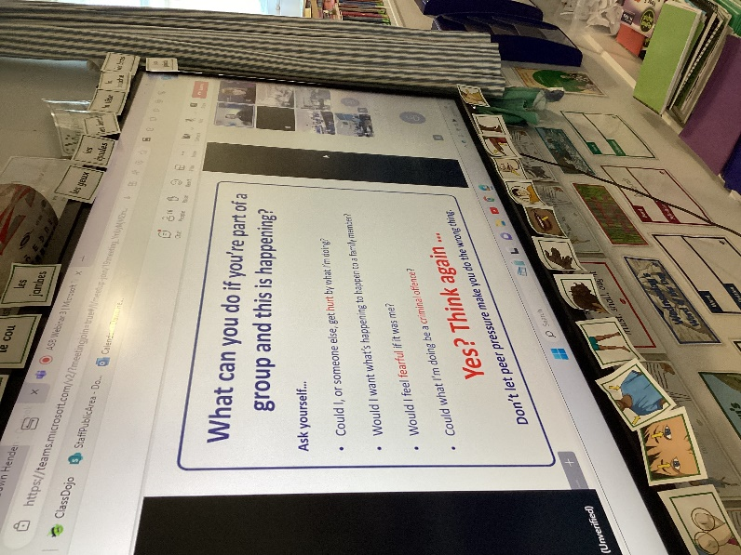
Police officers taught us what we can do to report anti-social behaviour and how to avoid getting into trouble for it.
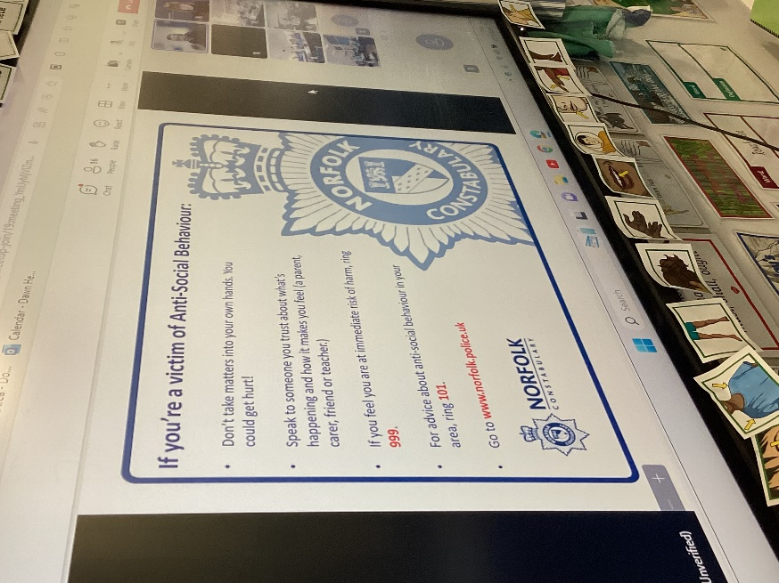
Finally, we were signposted to sources of support and there was an opportunity to ask questions and share our experiences.

