The Christmas Fayre is coming…
Preparations are well underway in Class 4 for the forthcoming Christmas Fayre.
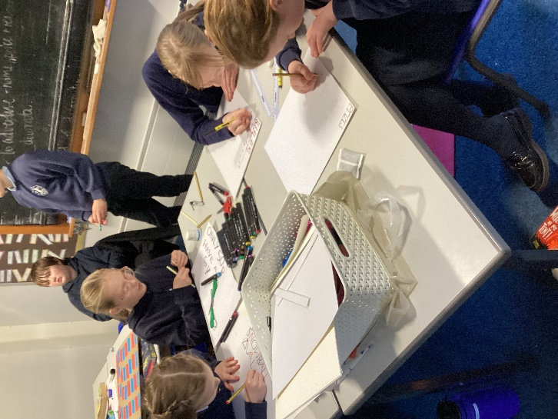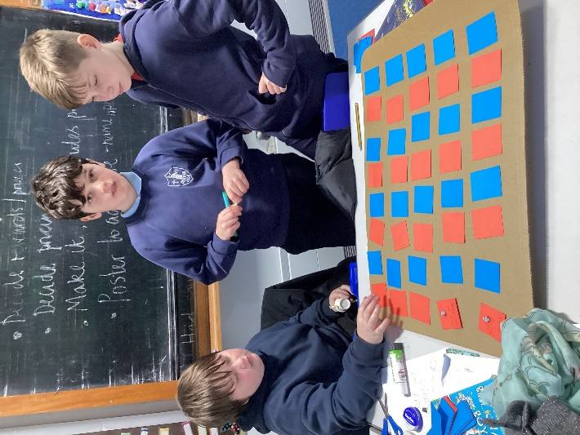
In small groups, the children decided on an idea for the game for their stall, made the games and resources to run it, decided on pricing, then made posters to explain the rules and to advertise their stalls.
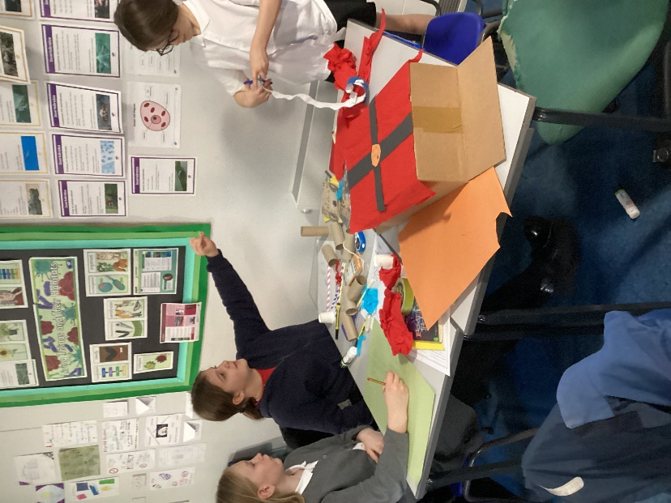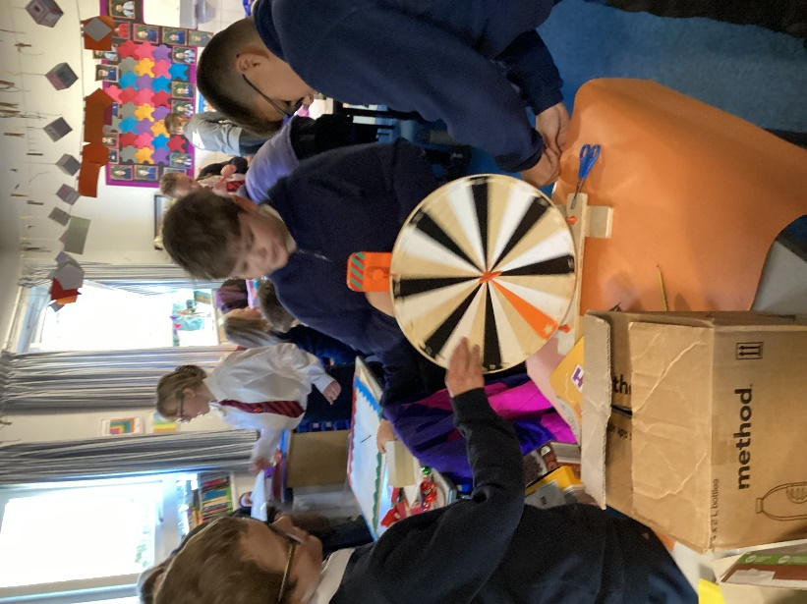
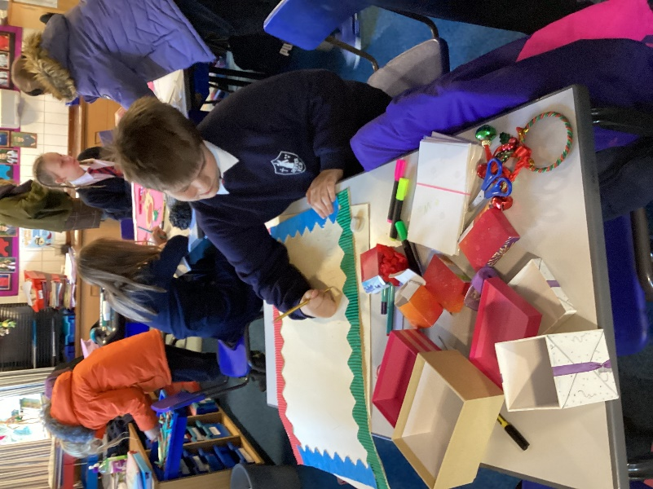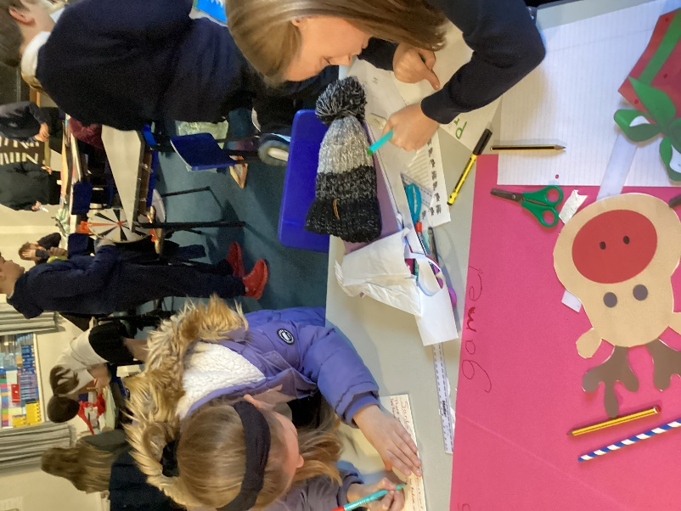
They look forward to welcoming as many visitors as possible on Thursday 28th November.


