Game Changers
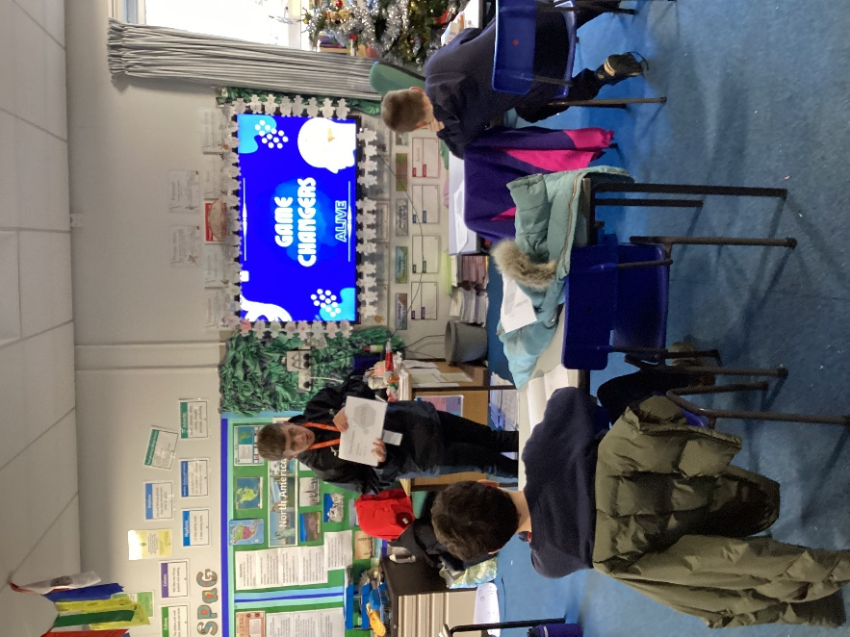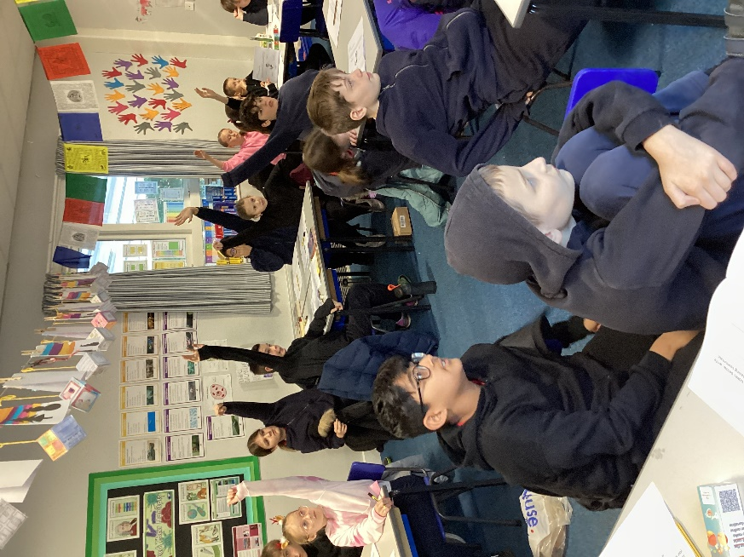
For three weeks, Harry from Alive Leisure will be delivering Game Changers sessions to Class 4. These sessions are about exploring the link between physical activity and positive mental health.
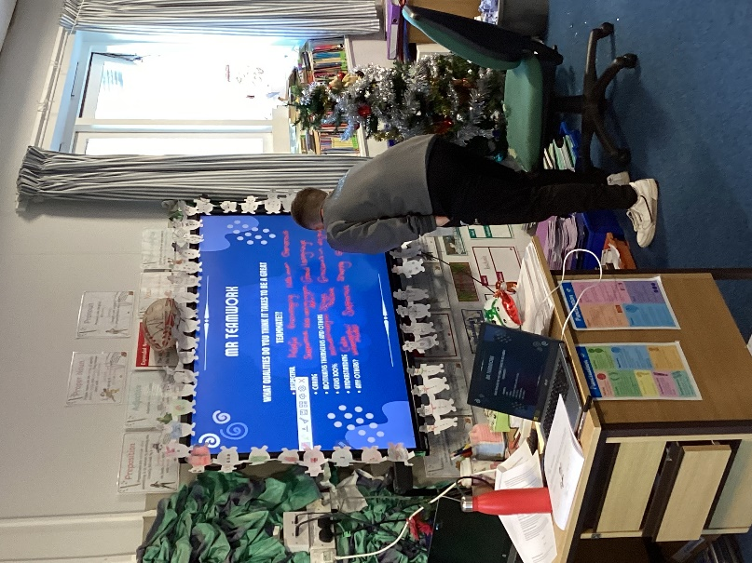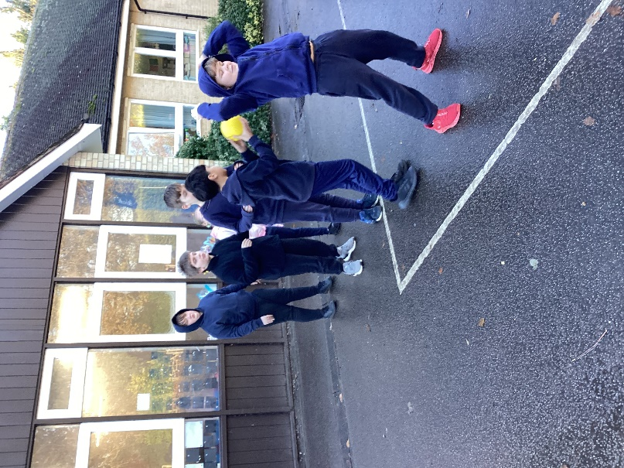

Each session begins with some class-based activities. In this first session on Friday 29th November, the children explored the role of physical activity in promoting both individual and teamwork skills. The children identified the skills of a great teammate and then shared a famous person who they most admire for being a team player.
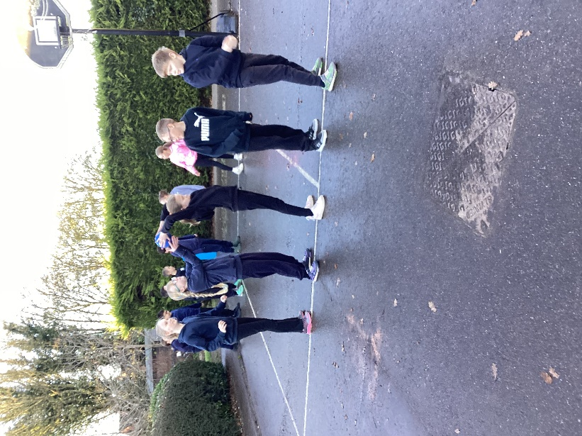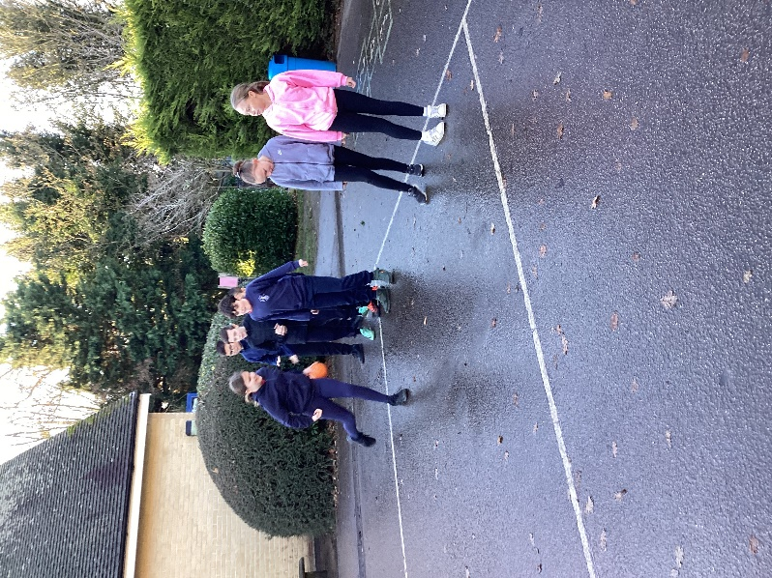
Then it was off to the playground to do some activities that involved being a team and using the skills we had identified in class. This involved ‘Over and Under’, ‘To the side’, coaching one another and ‘Chase Tag’.


