Christmas Party and Father Christmas Visit 2024
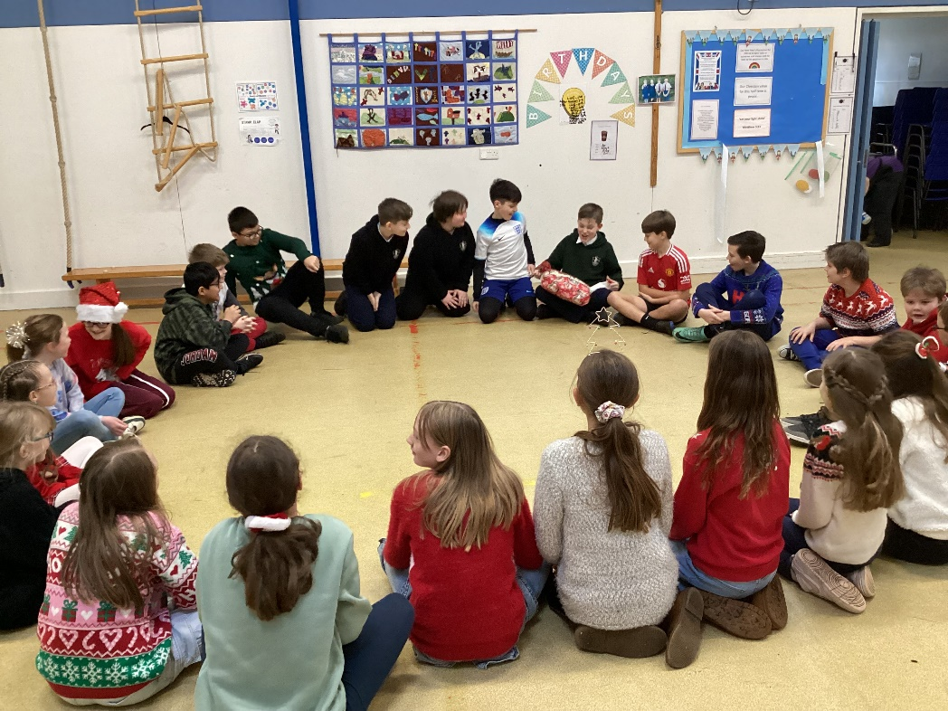
On the last day of term we had a good morning of finishing off, chilling out to DVDs (while the adults tidied up and did some preparation for the Spring term) and then our party in the afternoon.
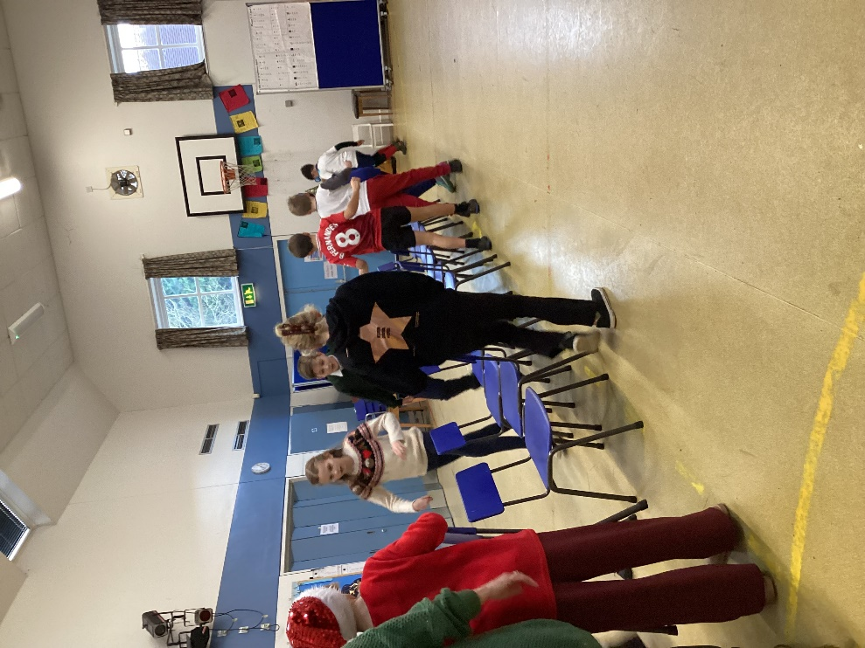
The party began with the traditional Pass the Parcel game kindly made by the Friends. Rowan was the lucky winner of the main prize.
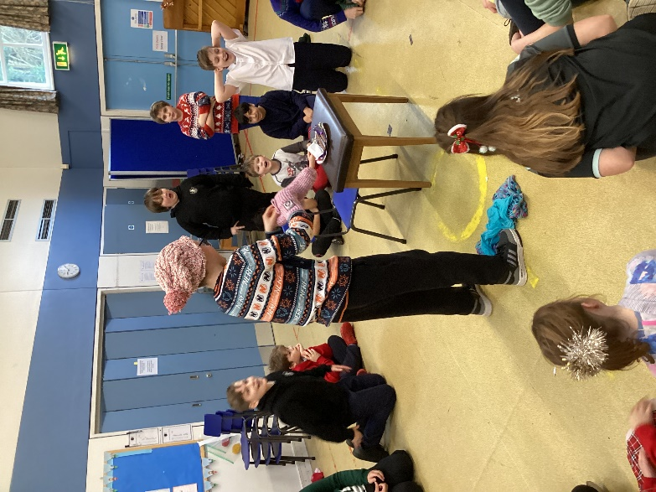
Musical chairs followed this and then a game with chocolate. The aim was to score a six on a dice, then put on a hat, gloves and mittens and attempt to eat a bar of chocolate with a knife and fork before someone else scored a six. This turned out to be a competitive game but most kept to the rules and didn’t sneak any chocolate when it wasn’t their turn!
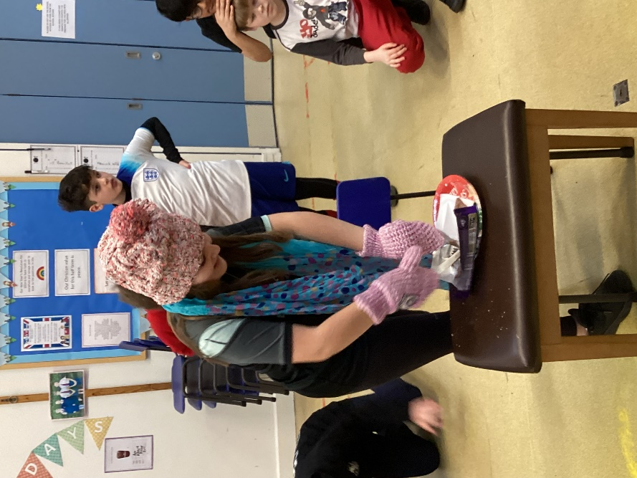
Father Christmas was a welcome interruption to the proceedings. He joined us in the hall with his elf. The children asked him some interesting questions. A selection box was given to all children (also kindly donated by the Friends).
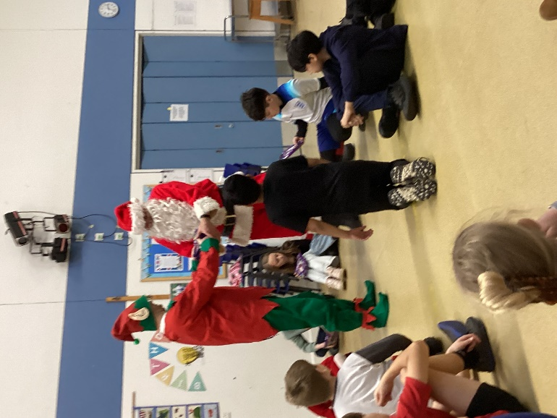
We had time for a couple of rounds of the corners game before having to prepare for celebration assembly.
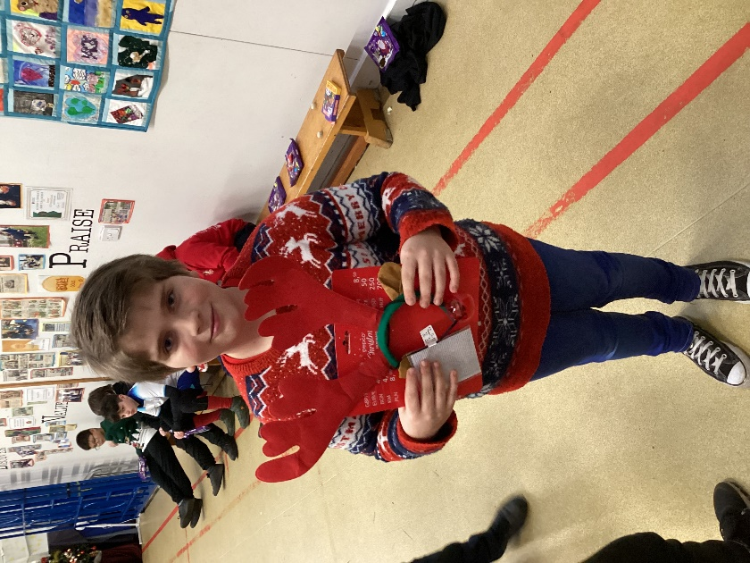
It was a fitting way to end the term after a long and busy term!

