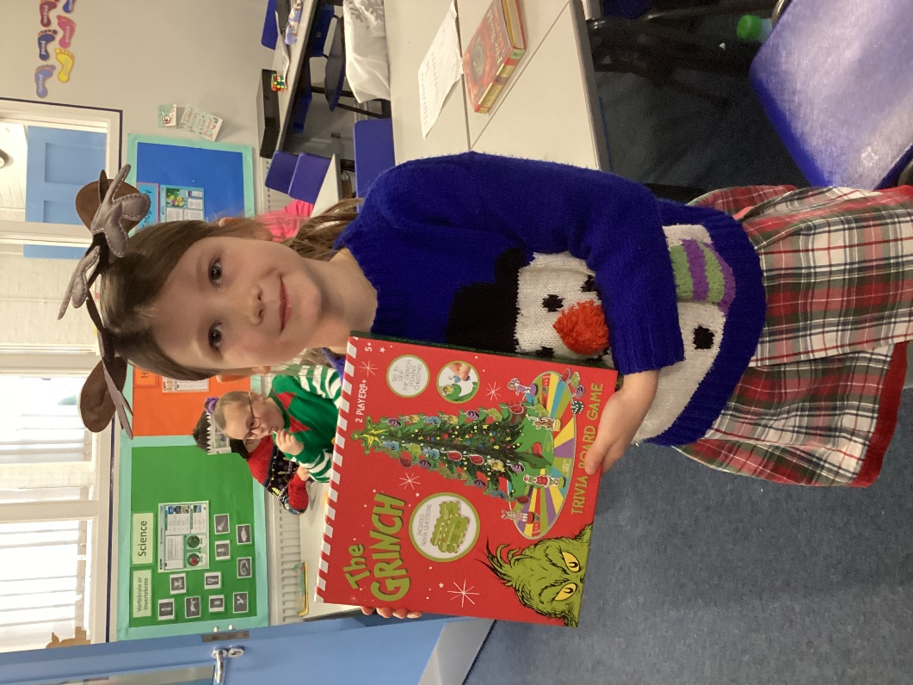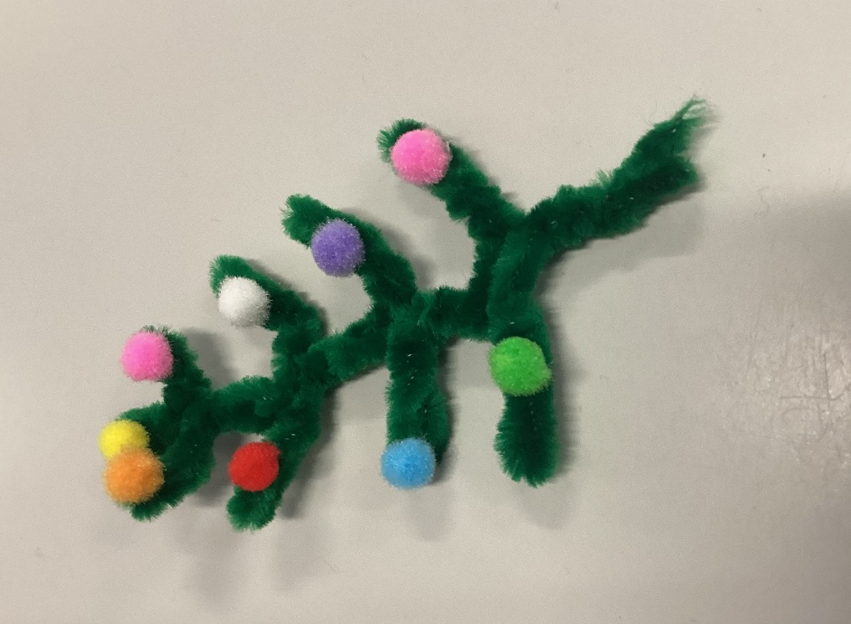

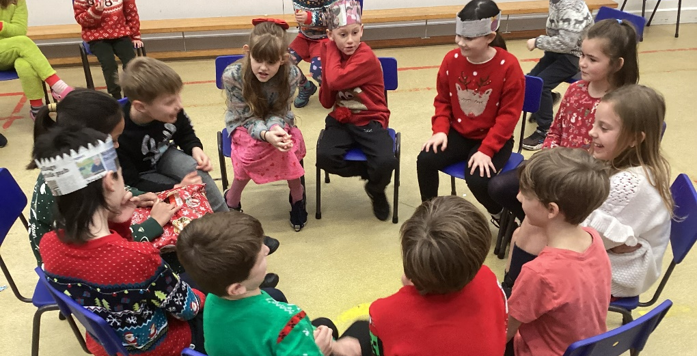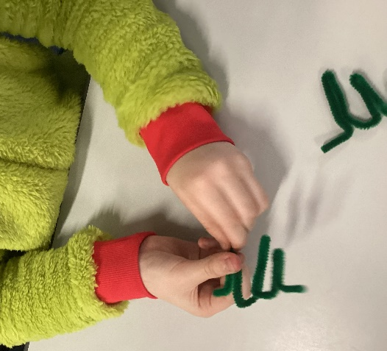
Class 3 Christmas Party 2024
On Wednesday 11th of December, Denver had our Christmas School Lunch. What made the day even more special for Class 3 was that we had our had Christmas Party in the afternoon. We had a great game of Pass the Parcel. Ottilie was the last to open the last layer of wrapping paper so won the final prize. We then went back to class for some creativity. The children made different Christmas Trees using various coloured pipe cleaners and then decorated them.
Thank you to the Friends of Denver for providing the prizes.
Ottilie: “I felt really happy and proud to have won Pass the Parcel and I got a Grinch Game!”

