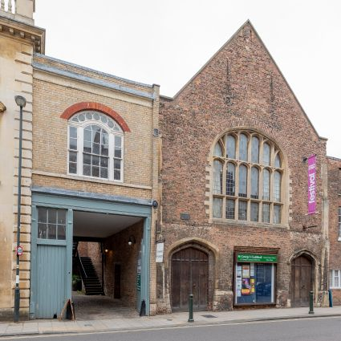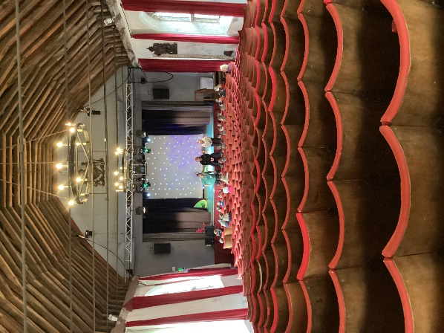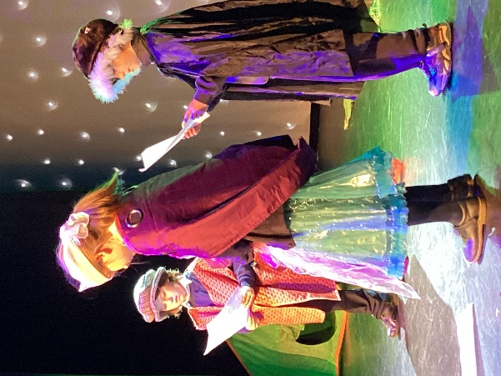
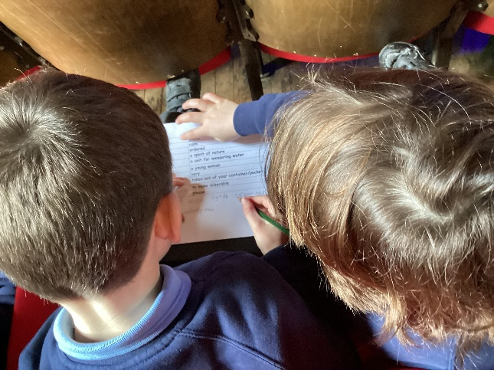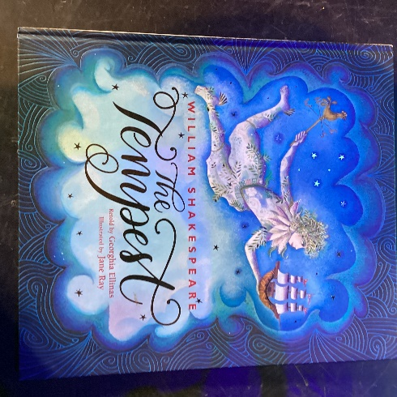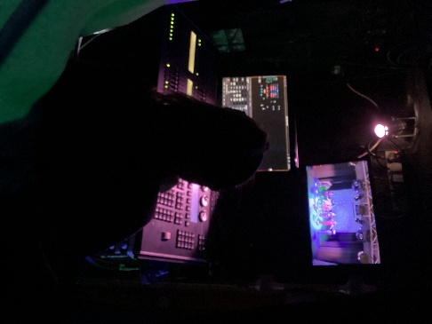
King’s Lynn Guildhall Theatre Visit
On Friday 24th of January 2025, Class 3 visited the oldest working theatre in the country. The first recorded performances at the King’s Lynn Guildhall were in 1445 and they have hosted plays and shows every century since then. It is also believed that Shakespeare visited the Guildhall when he was alive.
We had an introduction to the Guildhall and who built it. We learnt about the underground tunnels and how Shakespeare and his company visited the location and performed. We did a Shakespearean treasure hunt before trying to work out what some of the words meant. We heard the story of The Tempest before getting our scenes. After deciding our roles we rehearsed and planned what we were going to do. After lunch we were able to go backstage to put on costumes before acting onstage to our audience. The children were very supportive of each other during the performance.
Comments from the children included:
Matthew L: “My best memory was watching people act.”
Rebekah: “I loved doing the acting and really liked doing the dressing up.
Isabella: “I loved going onstage and learning about the underground tunnels,”
Olivia: “The best thing about the acting was the clapping and the cheering from everyone.”

