World Book Day for Class 4, 6th March 2025
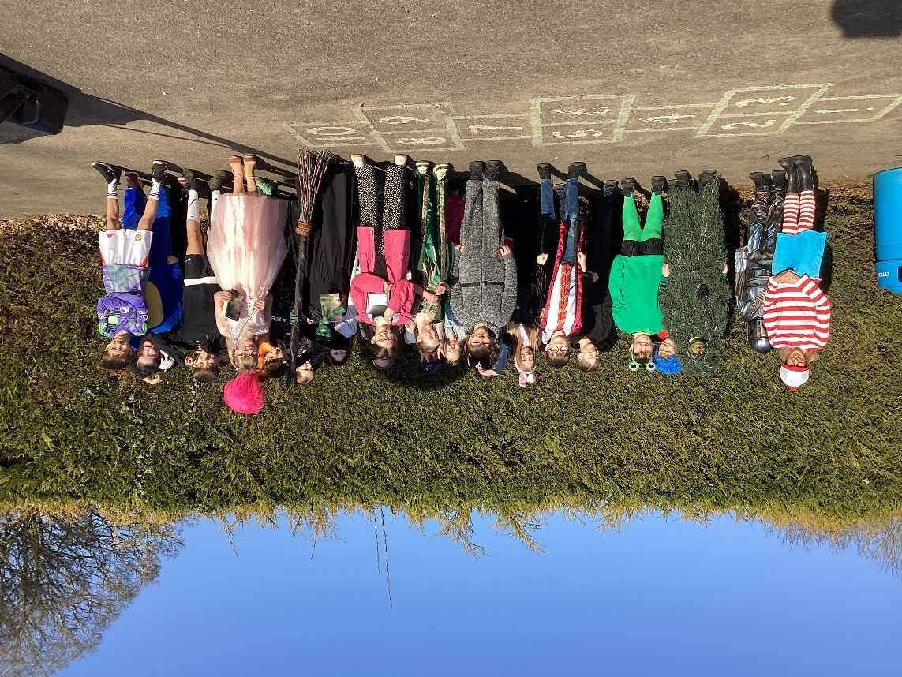
Once again, World Book Day was upon us. There were some tremendous efforts with costumes.
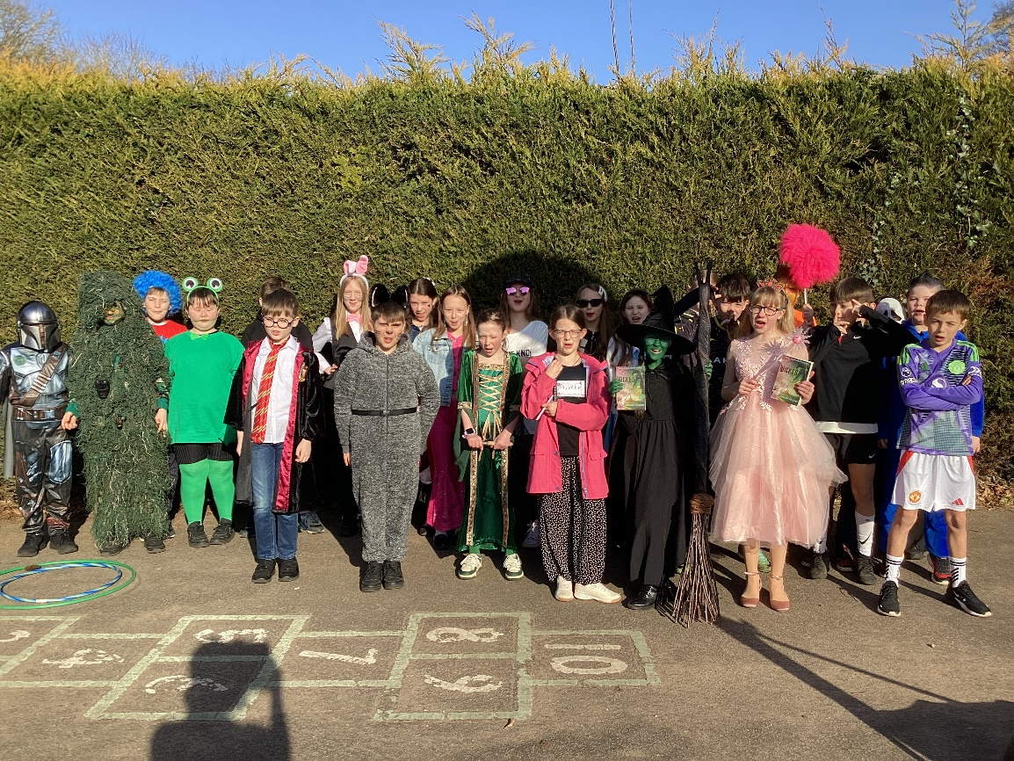
The day began with shared reading with the children in Class 1.
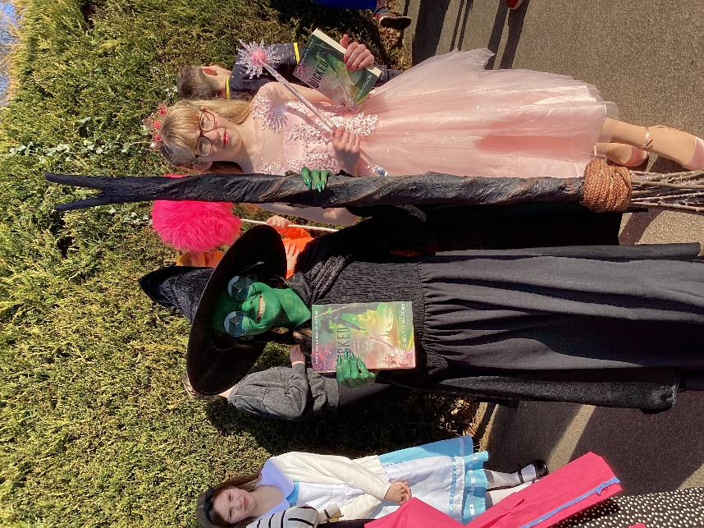
Soon after, we were joined by Class 3 for the National Literacy Trust and Premier League Primary Stars annual online quiz.

Then it was time to take part in the whole school display activity: designing the cover and a picture from our favourite books.
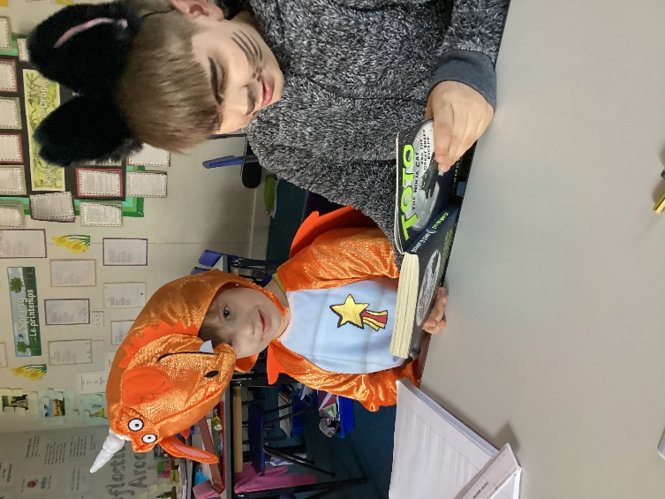
Finally, our annual in-school Key Stage 2 book quiz. We joined Class 3 and in 8 mixed teams took on four rounds of challenges. The winning team were rewarded with prizes in Celebration Assembly on Friday.


