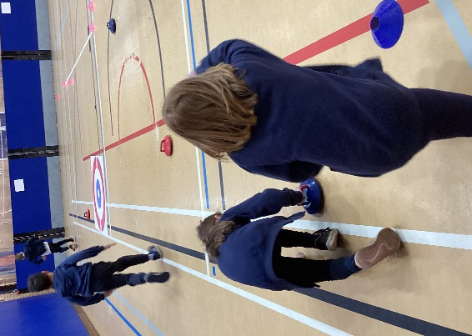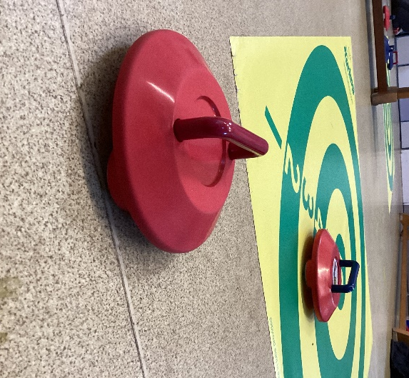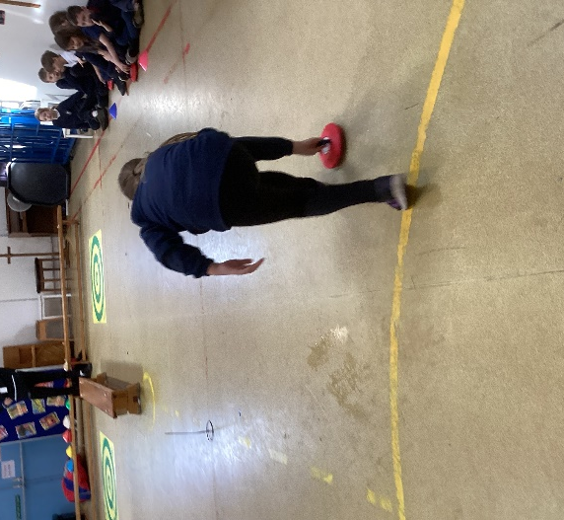

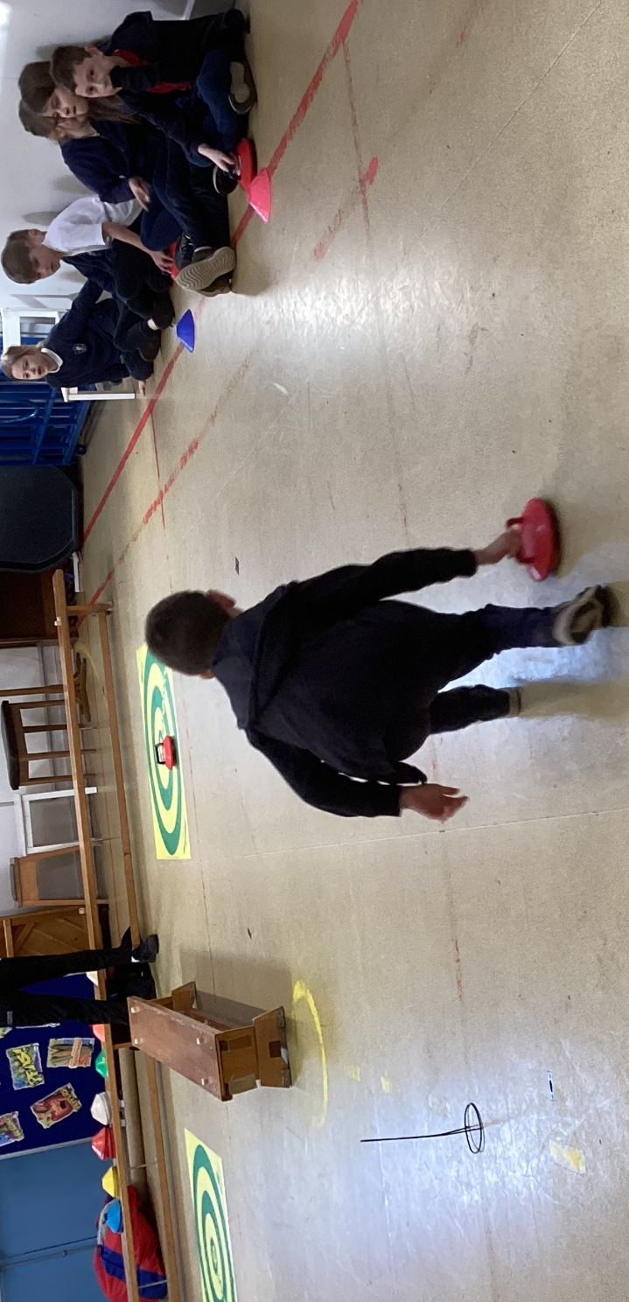

New Age Kurling, Class 3

On Friday 17th March Class 3 were lucky enough to take part in a New Age Kurling taster session. This was part of the Omnes Games set up by The West Norfolk School Partnership Programme.
The ‘Omnes Games’ meaning ‘For All’ was designed to give those children who don’t usually represent the school an opportunity to do so. The events are run as festivals, so no scores and results are recorded. Just an opportunity to come and play, have fun, meet new friends and fall in love with a new sport. A small group from Class 3 and Class 2 were able to join other schools on 24th March to share what they had learnt and play together.
“We had to roll a stone on wheels to get on a target.” Katie W
“I got a bullseye and no one moved it off. It was fun!” Lily T
“Joe told us to have fun and it was really fun,” Osian W

