Be Brave Workshop
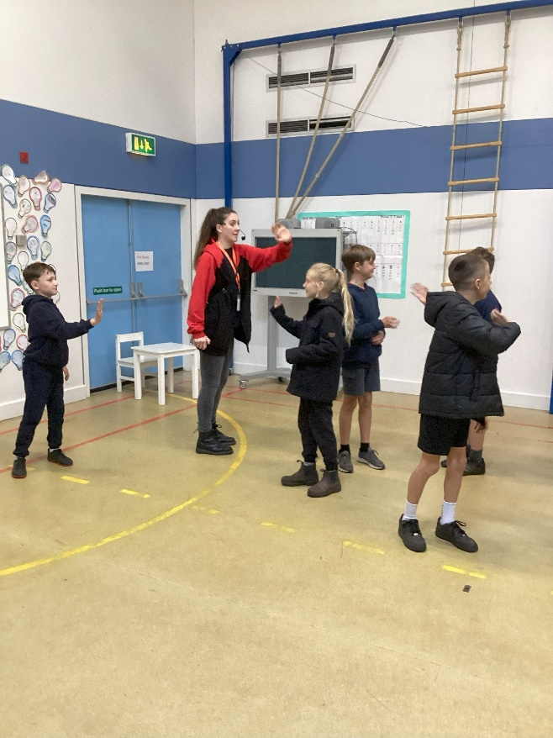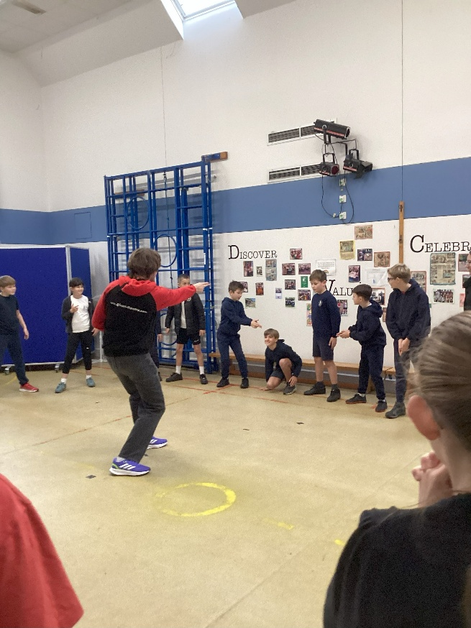
We were visited by members of a Christian theatre group for an entertaining collective worship and workshop with the theme ‘Be Brave’.
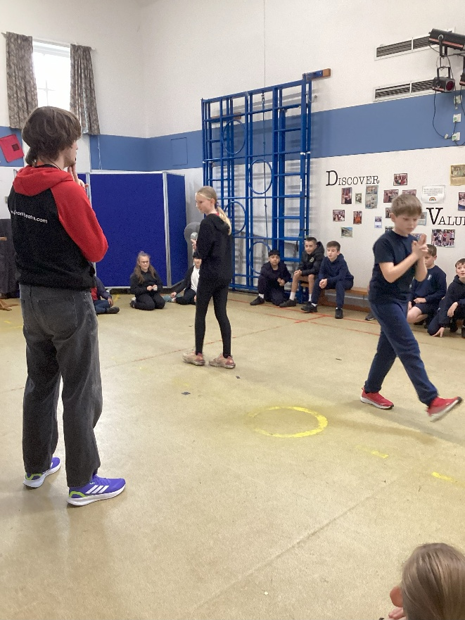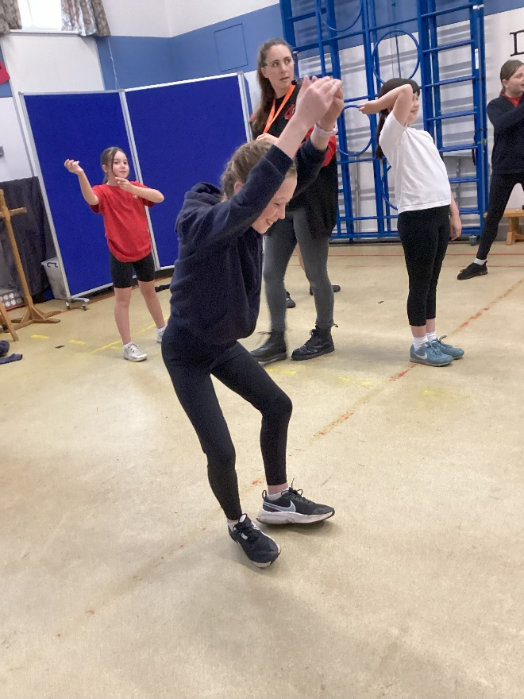

The collective worship involved characters called Esther and Donkey. They explored stories in the Bible where bravery had been shown. It was a funny presentation with a lively song to finish off.
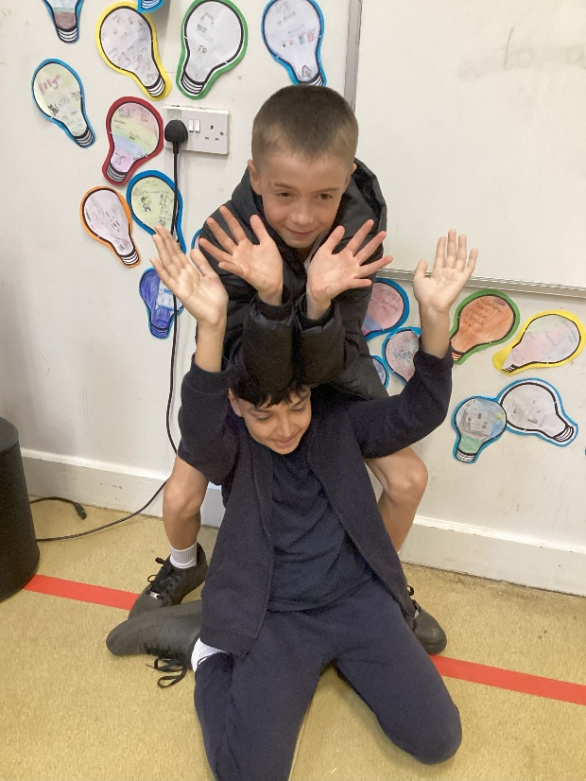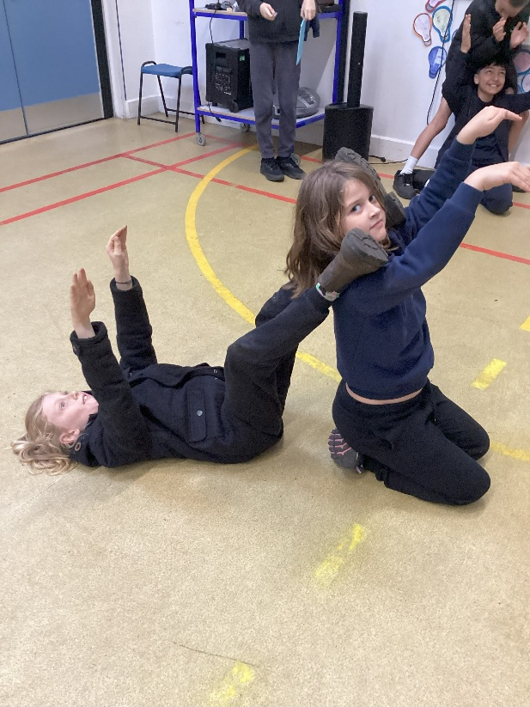
In the afternoon, we joined the cast members for the workshop. This began with games such as Splat! This progressed to using individual and then collective drama skills to represent objects and scenarios.
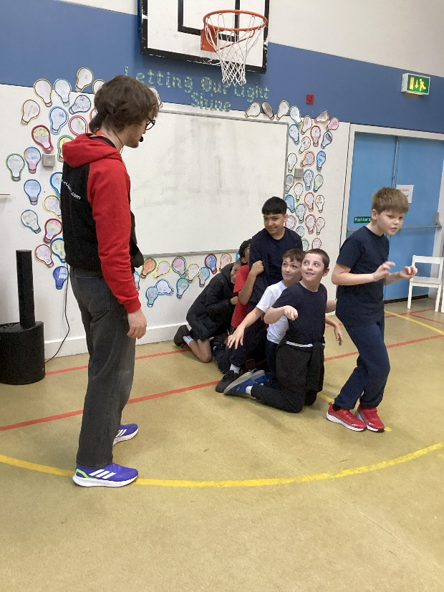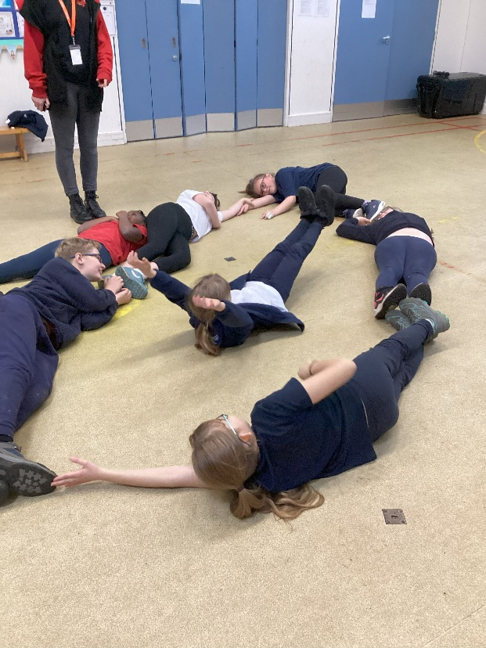

Then the Bible story of Shadrach, Meshach and Abednego was shared with groups representing the scenes of the story where the brave men stood up to the king and refused to idolise him.
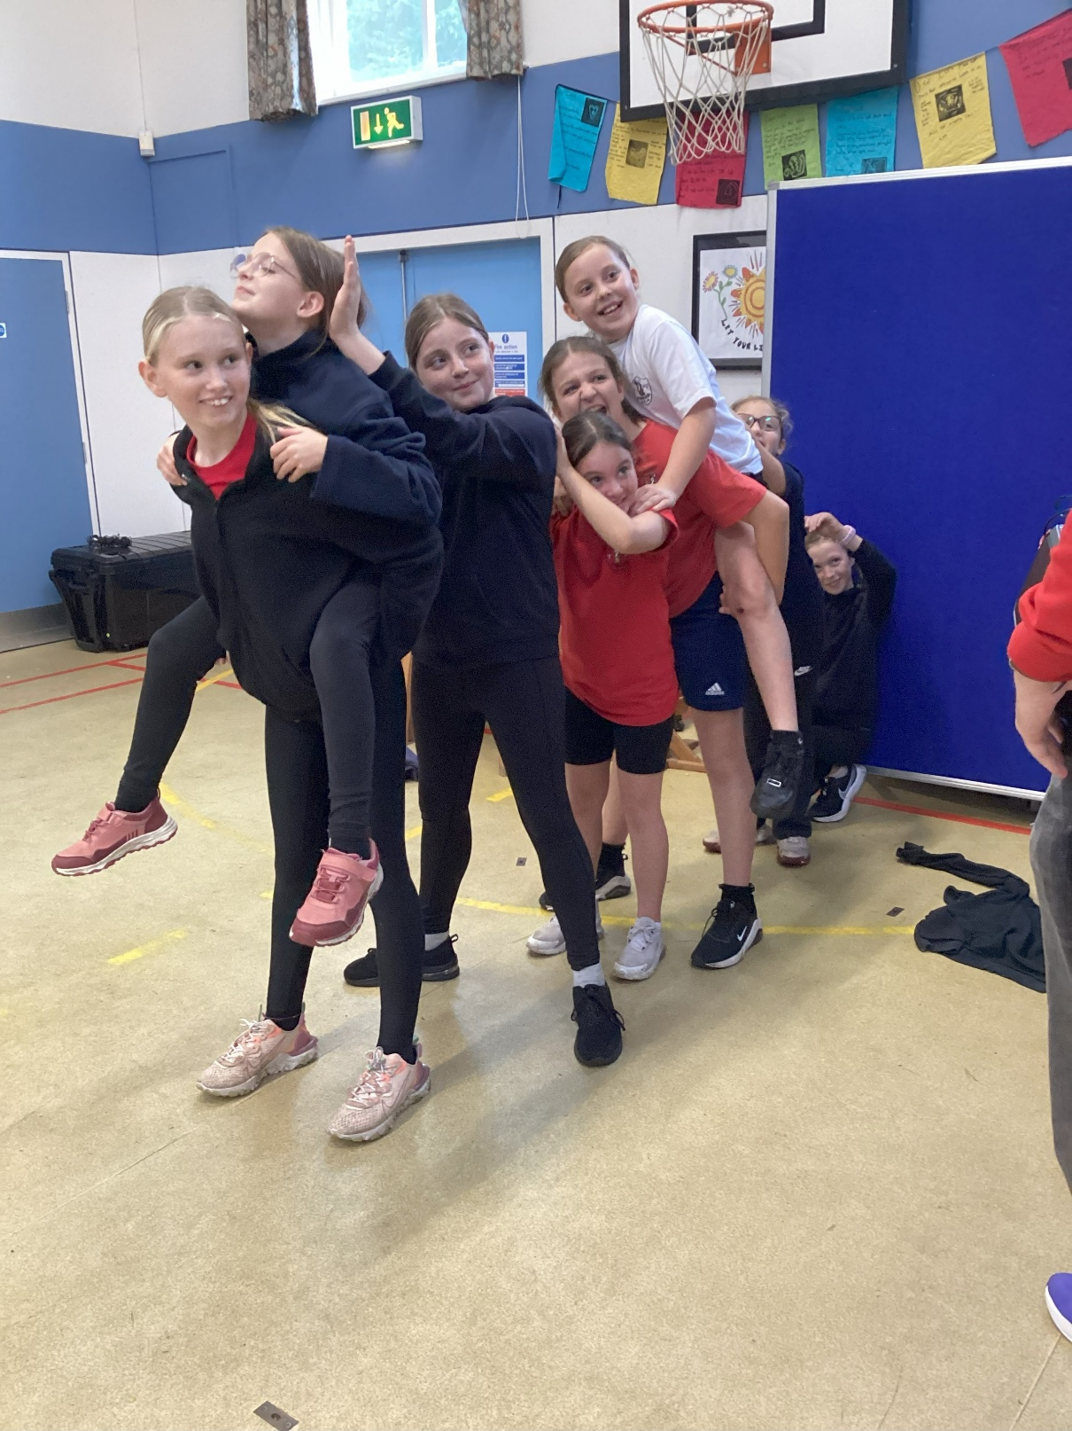
The smiles say it all.

