School Council visit to the Foodbank
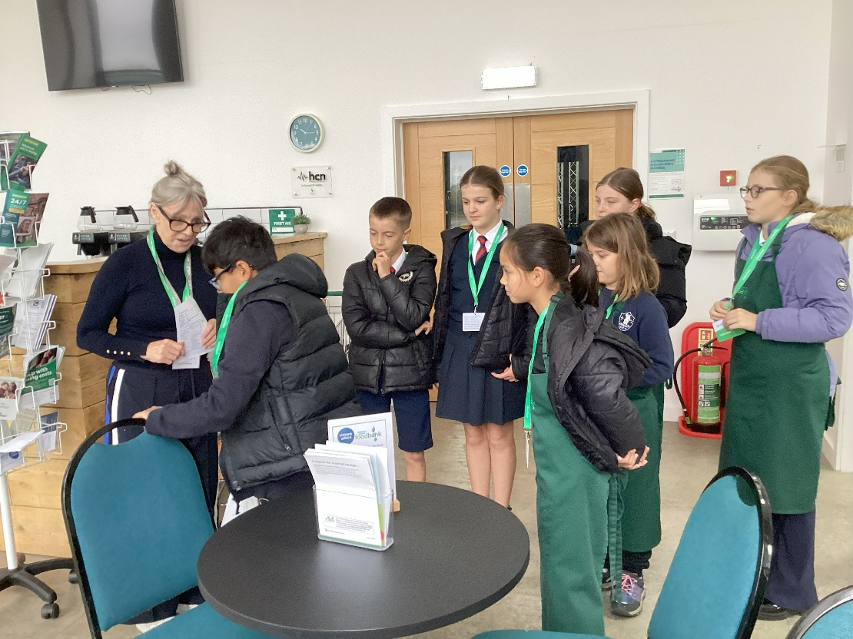
On Tuesday 14th October our school councillors visited Downham Market Foodbank to take the produce generously donated during our church harvest festival.


