Mothering Sunday
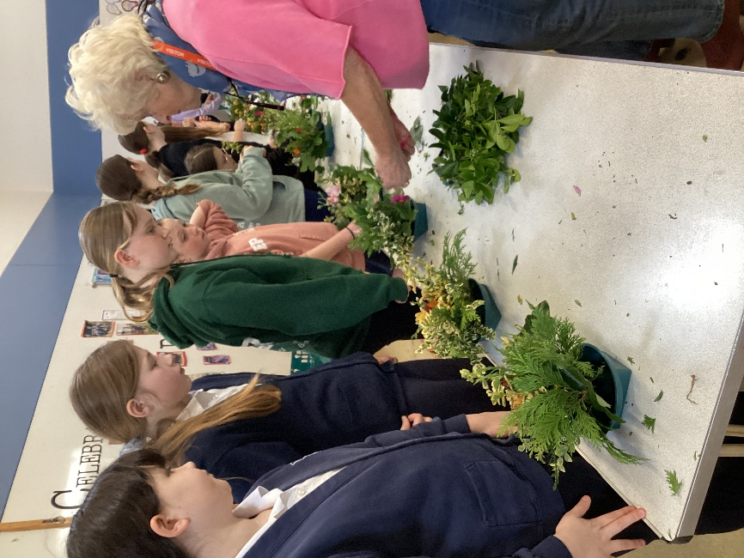
To celebrate Mothering Sunday, we were very fortunate to have representatives from St Mary’s Denver and Downham Market Academy (including students) to support us in making posies. Thank you also to the Friends who supplied the flowers.
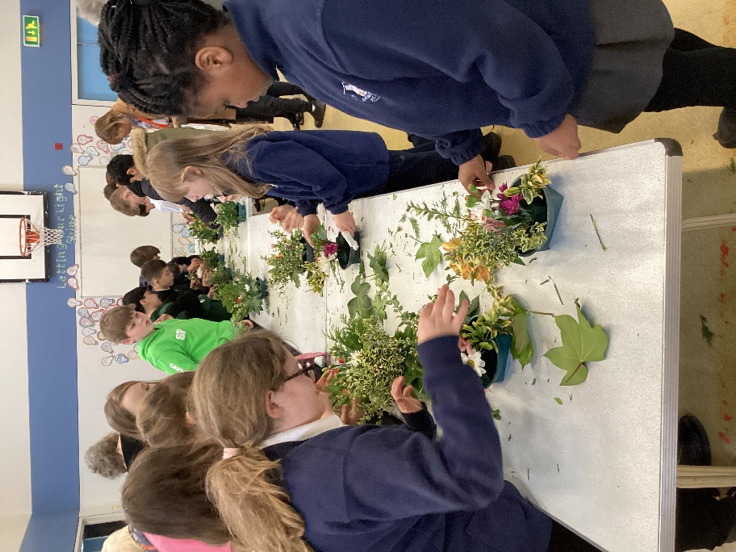

In class we also made some cards to express our gratitude to our amazing mothers and carers who do so much for us.
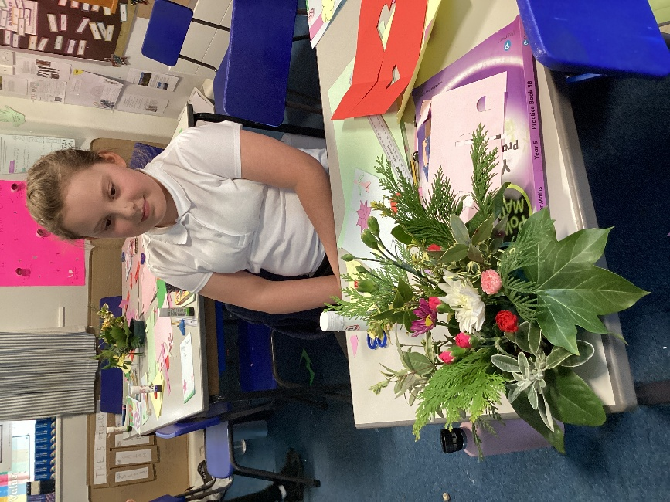
Happy Mothering Sunday 2026!


