British Science Week 2026
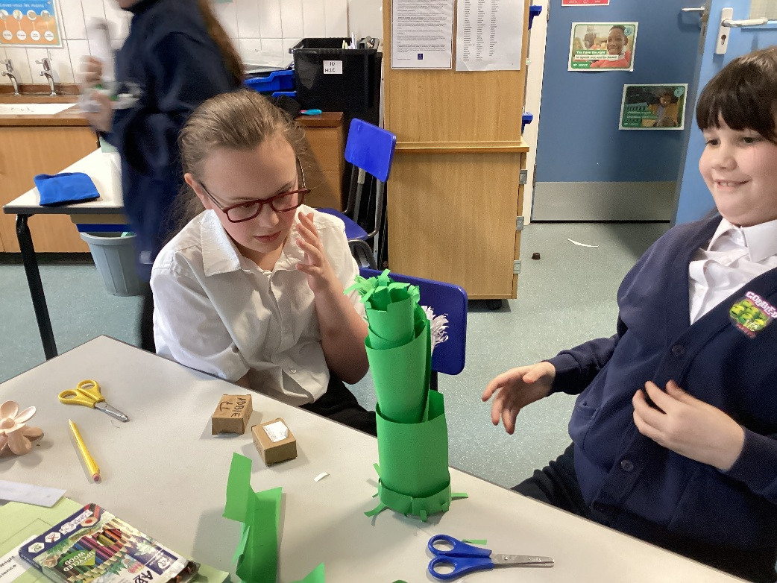
As part of British Science Week Class 4 children have been taking part in the STEM (Science, Technology, Engineering and Maths) Organisation challenge. This involved creating a paper tree using only scissors and paper. No glues or fasteners were allowed. Instead, the children were encouraged to use a variety of paper engineering techniques: cutting, folding, pleating, rolling and slotting to assemble their trees.
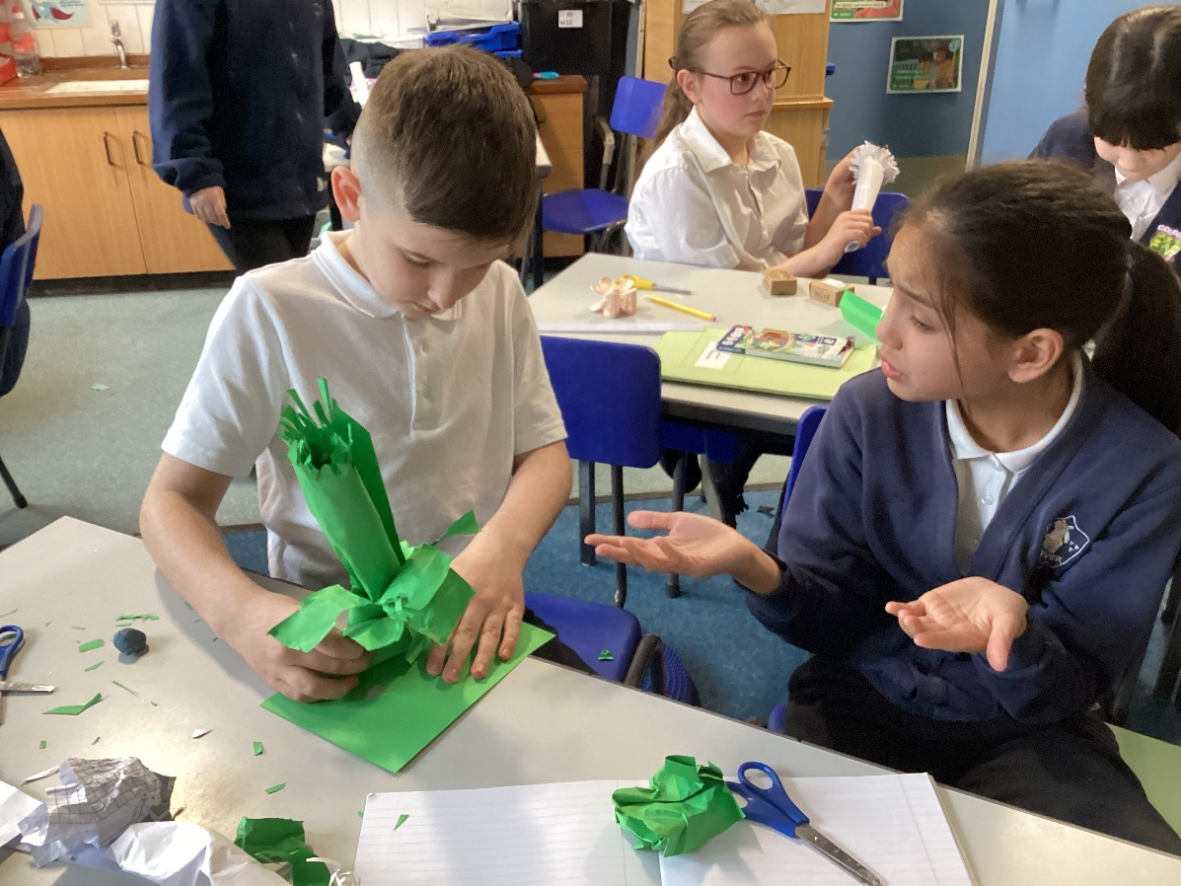
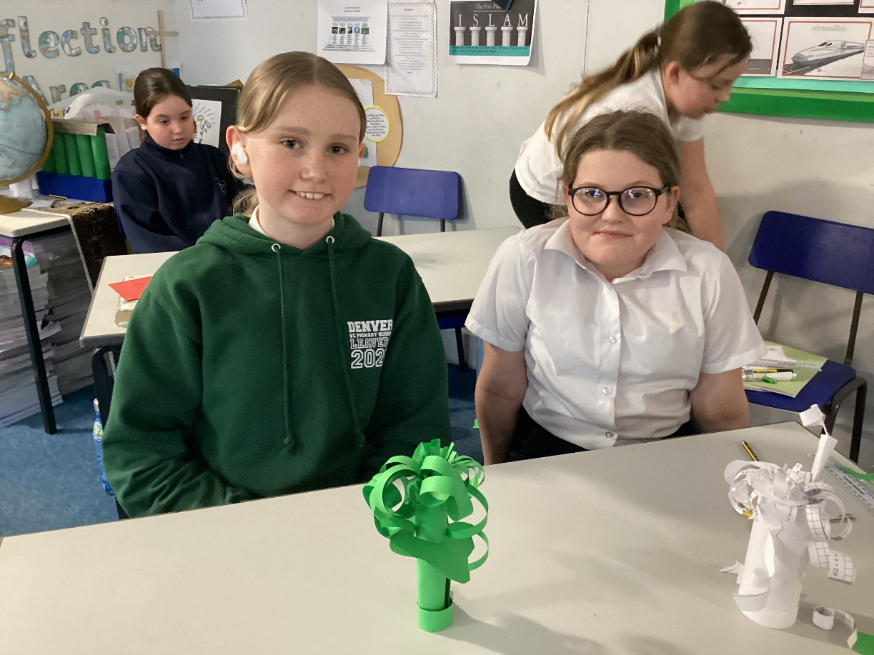

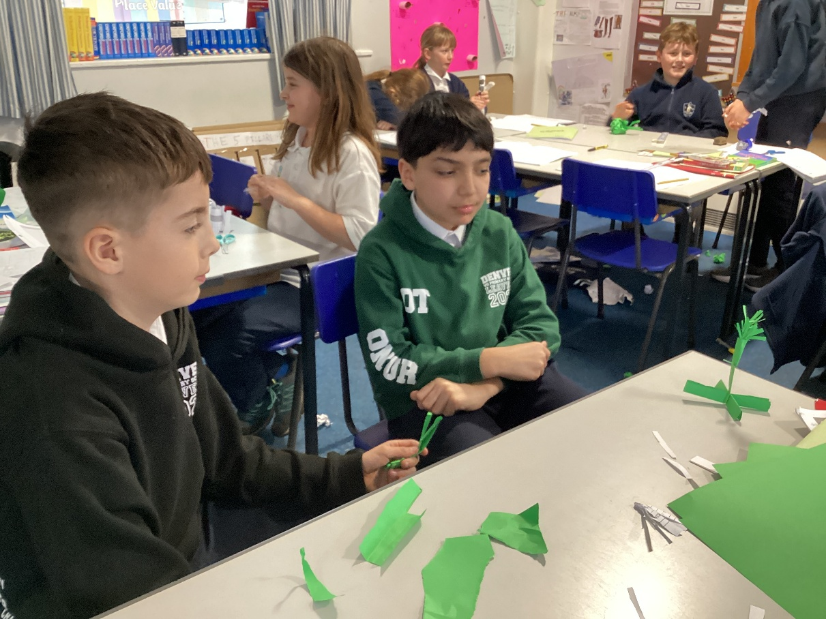

In addition to this, the children also joined the Picture News Online Worship for Science Week where we learned about the different layers of the sea. These were modelled by the experts who used different liquids to create the layers, demonstrating how different substances have different densities. This allowed the children to focus on aspects of spirituality: beauty and beyond.



