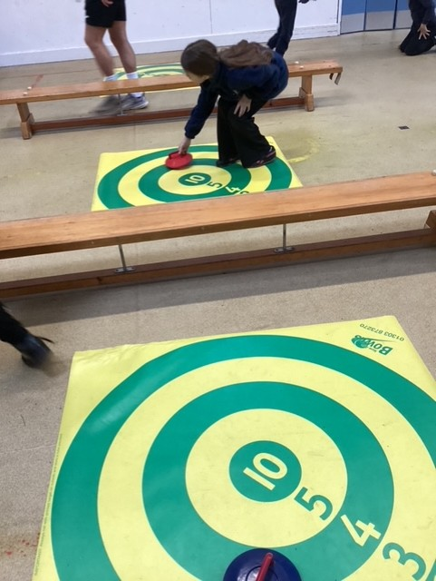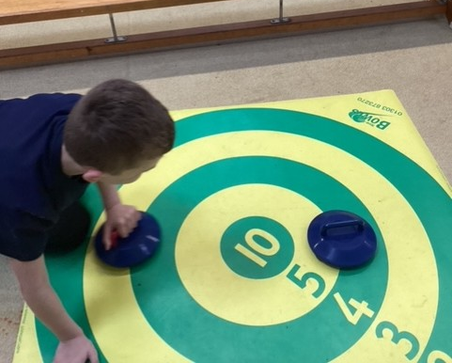
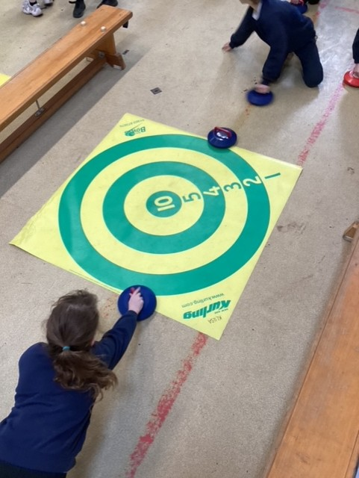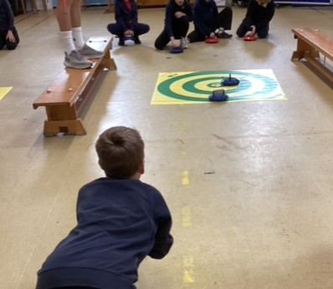

Class 3 try Kurling!
On Monday 16th of March, Class 3 was able to try the sport of indoor Kurling. New Age Kurling is a form of the original curling game, but adapted so that it can be played indoors on any smooth, flat surface, such as a sports hall, rather than on ice. It involves players sliding stones across a smooth surface, aiming to get them as close to a target as possible, with strategies and techniques similar to traditional curling.
Comments for the children afterwards included:
“It was very fun, Ben made the instructions really simple.” Robyn
“I really liked it and the Kurling stones were really cool.” Ivy BB
“Kurling was fun and we played different matches.” Lily G
“The Kurling was very tricky!” Tarran

