Handa’s Surprise

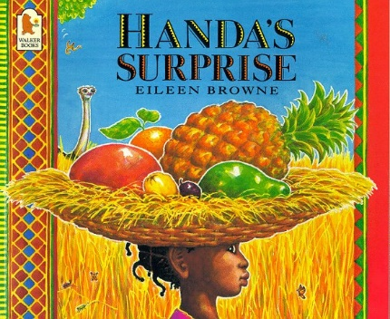
During their literacy lessons Year 2 have been learning about stories from different cultures. The book we chose was Handa’s Surprise by Eileen Browne.

The children looked at the different way of living and the different animals that Handa encounters on her journey to see her friend Akeyo. Handa takes a basket of fruit to her friend, but when she arrives there is a big surprise.
The children did a tasting of the fruits found in Handa’s basket. The children all tried the fruits and some of them were very surprised to find that they actually liked them. Others were not so keen!
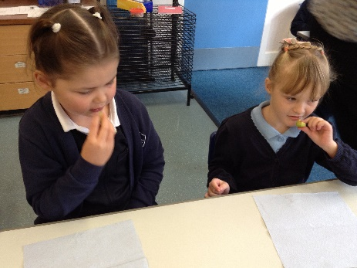
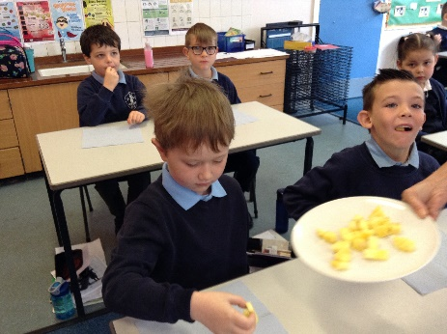

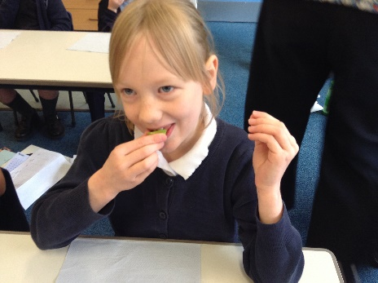
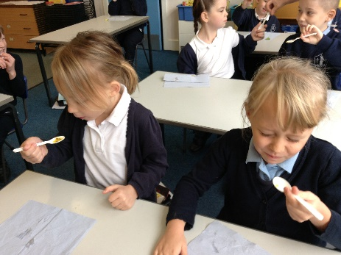

We tried mango, passionfruit, tangerines, pineapple, avocado and bananas.

